Day 47
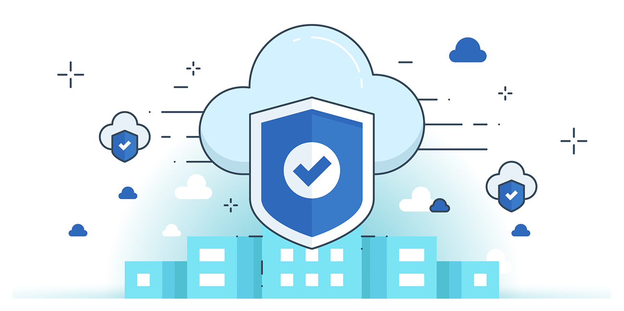

“CLOUD SECURITY”
What is Cloud Operation?
Cloud Operations refers to the process of efficiently running, managing, and delivering cloud infrastructure and services to ensure high performance, availability, security, compliance, and cost-effectiveness. It involves monitoring resources, maintaining configurations, automating management tasks, ensuring disaster recovery, and meeting service-level agreements while optimizing performance and capacity for users.
What is Cloud Operation Security?
Cloud Operation Security focuses on protecting data, networks, and applications in cloud environments, which differ from traditional on-premises setups. It involves using tools, protocols, and agreements between providers and consumers to ensure availability (uptime), integrity (authorized changes), and confidentiality (preventing unauthorized access). Key practices include monitoring logs, isolating resources, securing records, and continuous service improvements to mitigate threats and maintain compliance.
Fundamentals/Strategies to Secure Cloud Operations:
- Encrypt sensitive data
- Enforce improvements across the lifecycle of operations
- Control access to cloud configuration and management tools
- Use automation to reduce human errors due to misconfigurations
- Monitor ephemeral and new types of cloud assets via visibility and vulnerability management
Virtualization Management tool:
A Virtualization Management Tool is software that helps manage cloud virtual environments by integrating the virtual layer with underlying physical hardware. It allows organizations to efficiently administer cloud resources, including managing processor and memory allocations to virtual machines (VMs), ensuring smooth cloud operations.
Best Practices for Secure Configuration of Virtualization Management Tools:
- Ensure all management takes place on an isolated management network
- Install management tools on the host based on the virtualization platform
- Install the latest tool on every host
- Ensure the configuration management plan includes rules for updating tools
- Deploy sufficient server resources for VM movement during platform/tool updates
- Conduct external vulnerability testing of the tools
- Follow vendor-provided security guidance for configuring and deploying tools
- Implement role-based access to management tools
- Audit and log management tools
- Understand the vendor’s management tools and install/configure them securely based on system configuration
DHCP Options Set in AWS:
Steps:
Look for VPC:
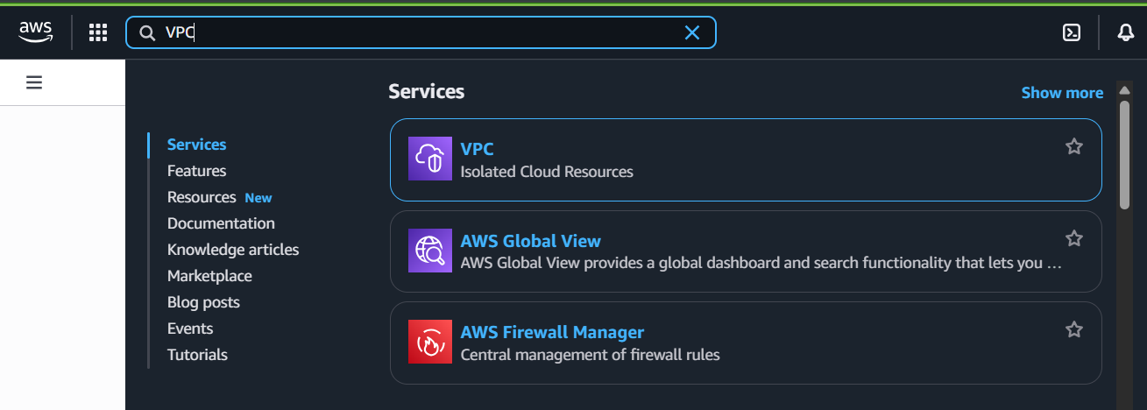
Look for “your VPC”:
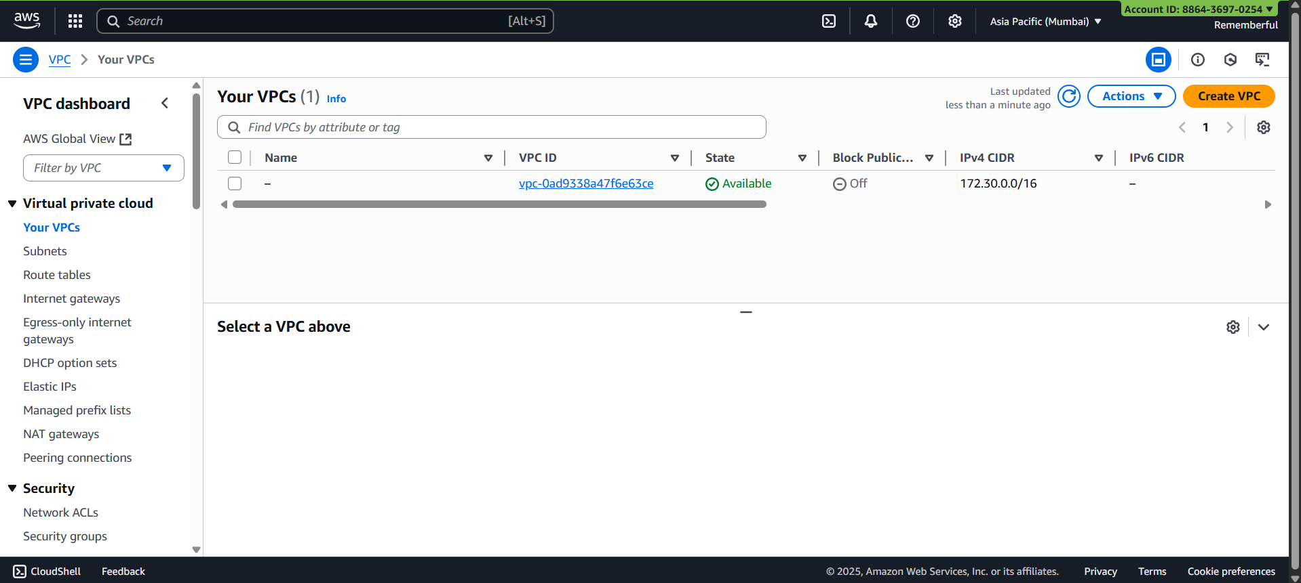
Open the VPC:
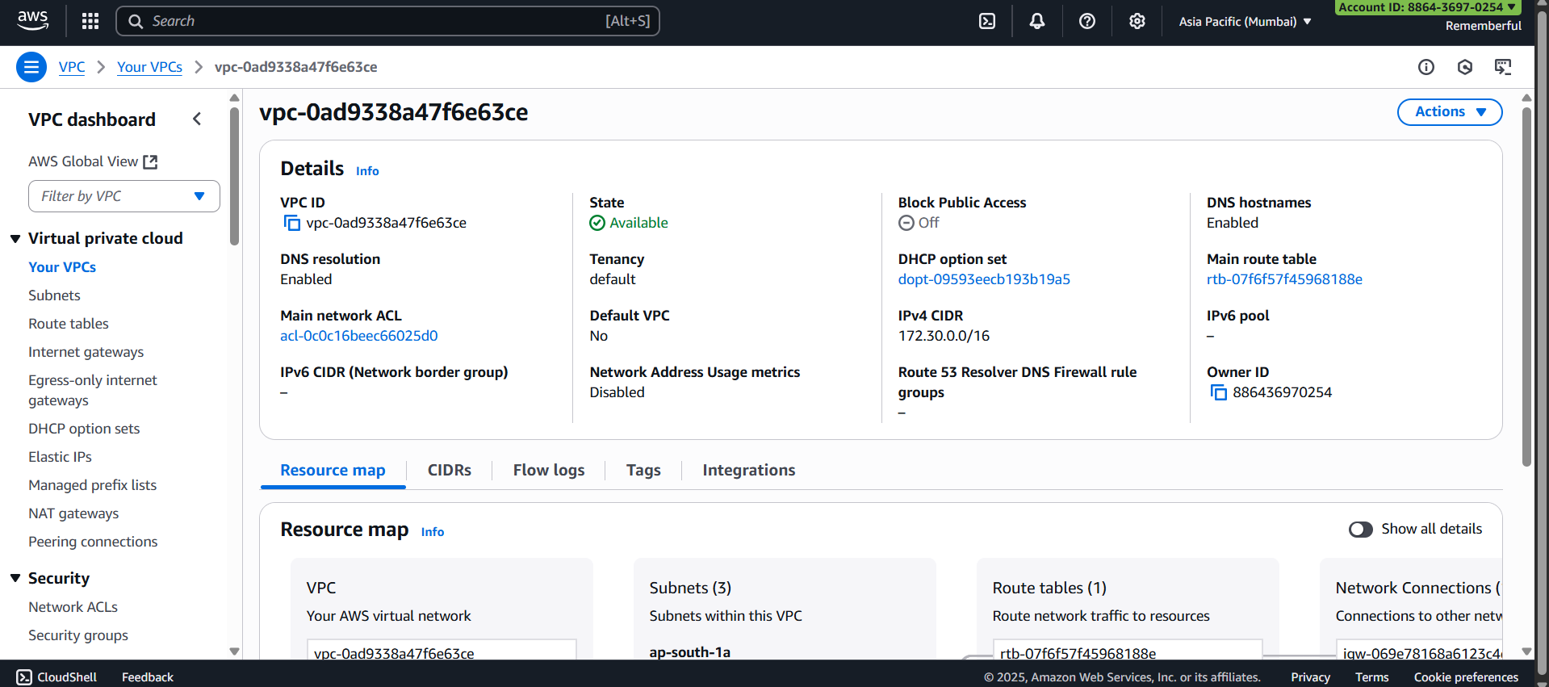
Click on “DHCP option set”:
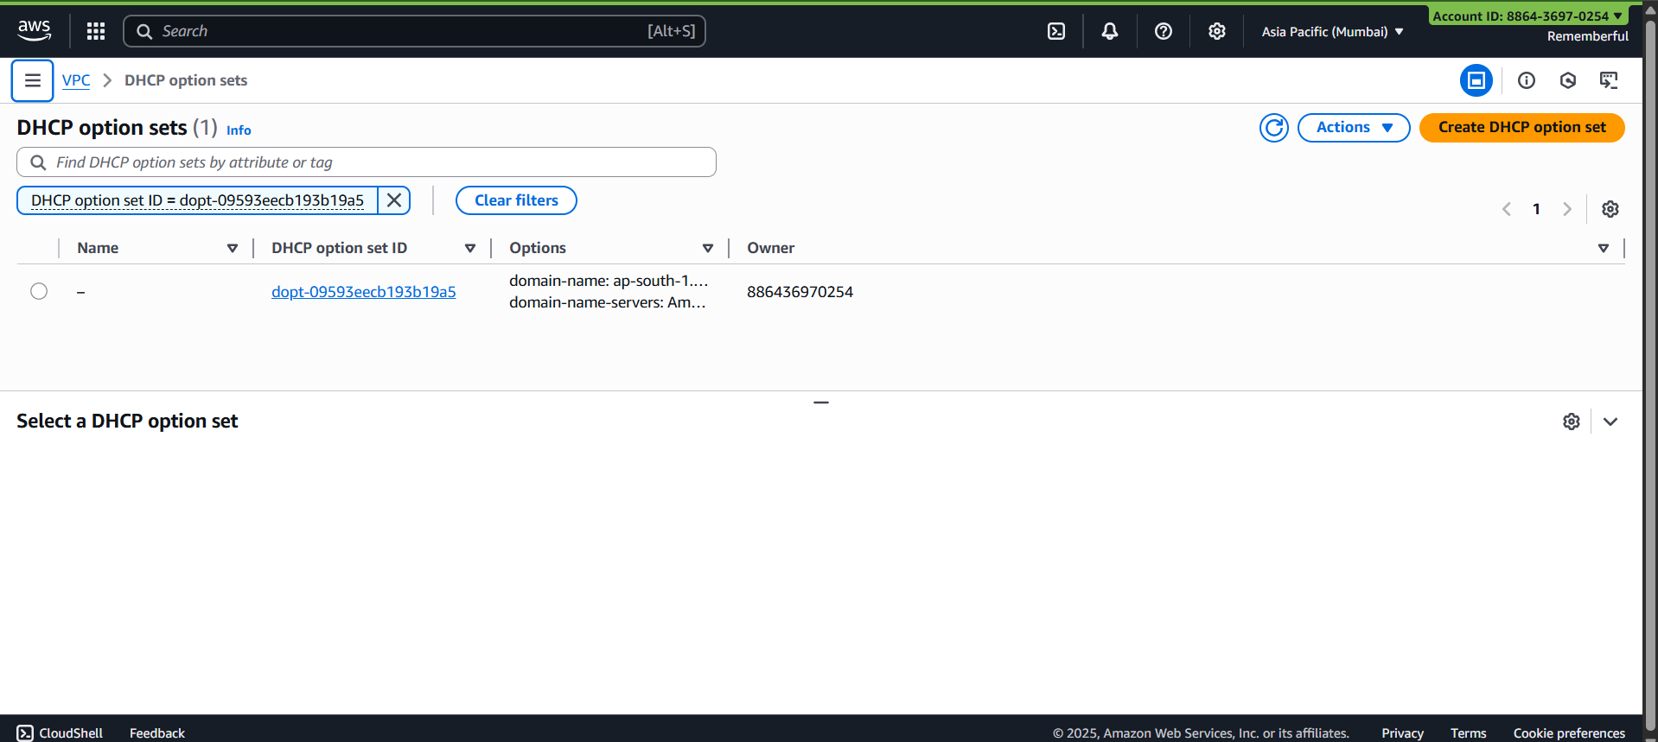
Click on “Create DHCP option set”:
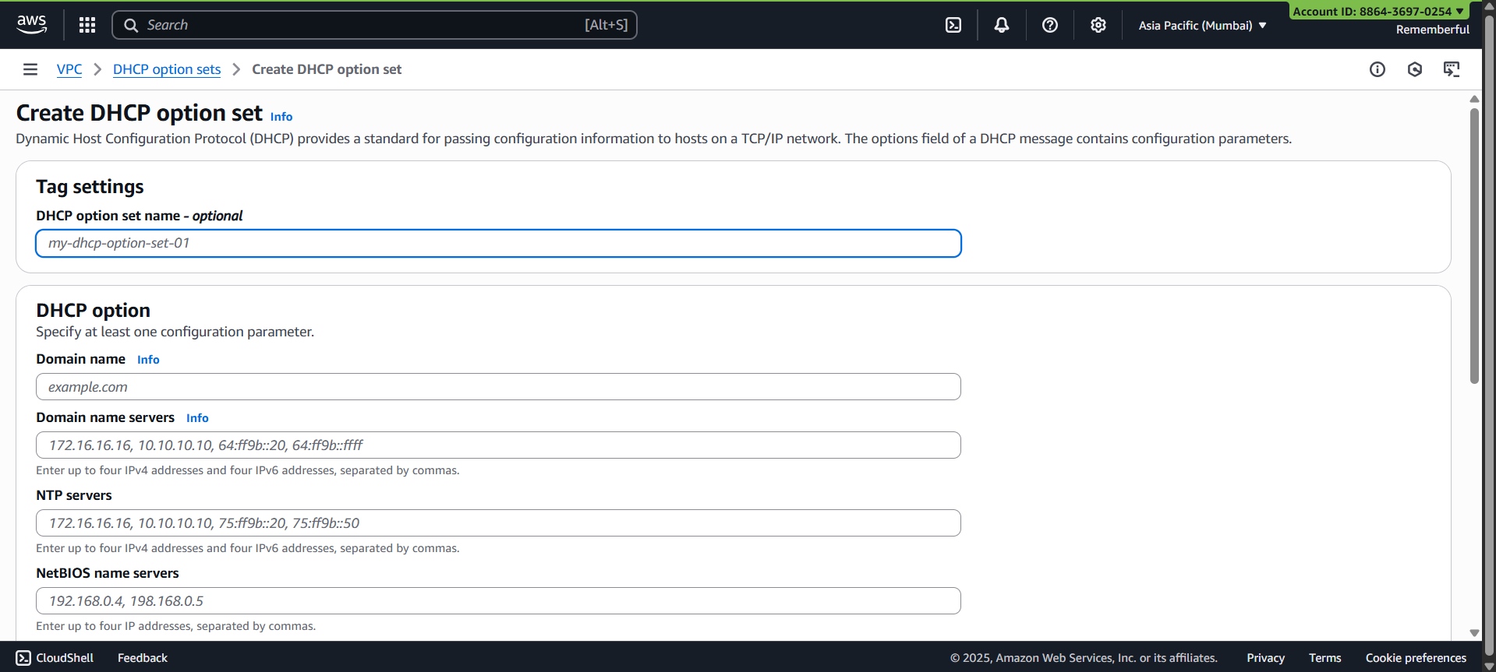
Fill it and you are done!
--The End--

