Day 43


“CLOUD SECURITY”
Enable Amazon S3 Default Encryption:
Steps:
Look for S3:
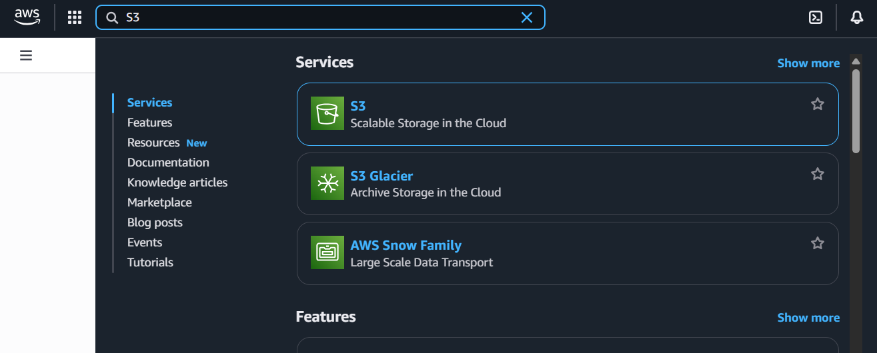
Select the bucket you want to encrypt:
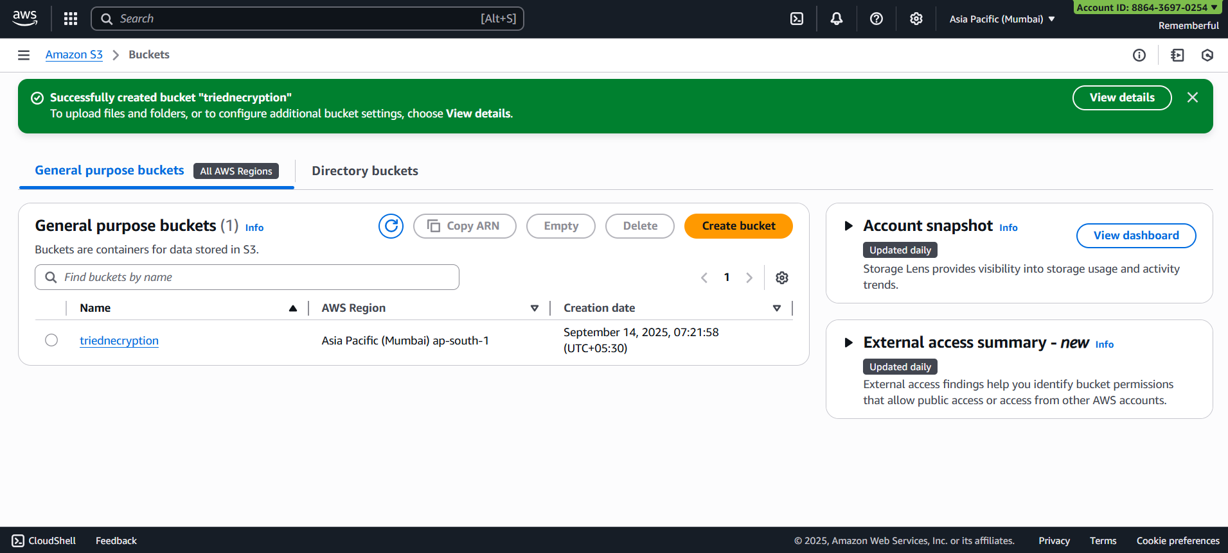

Open the bucket:
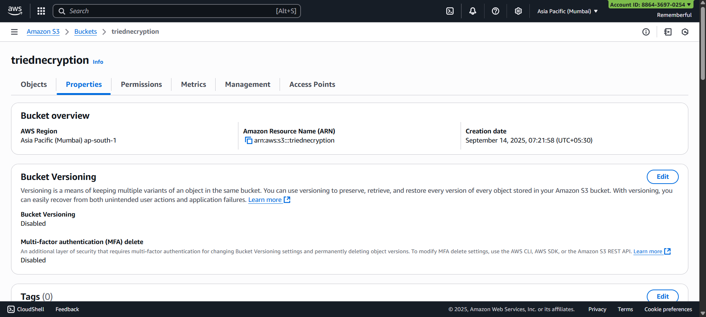
Scroll down to “Default Encryption:
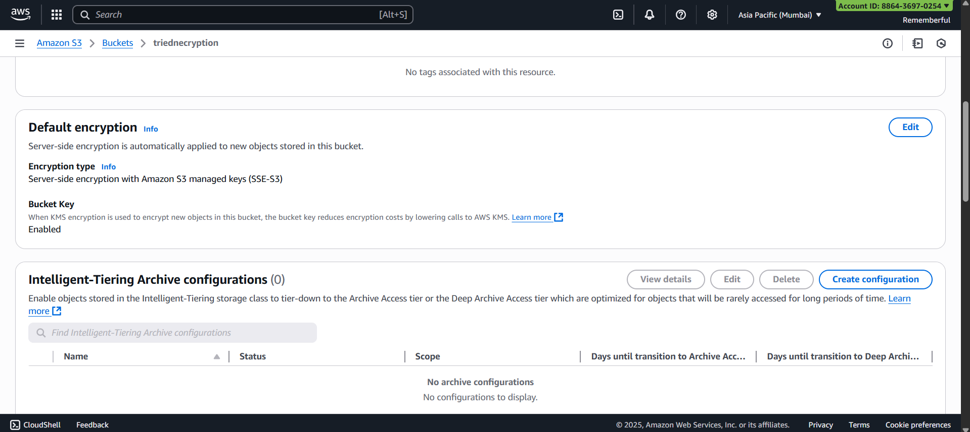
Click on “edit” button: following screen will appear
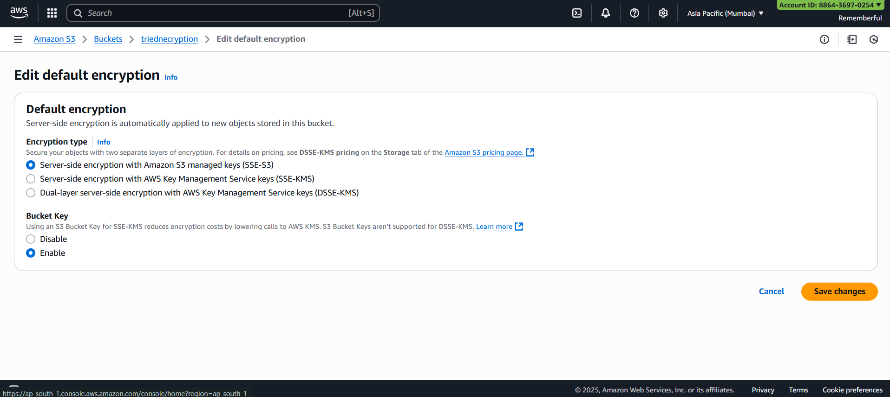
Enable Server Access Logging for Amazon S3 Bucket:
Steps:
Open the bucket:
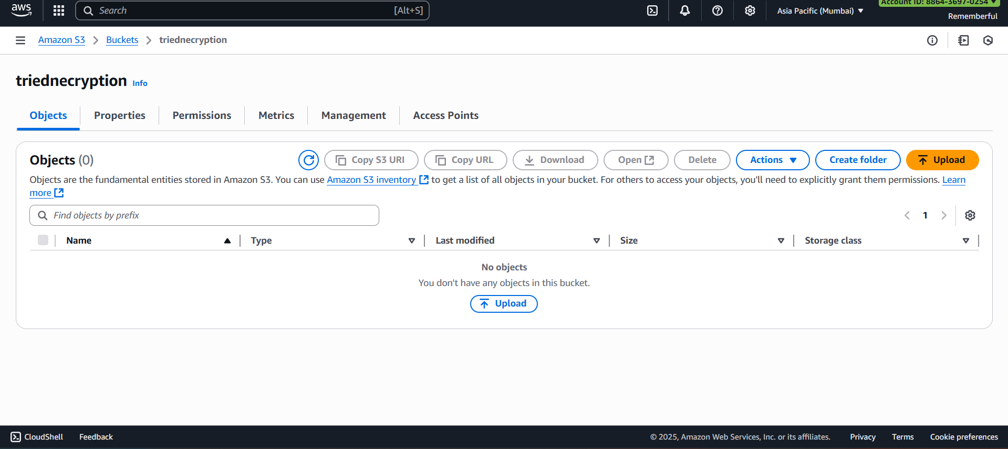
Go to “Properties” Section;
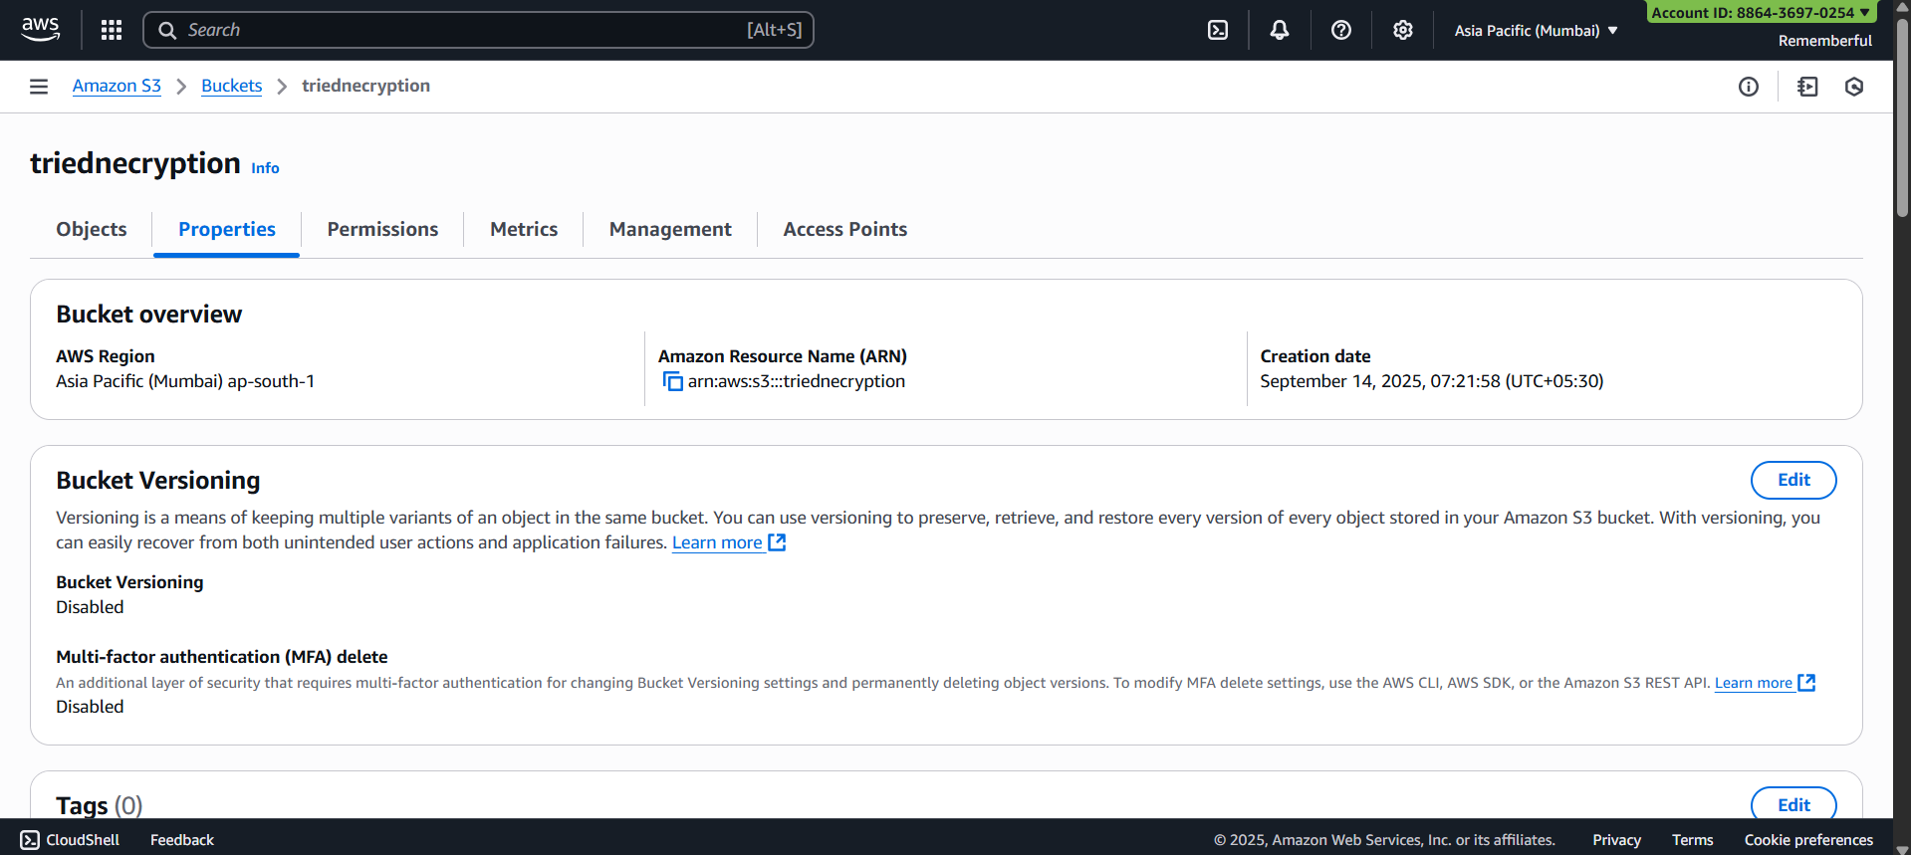
Scroll down to “Server access logging”: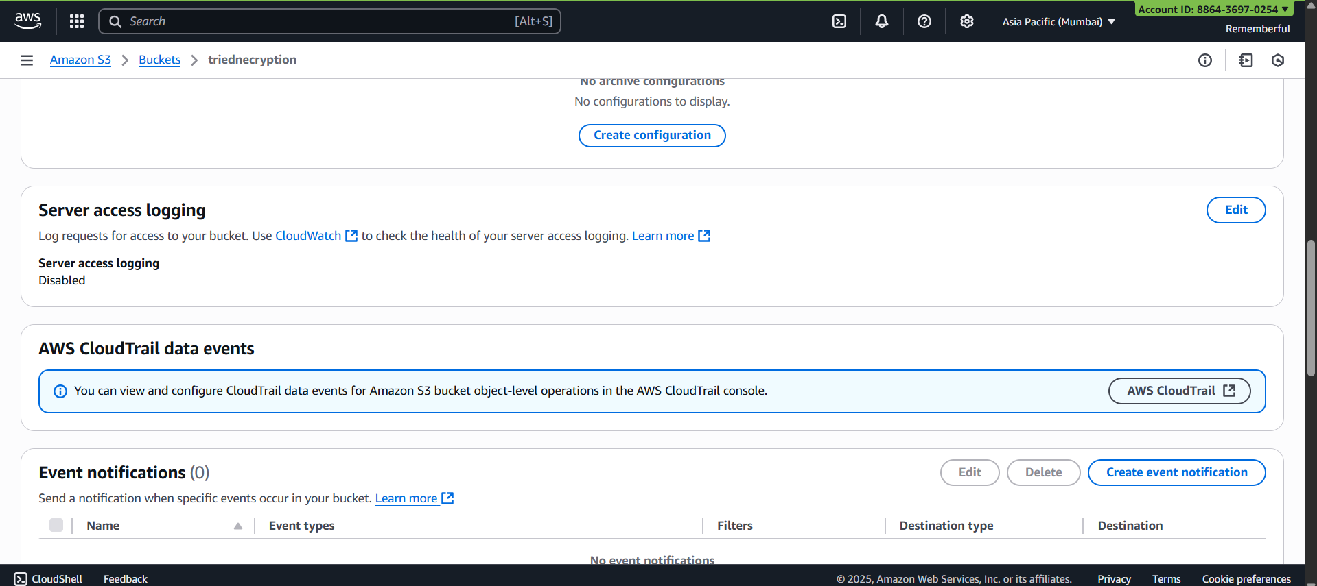
Click on “edit” button: following screen will appear
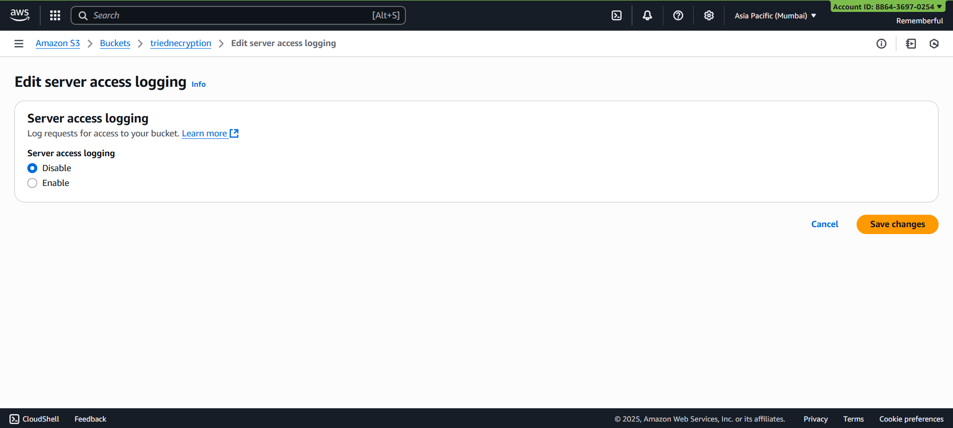
Click on “enable” button: following options will appear
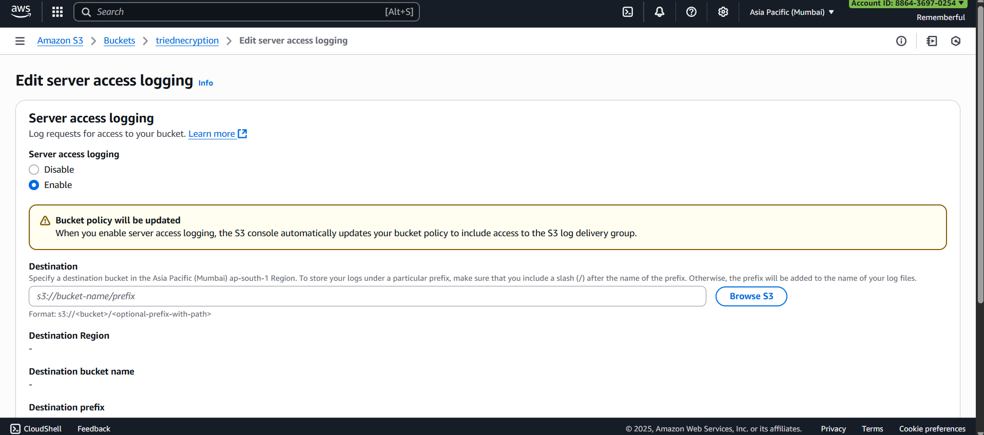
Browse S3:
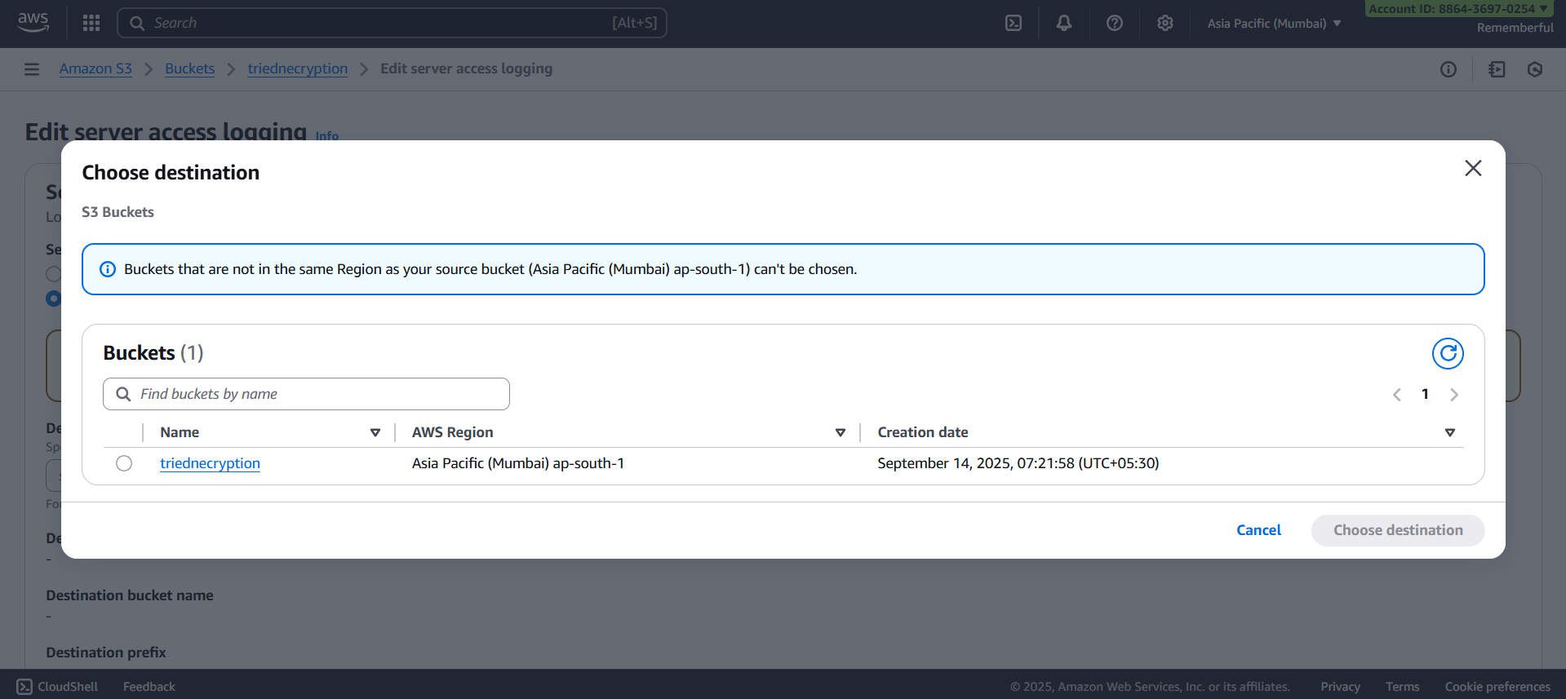
Select the bucket:
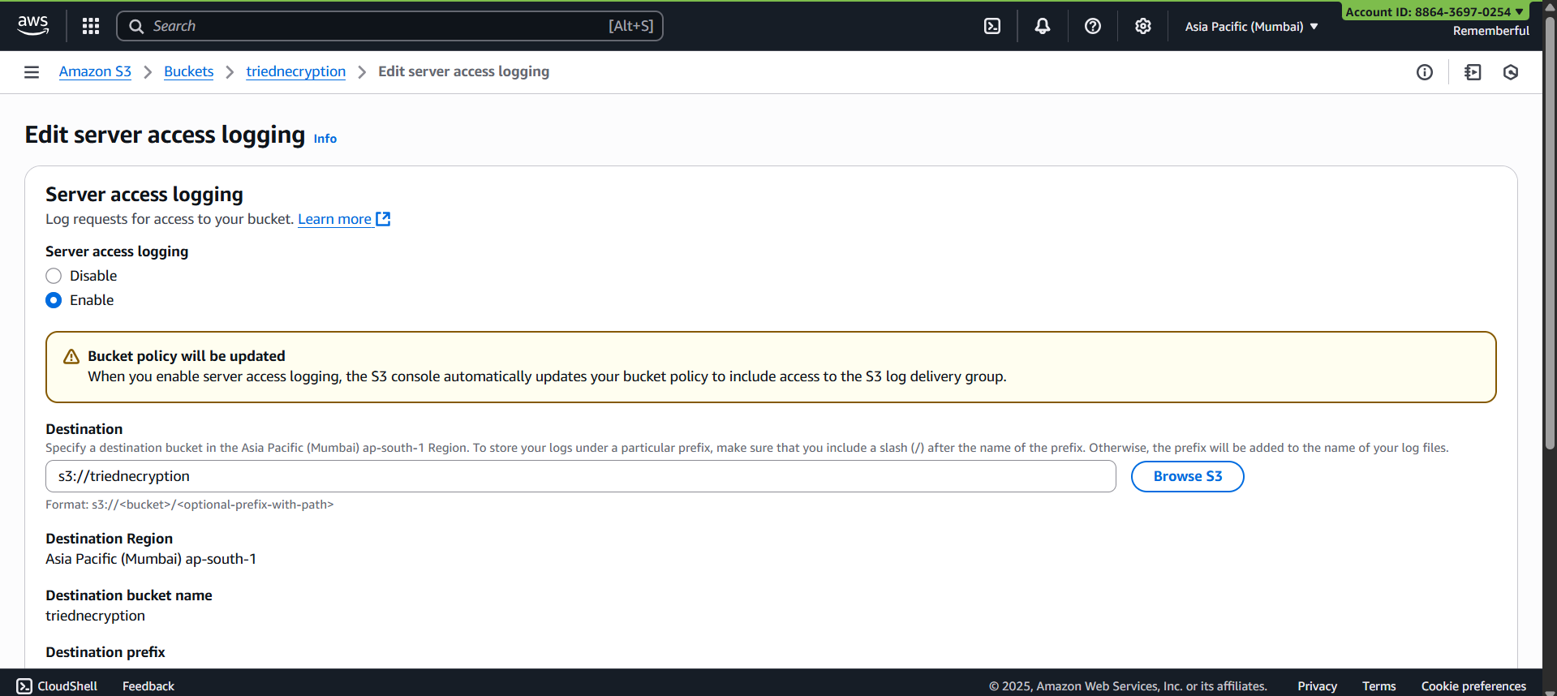
Click on the orange button at bottom, following confirmation will occur:
