Day 44
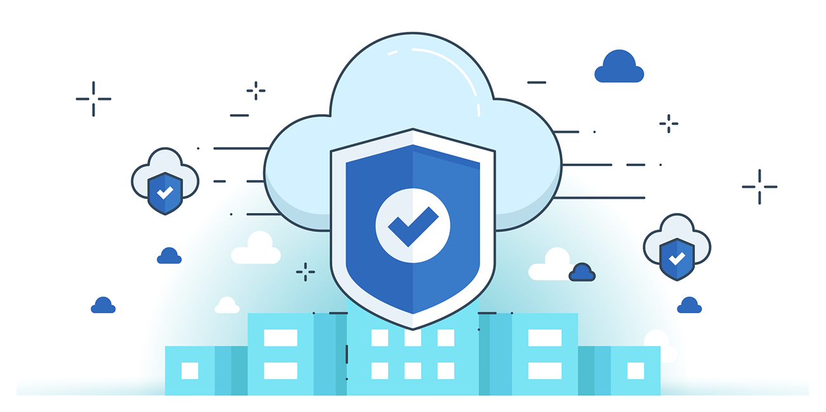

“CLOUD SECURITY”
Block Public Access to S3 Buckets:
Steps:
Look for S3:
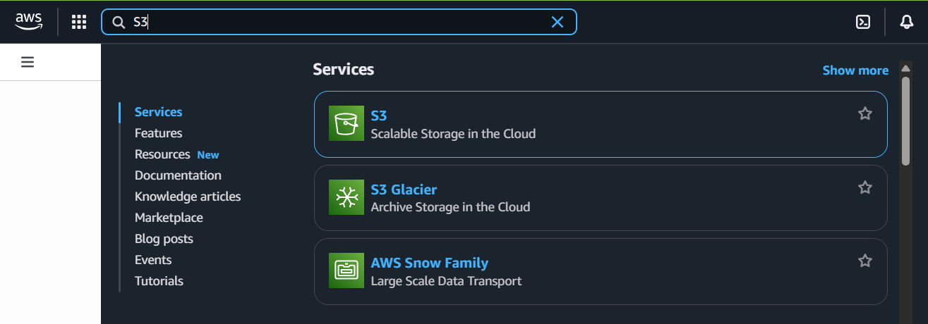
Start creating a new bucket: look for following section
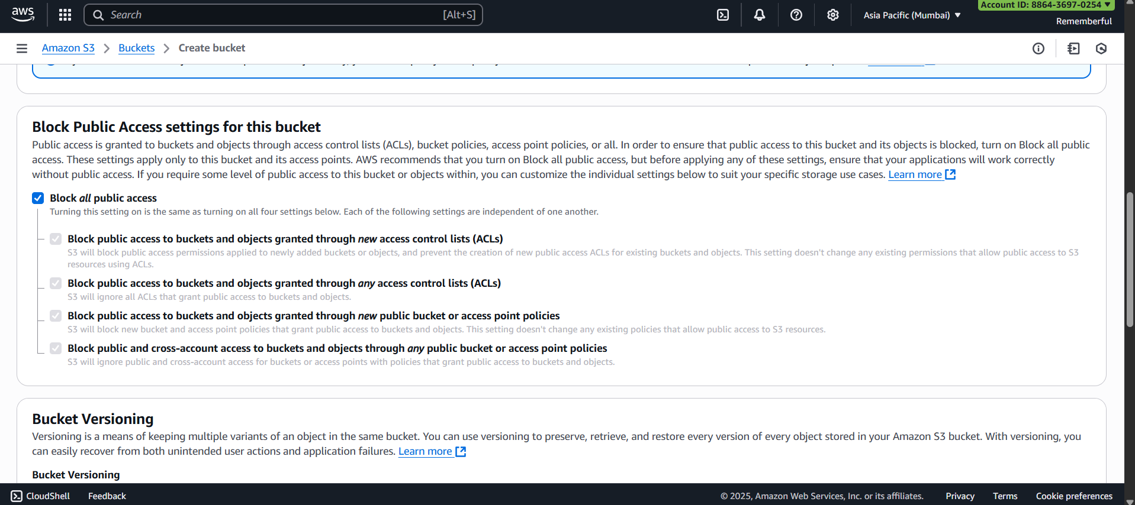
Click on save changes, and you are done.

Restrict public access to S3 buckets via bucket policies:
Steps:
Create a bucket which can be publicly accessible. Say:
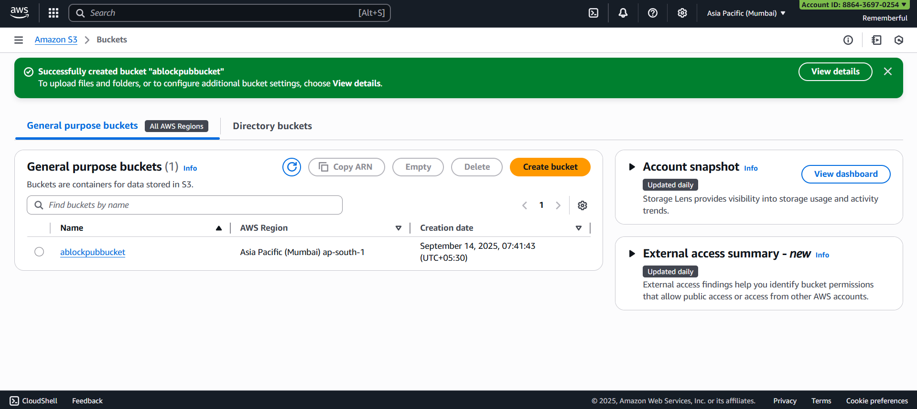
Open that bucket:
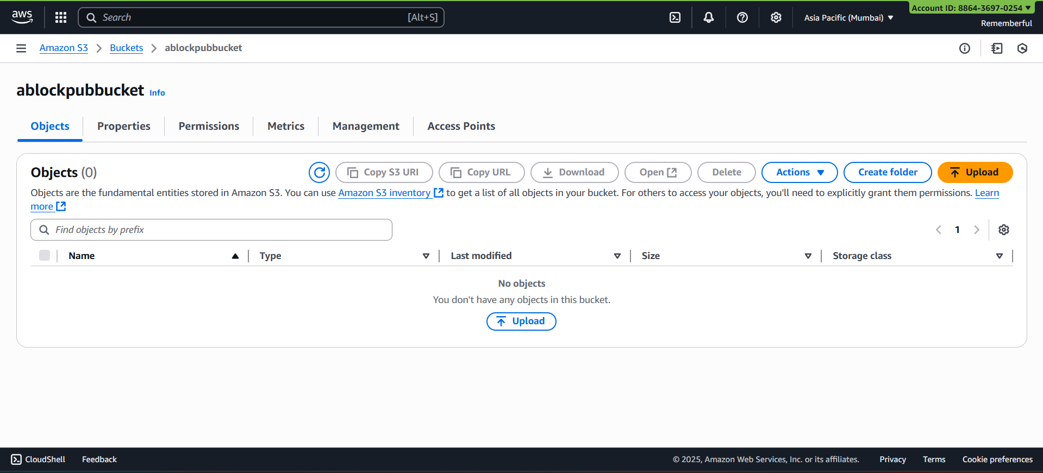

Go to permissions section:
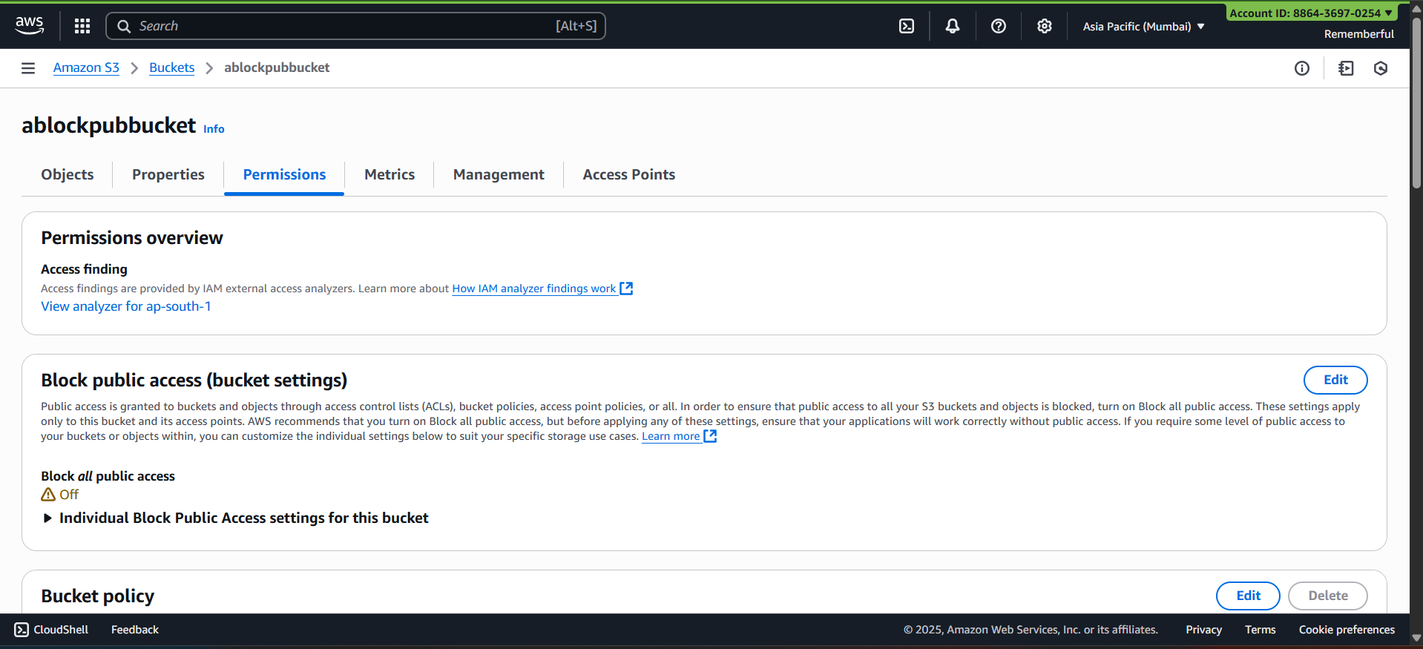
Click on the “edit” button:
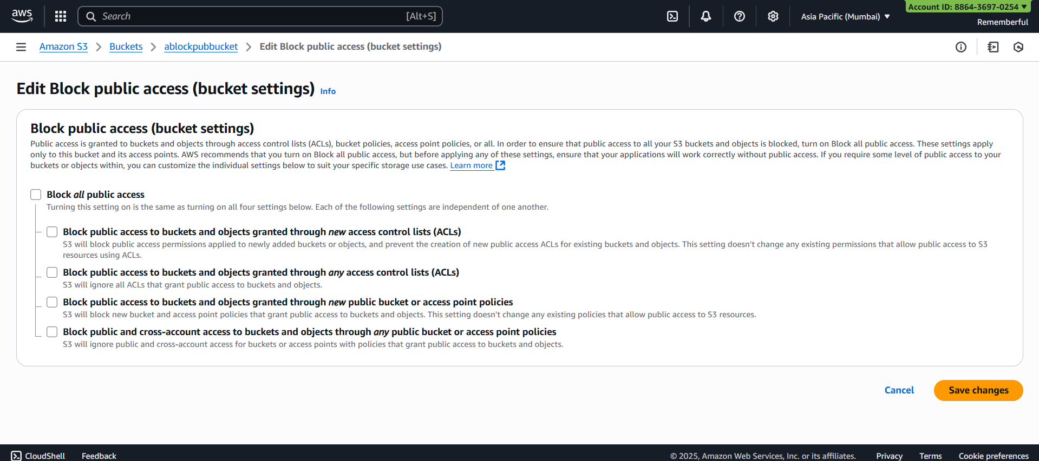
Check that box:
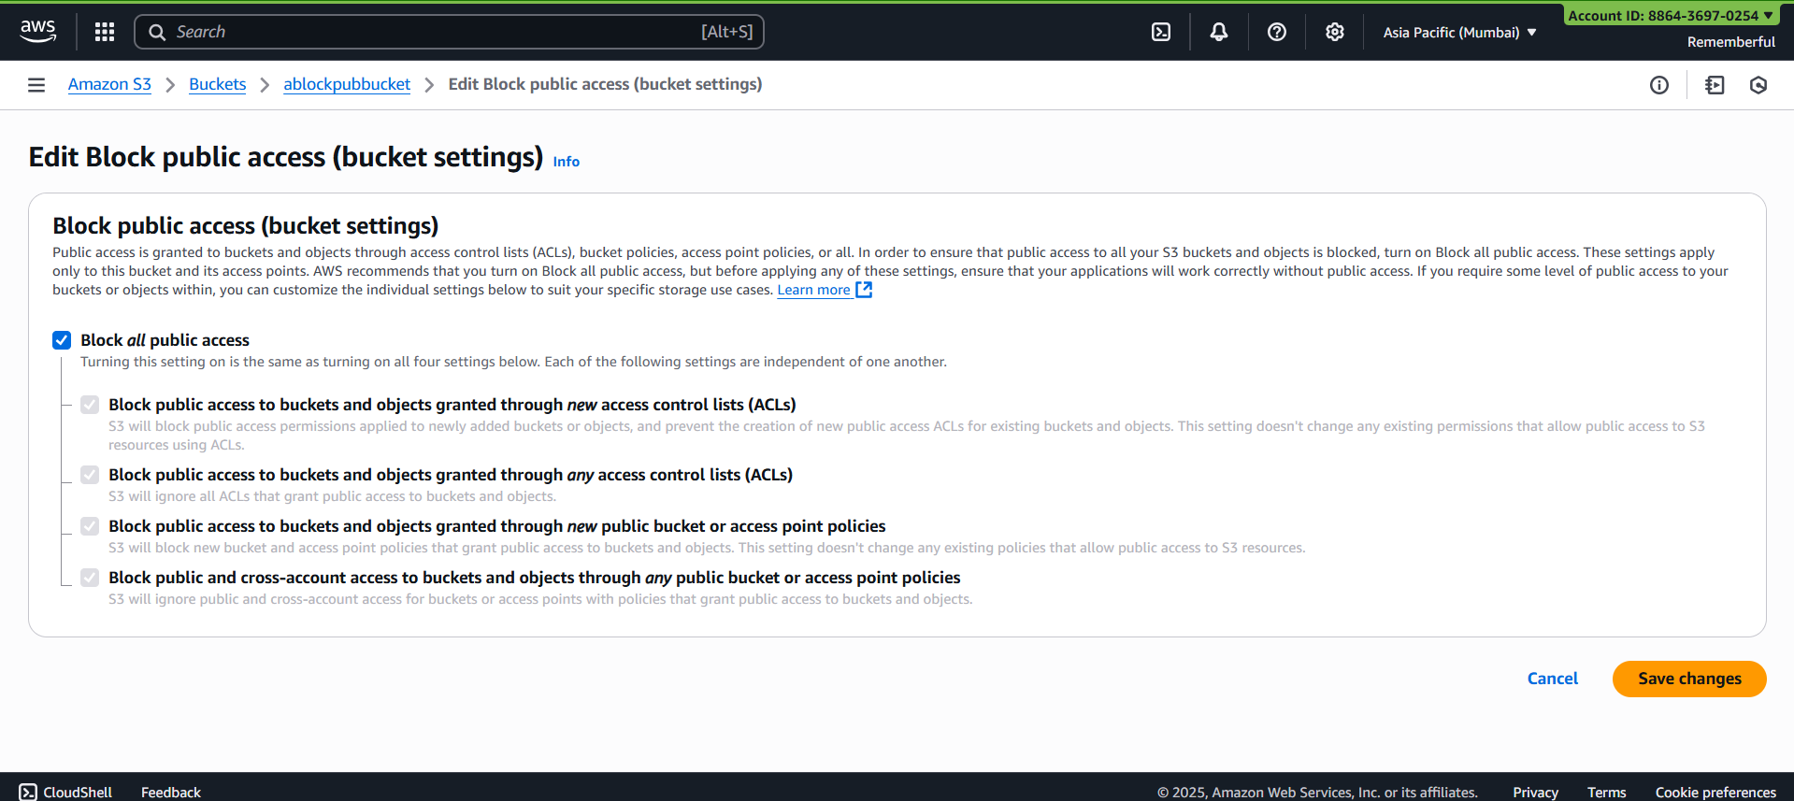
Or, you may go to bucket policy:
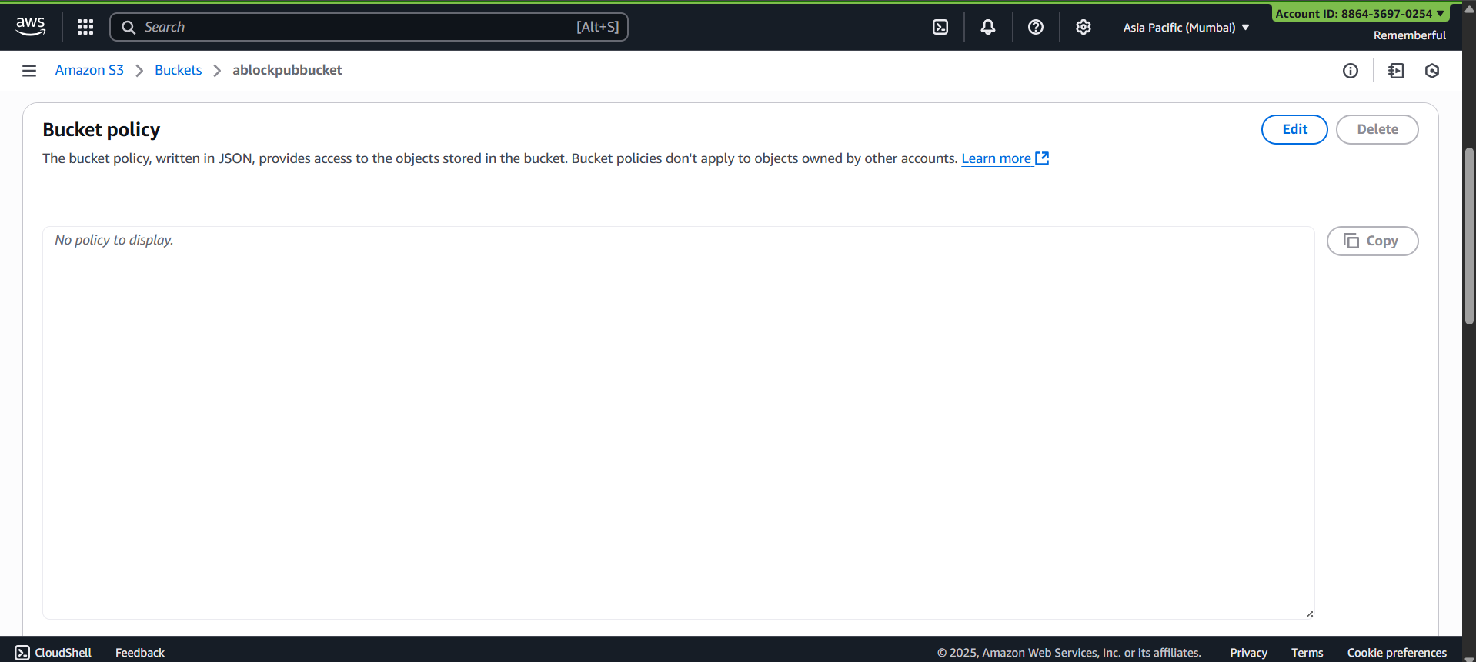
May use this policy:
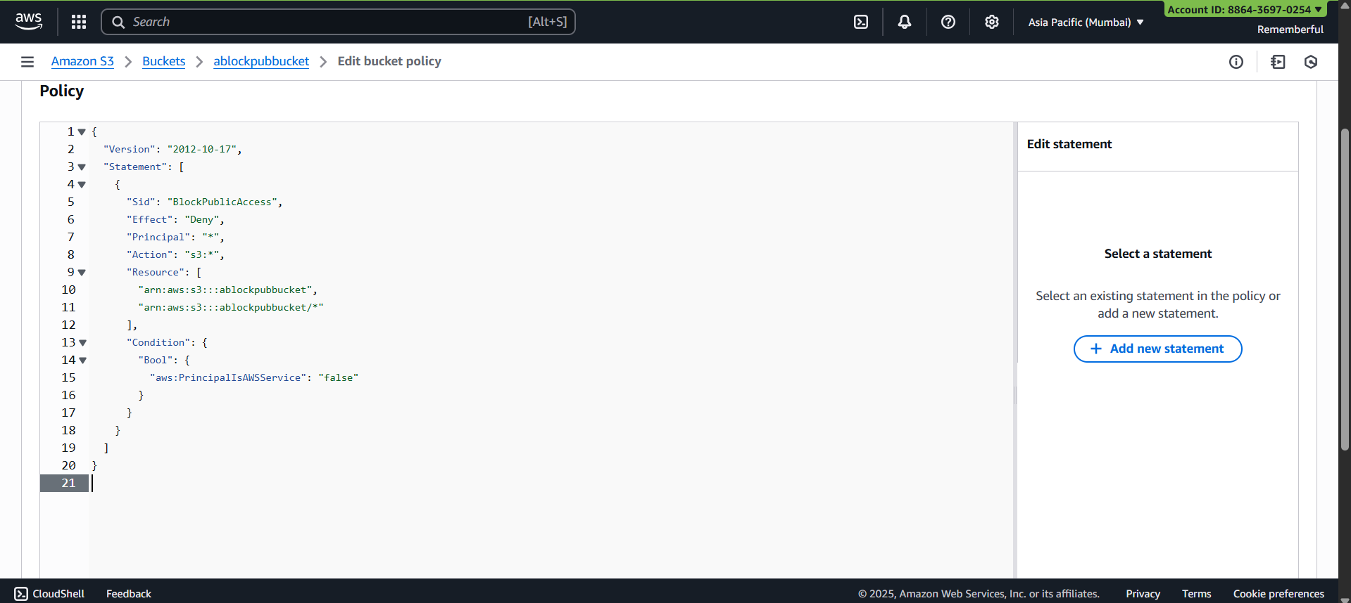
Save changes and you are done.
--The End--

