Day 42


“CLOUD SECURITY”
Preventing Accidental Deletion and Modification of S3 Objects using S3 Object Lock:
Steps:
Look for S3:
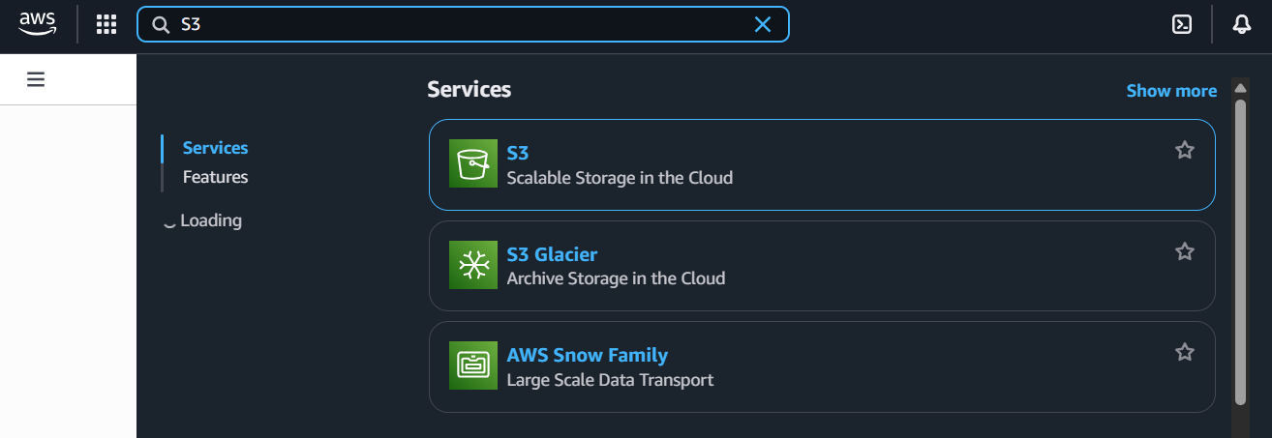
Following window will appear:
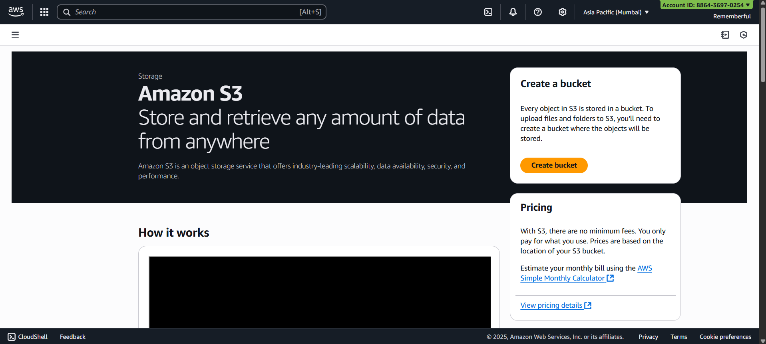

Click on “Create bucket”: type the name of bucket as well as the “ACL enabled” option
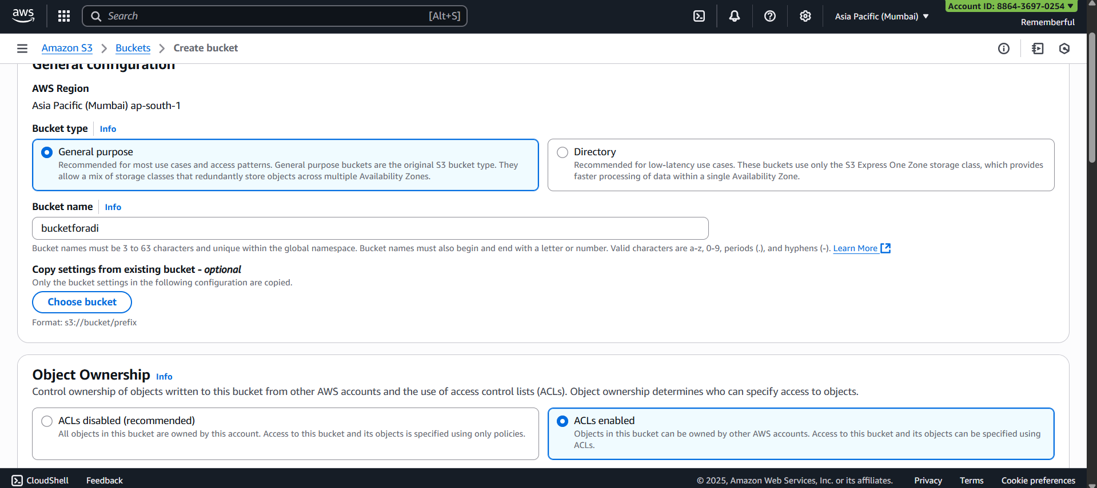
Following confirmation will occur:
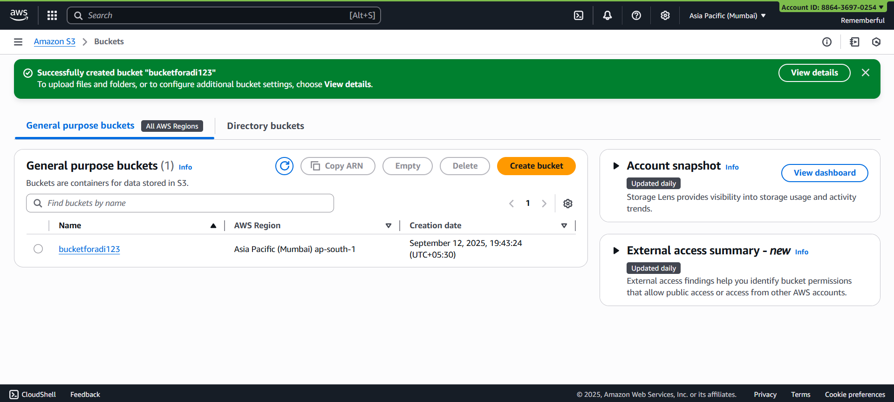
Now, upload an object in this bucket:
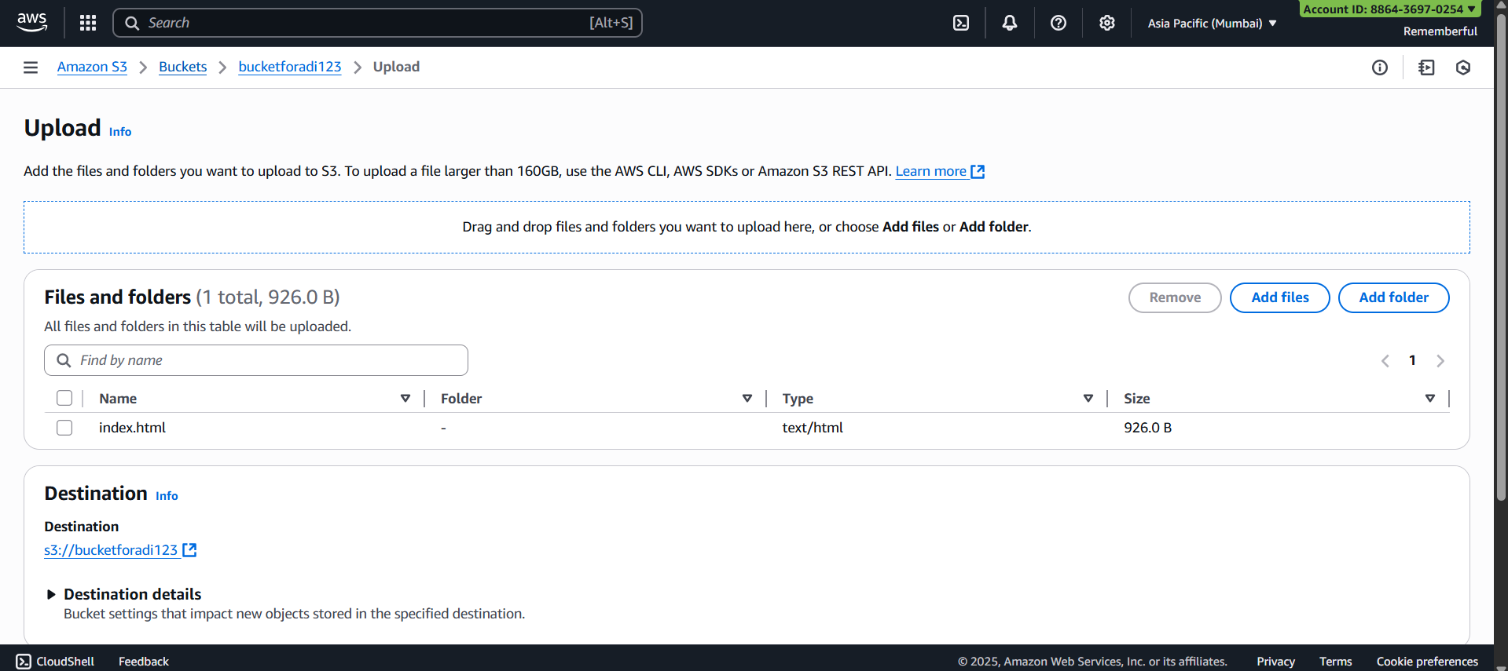
Confirmation of upload:
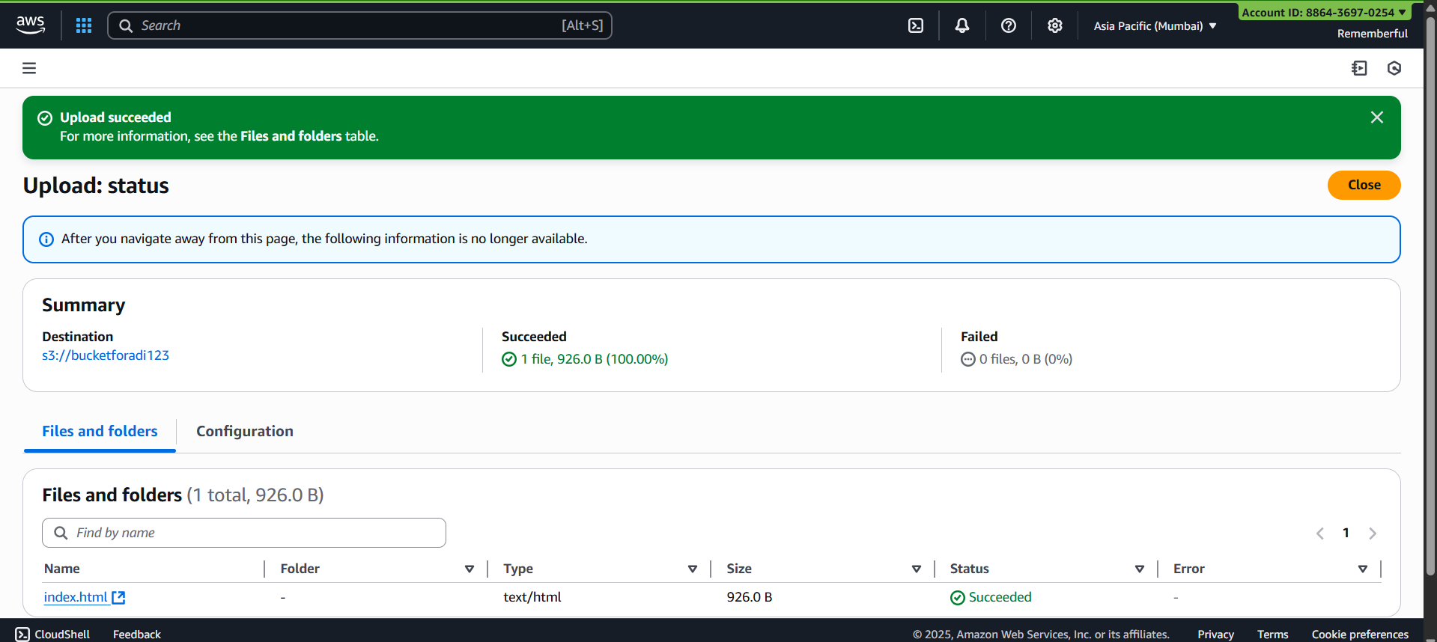
Now, open the object:
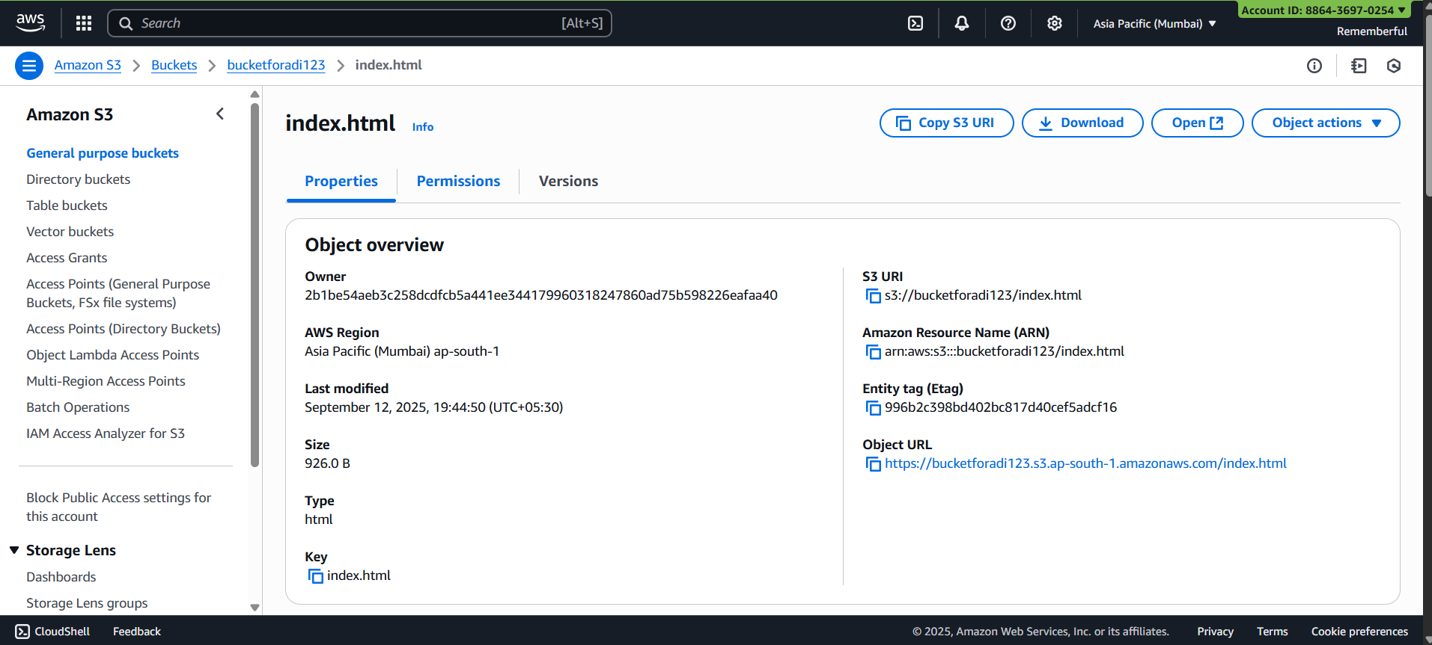
Scroll down to the “Object lock” section: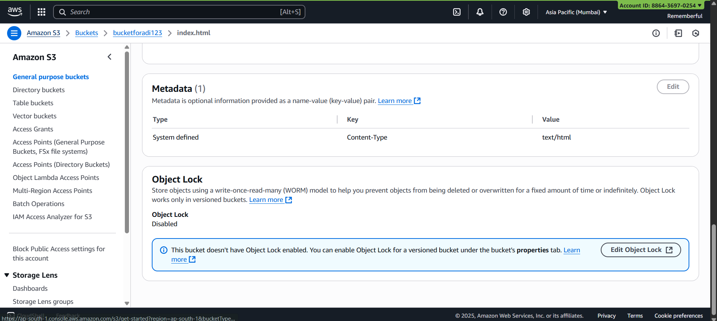
Click on “Edit object lock”, following page will open:
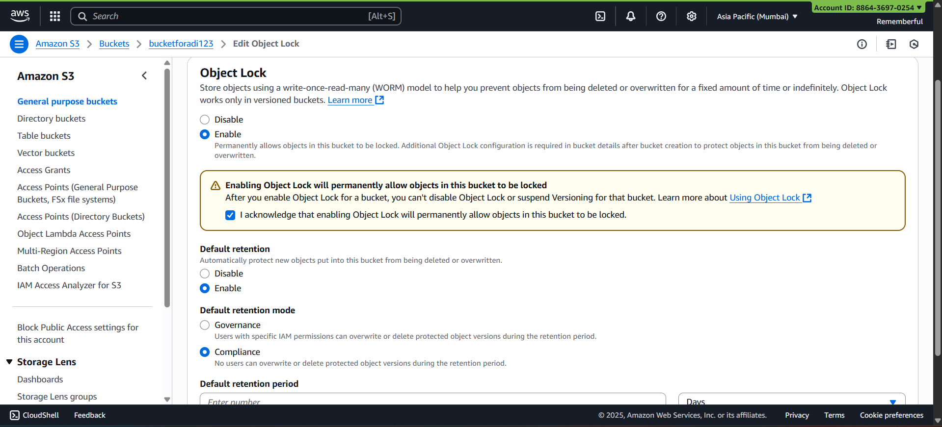
Following confirmation will occur:
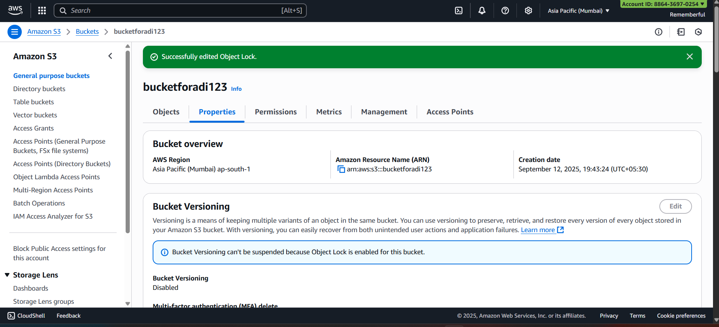
Now, try to delete the object, you will not be able to do so.
--The End--

