Day 38
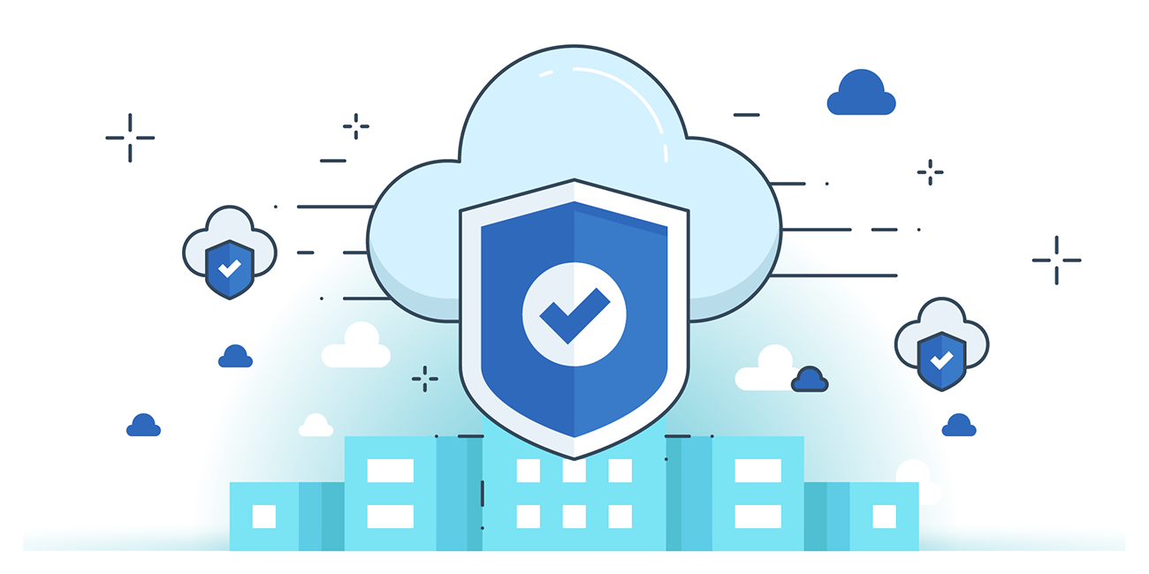

“CLOUD SECURITY”
Restricting access to AWS S3 buckets using ACL and Bucket Policy:
Steps:
Look for S3:
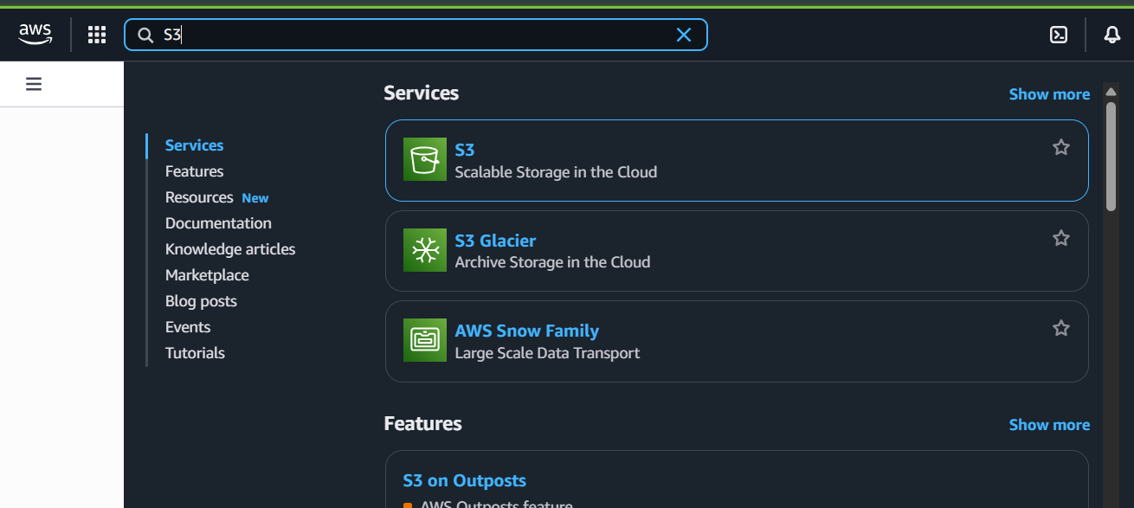
Following window will appear:
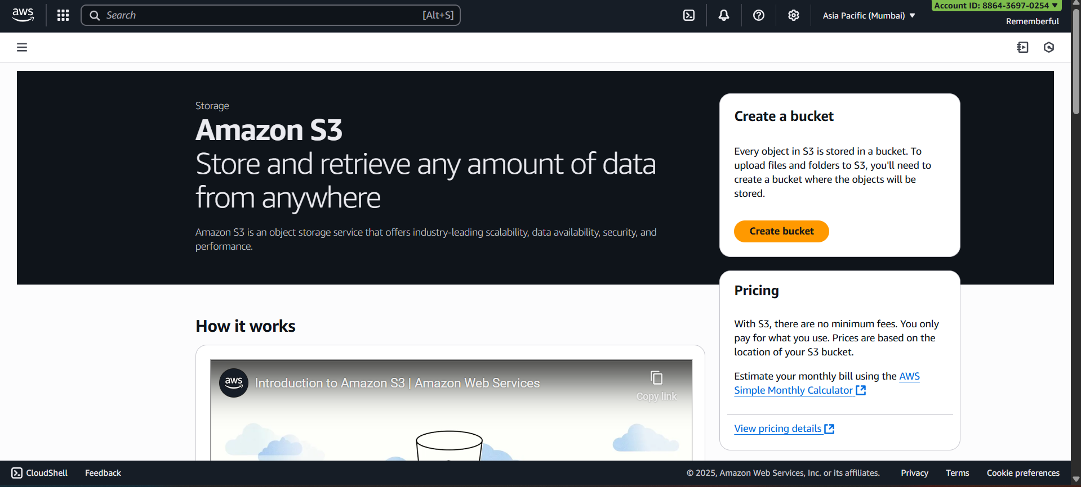

Click on “Create Bucket”, following form appears:
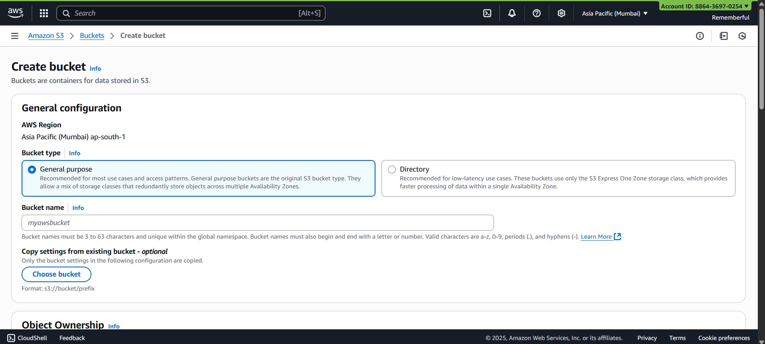
Fill it:
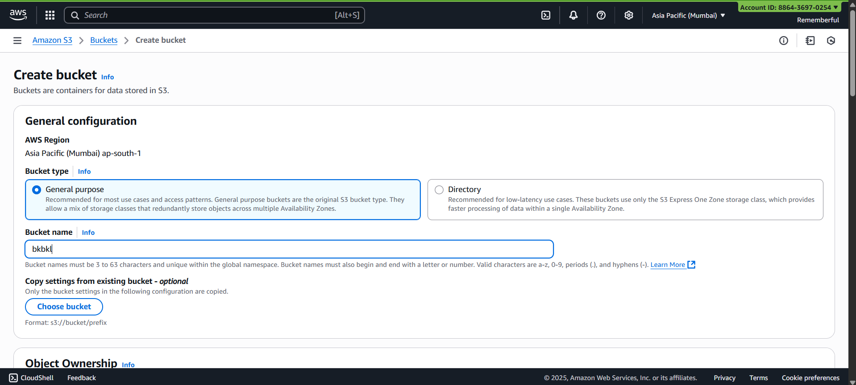
Change it as “ACLs enabled”: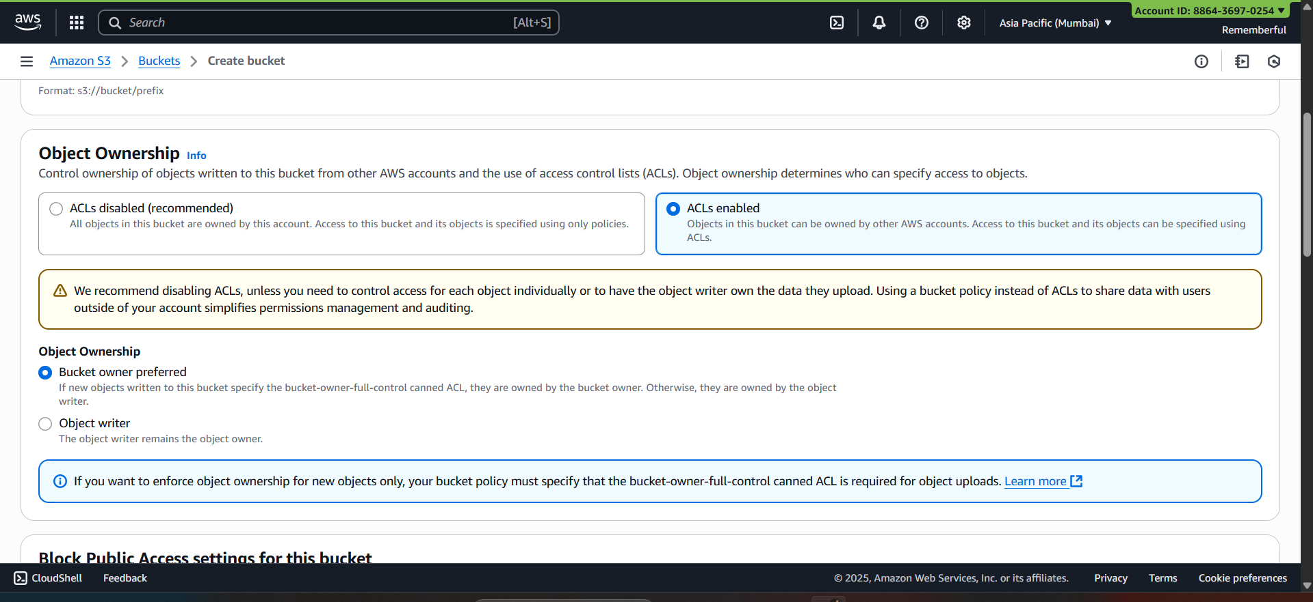
Change it to public: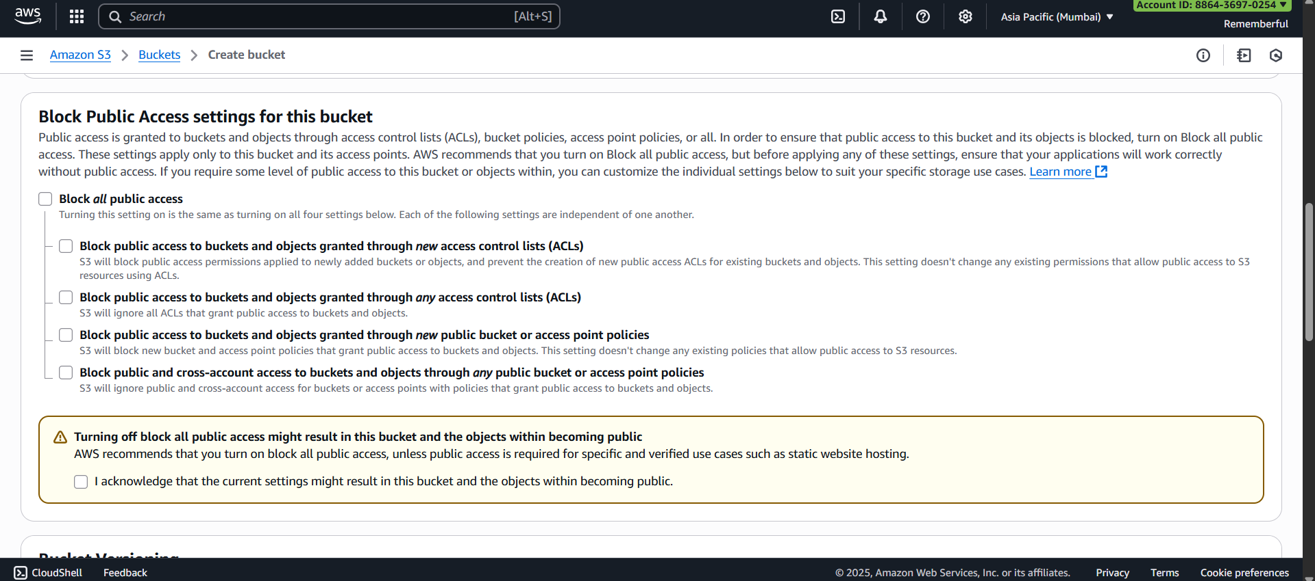
Following confirmation will occur:
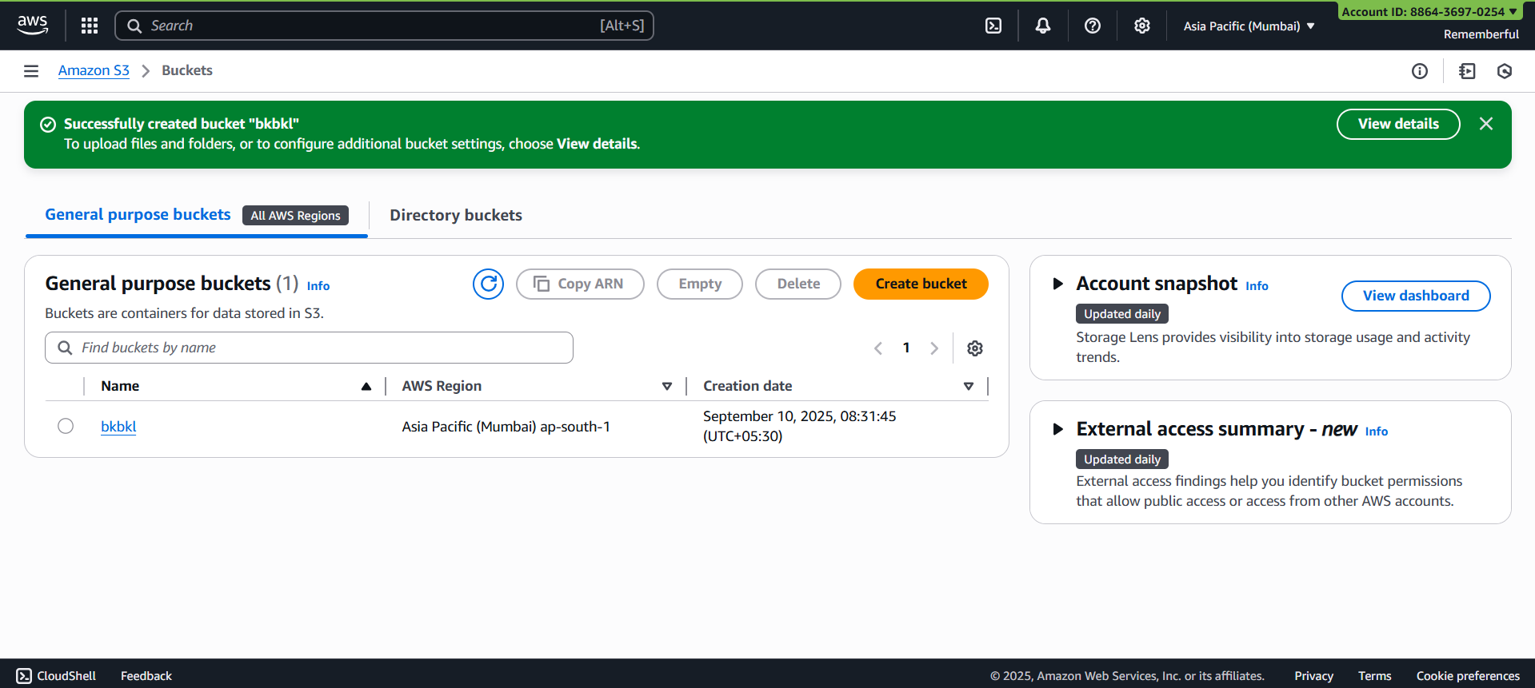
Open the bucket:
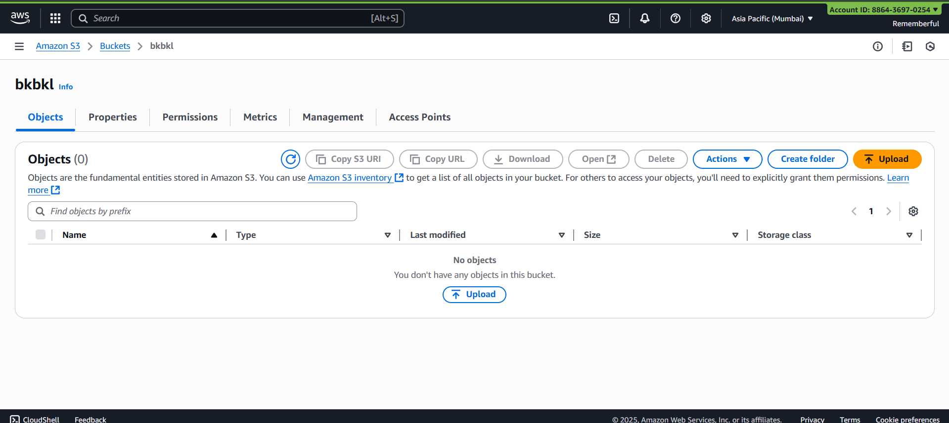
Go to “permissions” section: following section appears
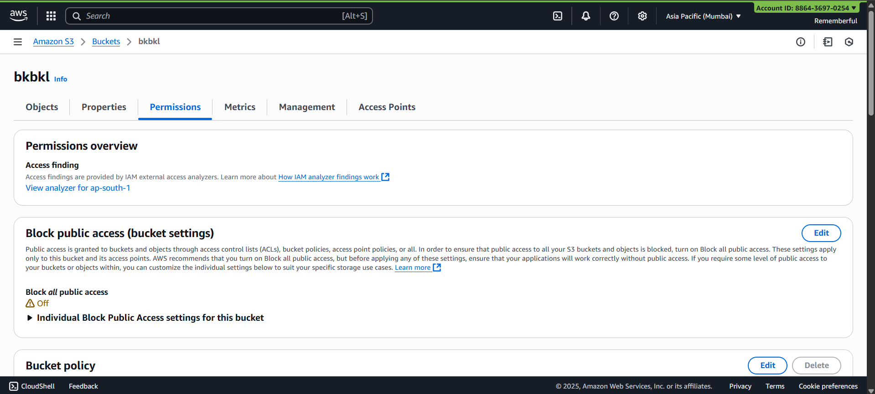
Scroll down to “Access control list (ACL)”
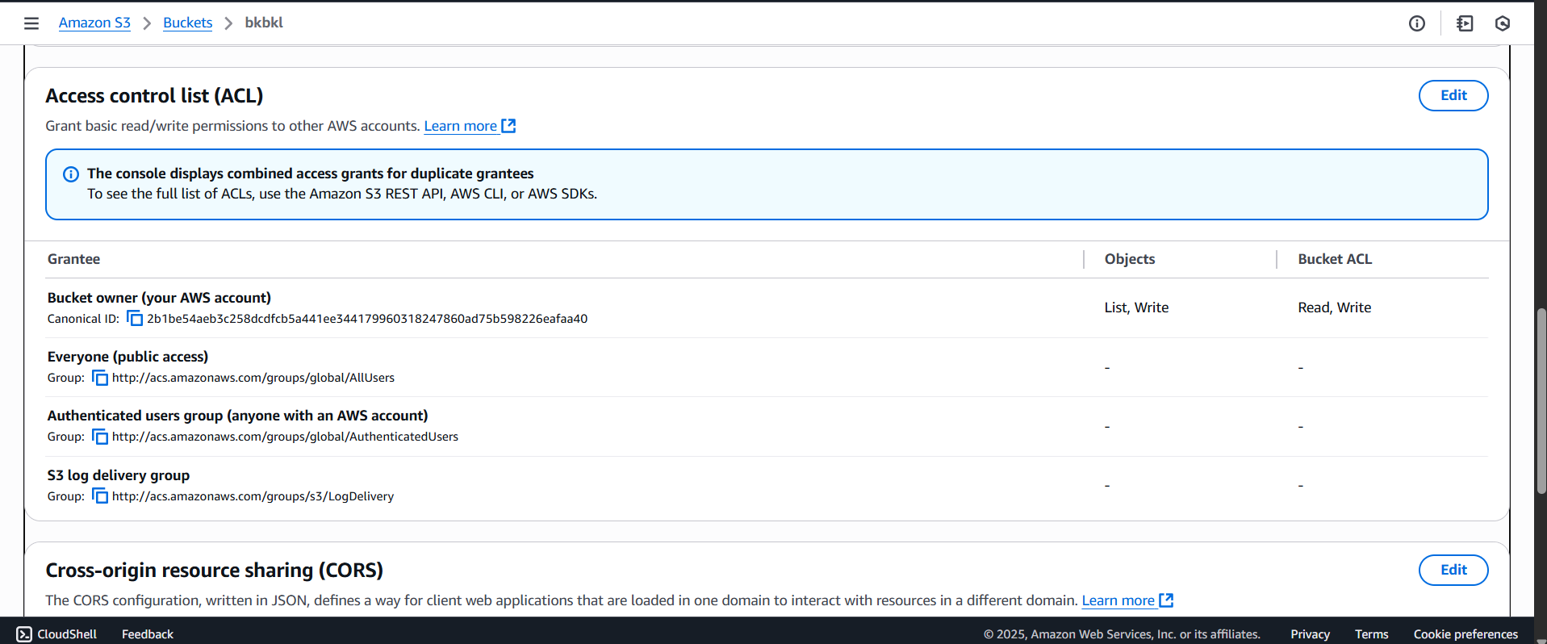
Click on “edit” button: following options will occur.
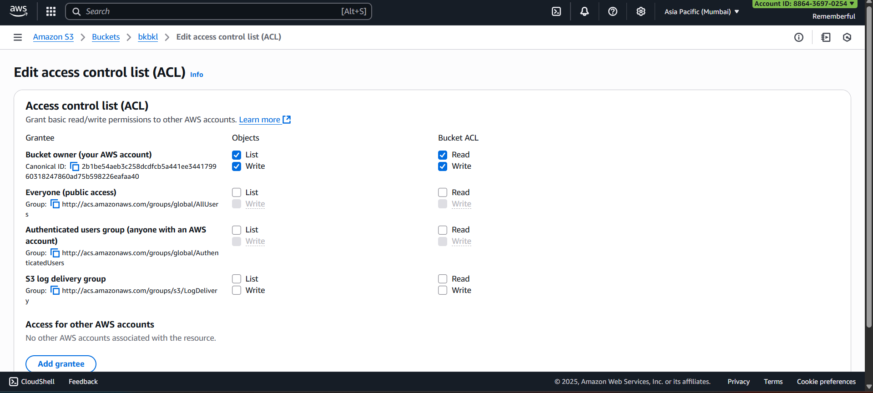
Keep it as it is, all List, Write, Read, write section as default.
Save, it following confirmation will occur:
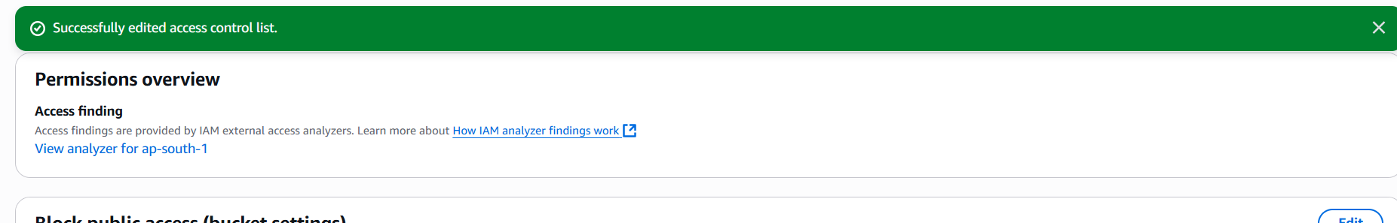
Go to the bucket section and select the bucket and ARN:
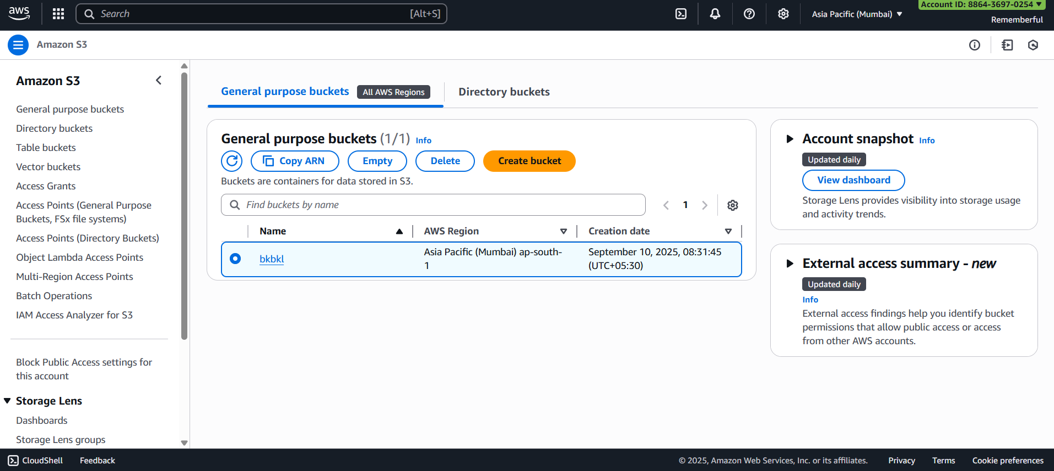
Copy paste the ARN in the notepad:
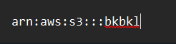
Again open the bucket we had created and go to the permissions section: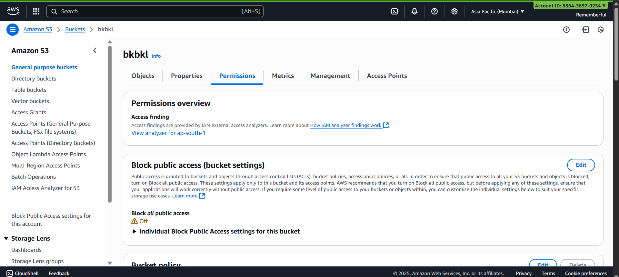
Scroll down and reach “Bucket Policy” 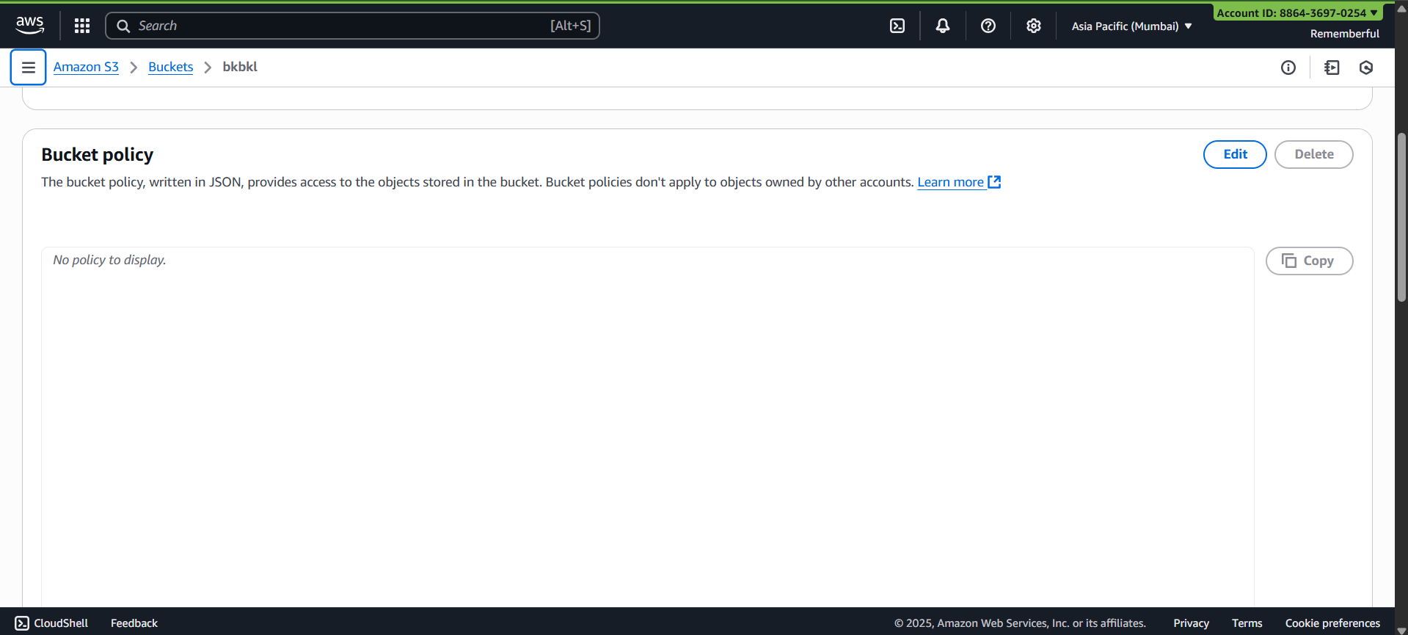
Click on “edit” button: following window will appear
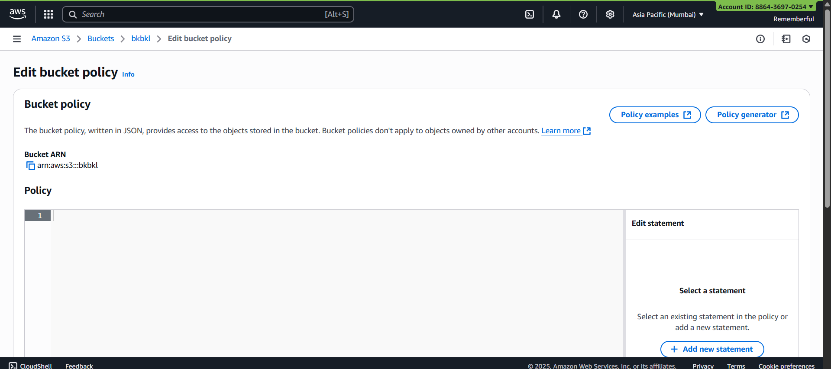
Click on “Policy generator” button: following screen will appear.
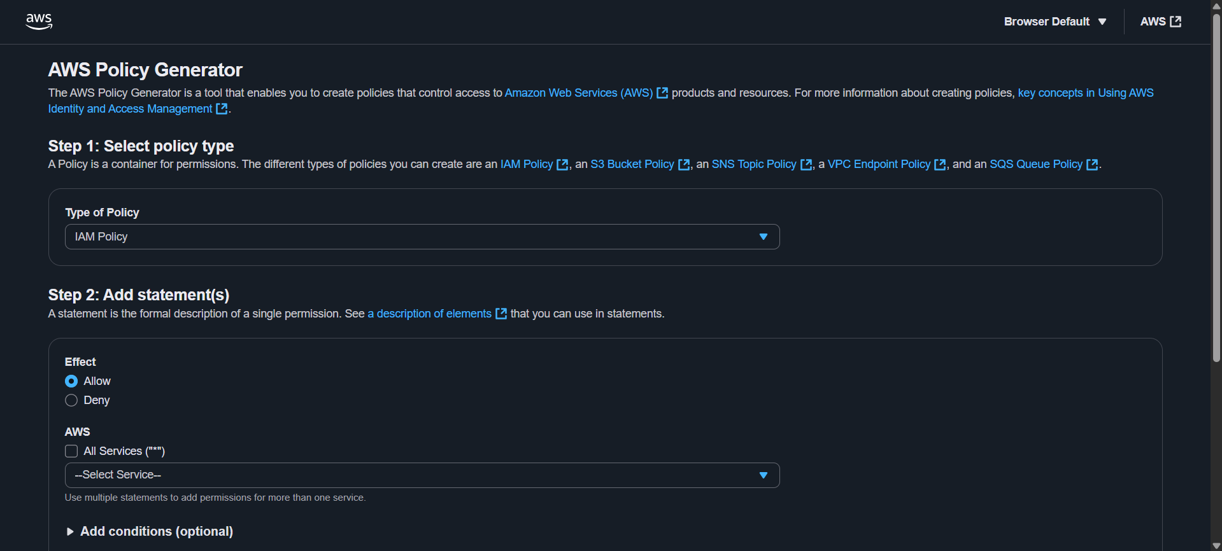
Make changes as shown:
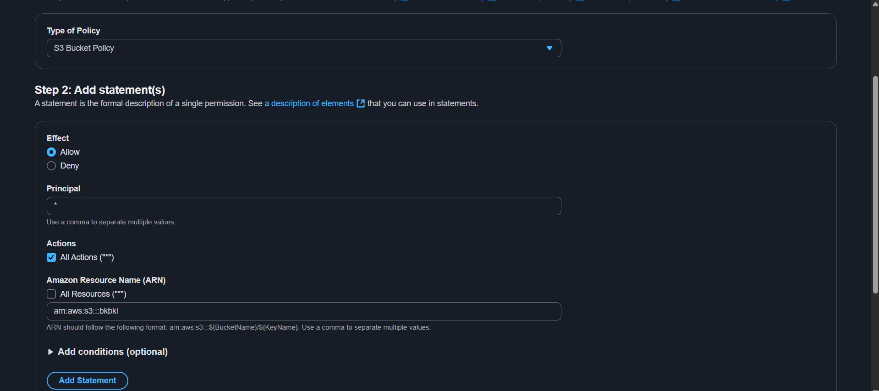
Following pop up comes:
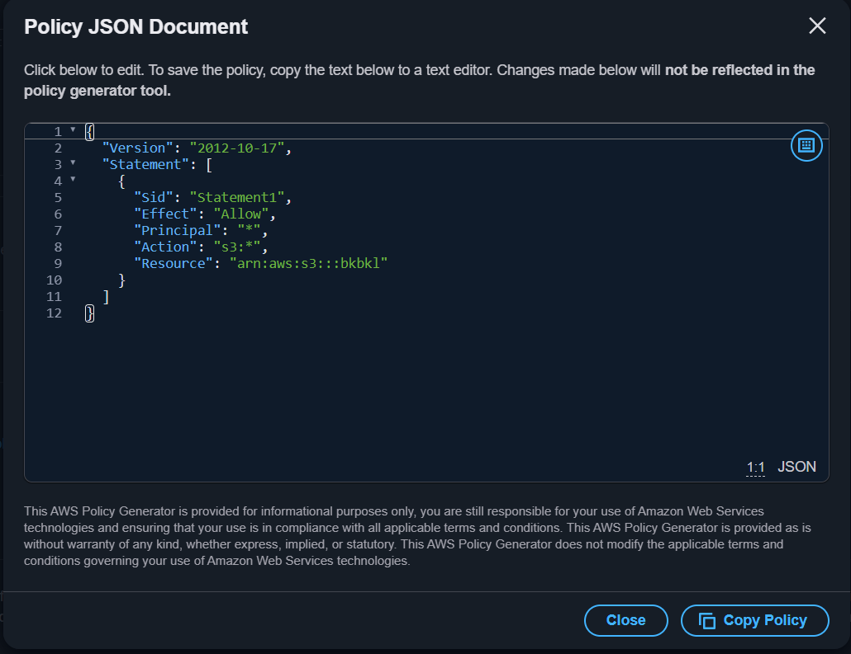
Copy the policy.

Come back to the earlier page:
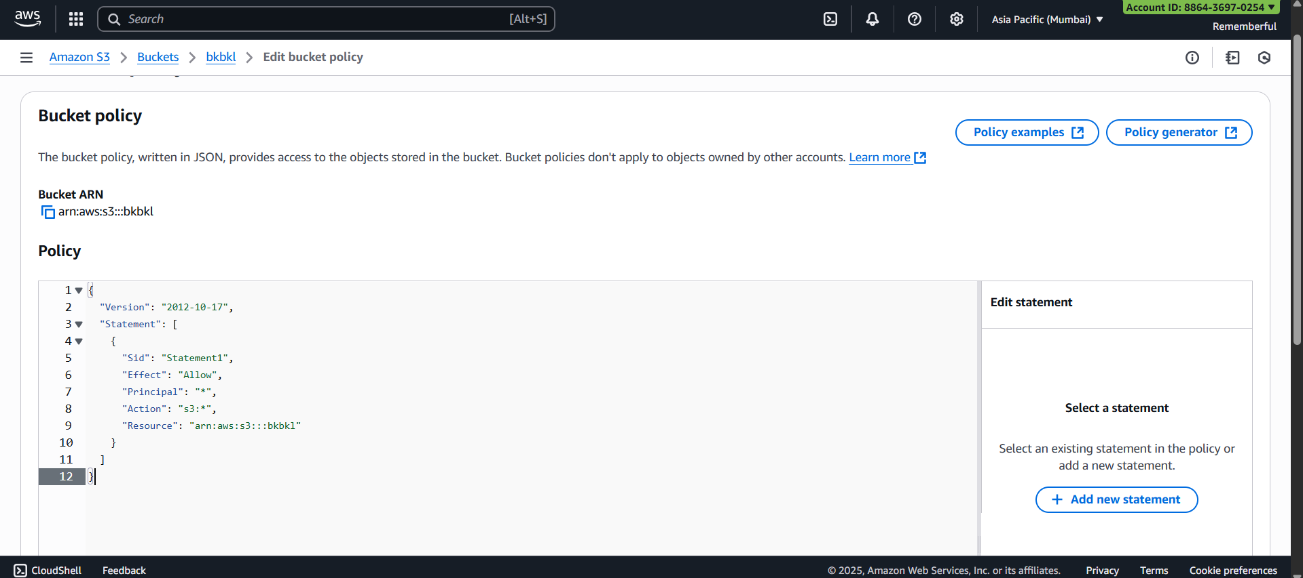
Click on save changes.
Following confirmation will occur:
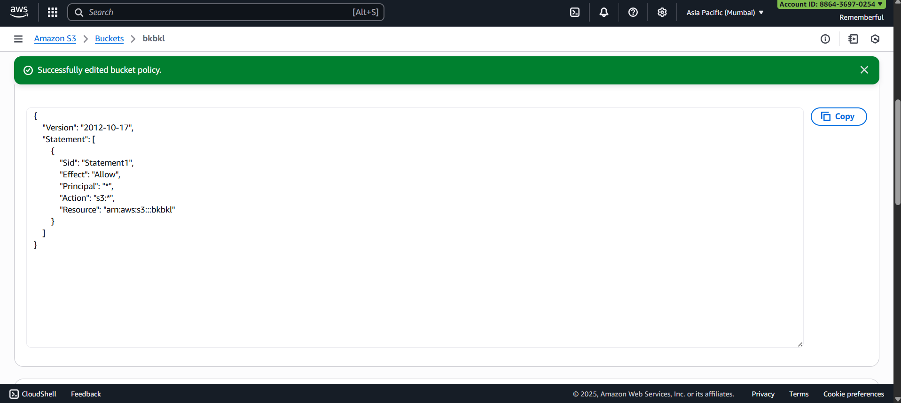
--The End--

