Day 39
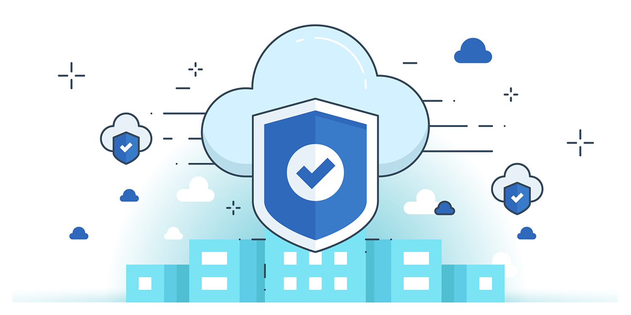

“CLOUD SECURITY”
Restricting Non-SSL Access for S3 Objects using Bucket policies:
Steps:
Look for S3:
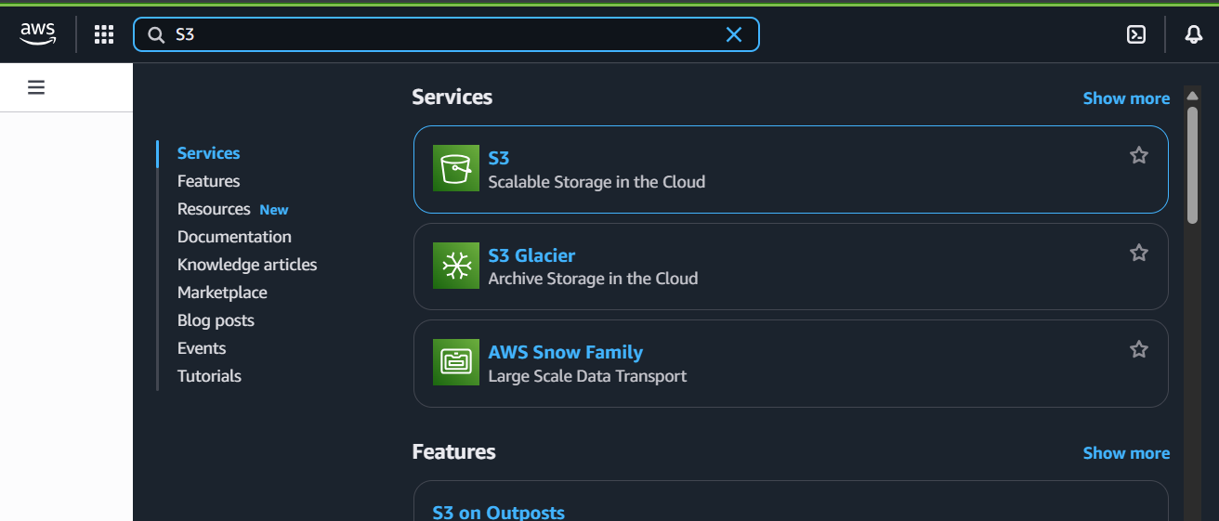
Following screen will appear:
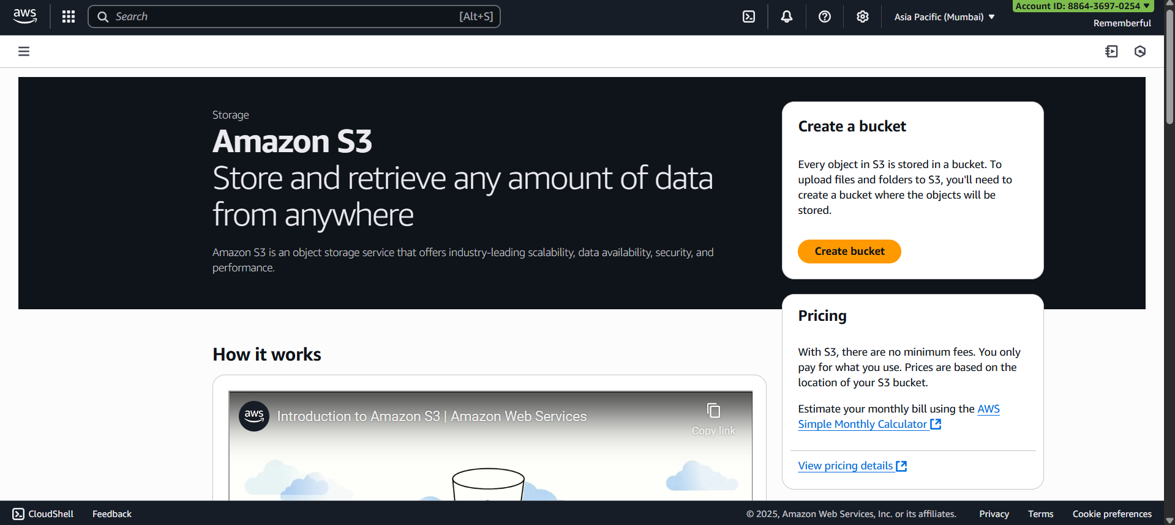

Create one bucket publicly available:
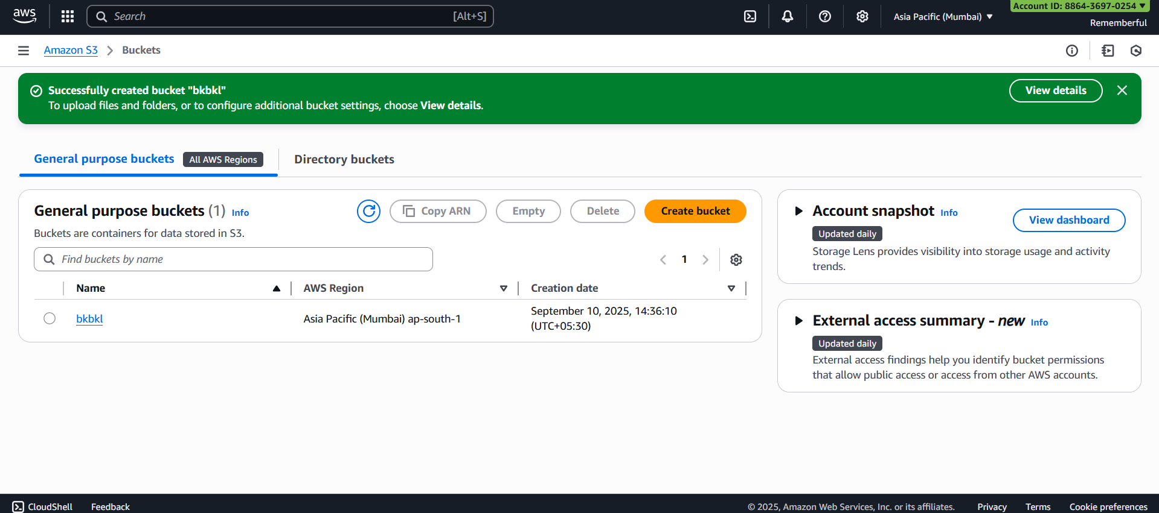
Open that bucket:
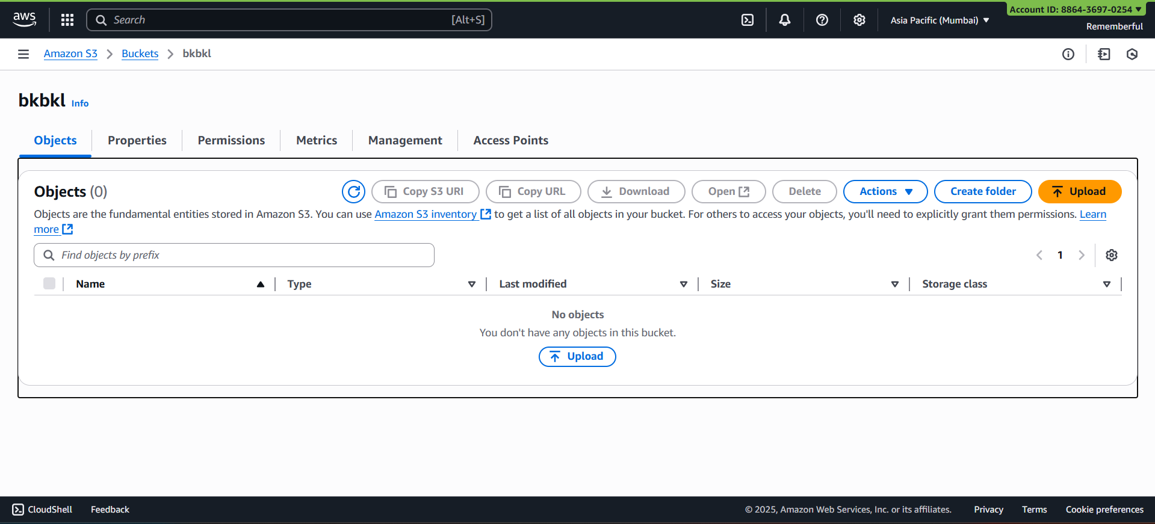
Click on “upload” button:
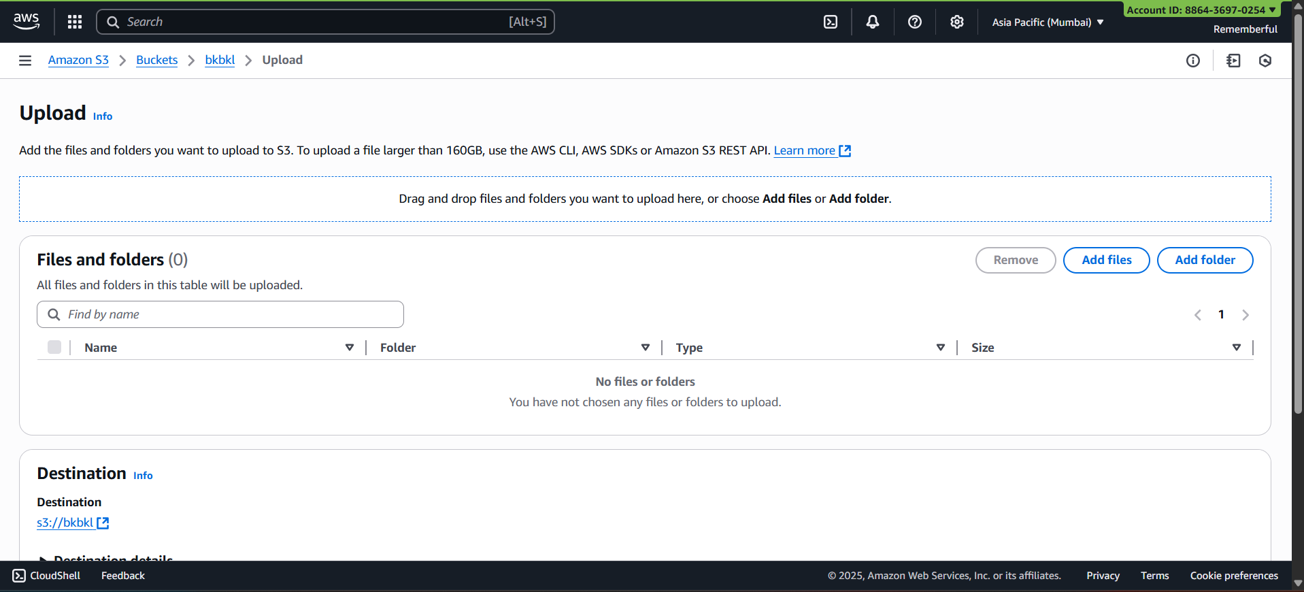
Add the .html file:
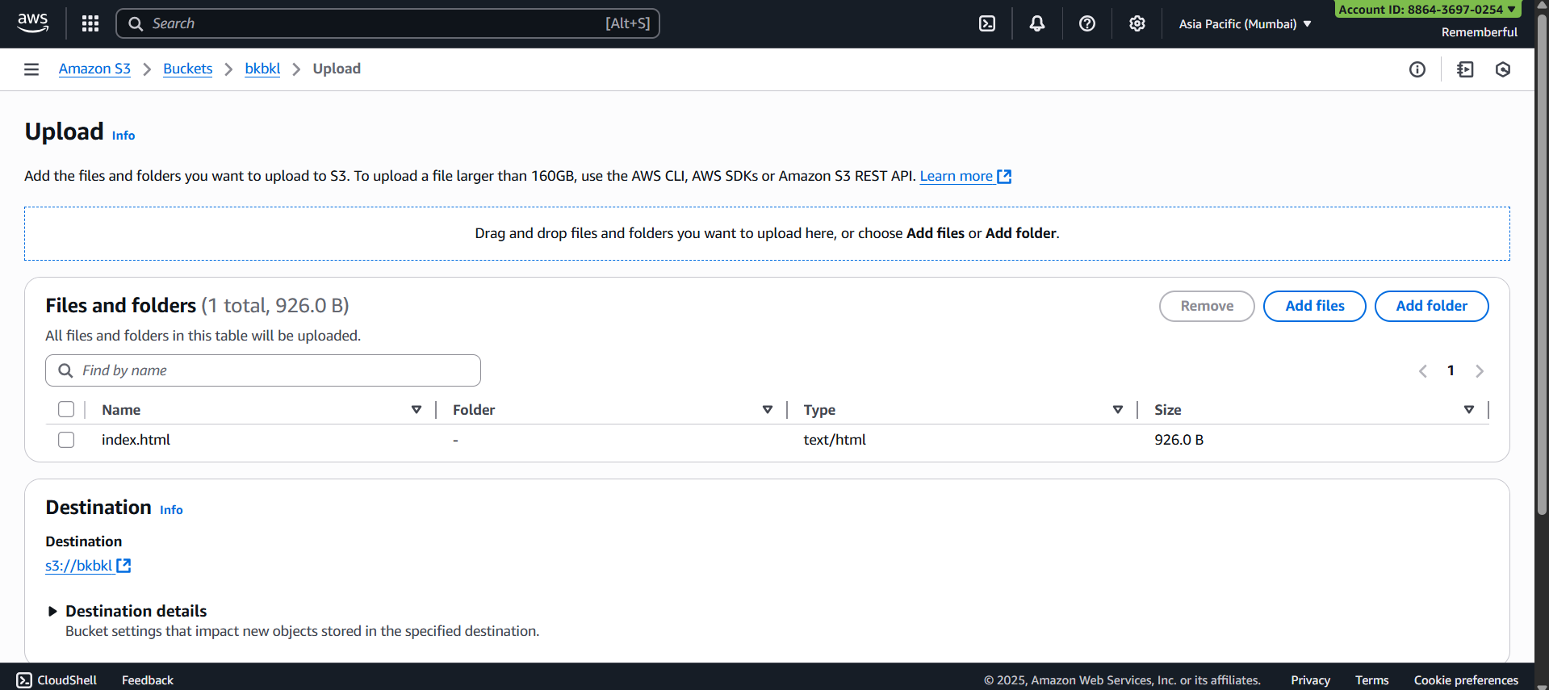
See the success notification:
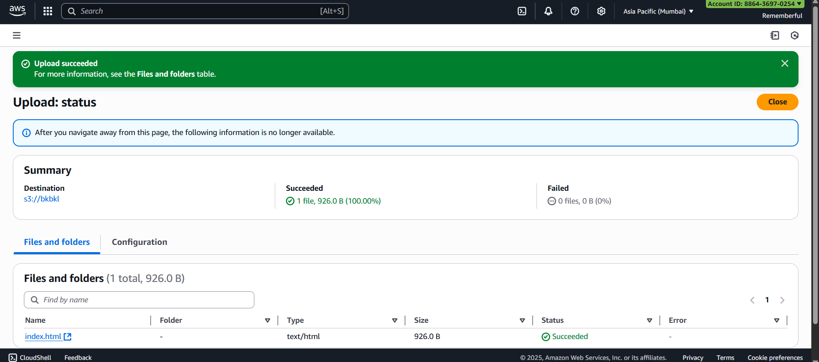
Select the object, and click on “Make public using ACL” from “actions”:
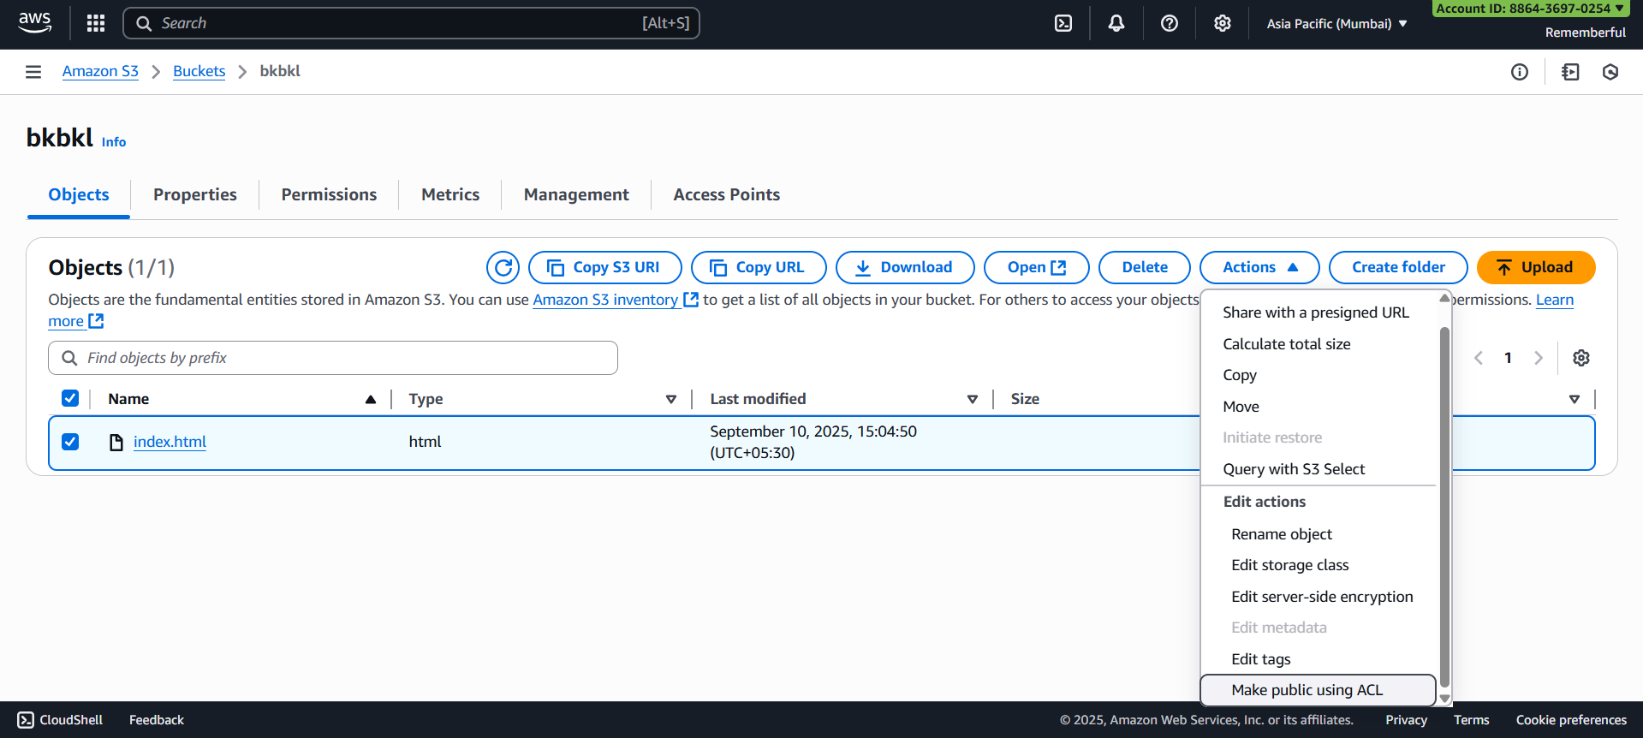
Following screen will appear:
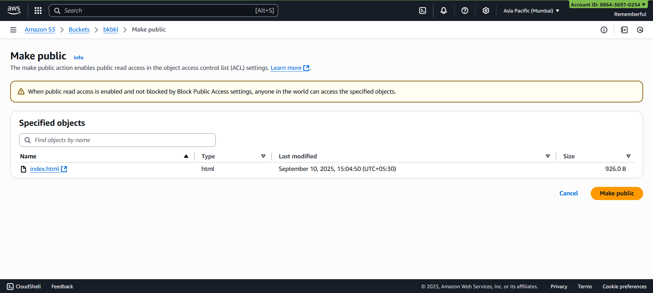
Click on “Make public” button: following confirmation will occur.
Click on the object, copy the object URL:
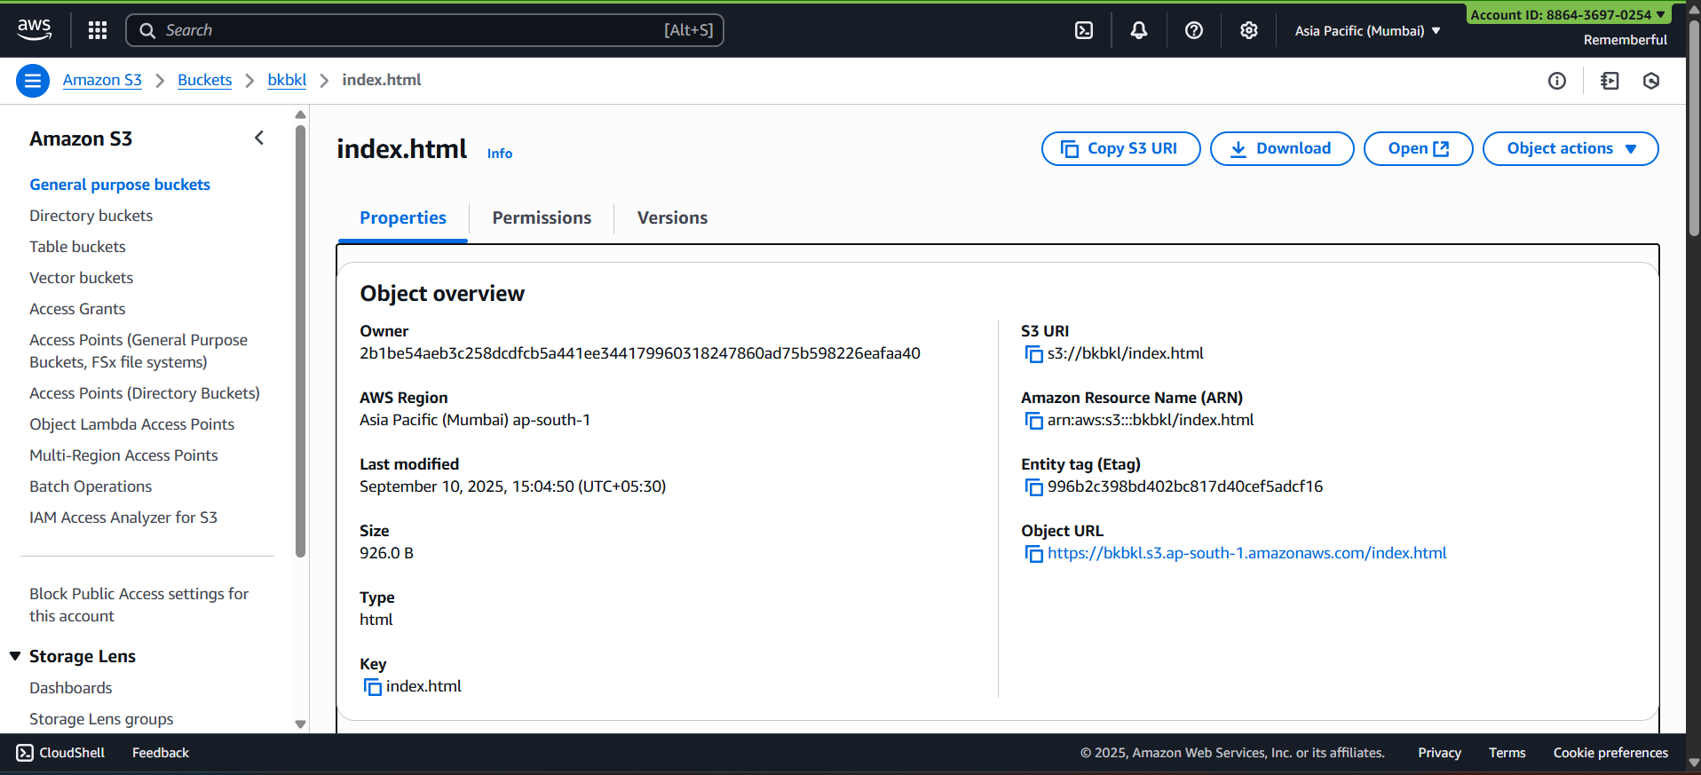
Paste the URL:
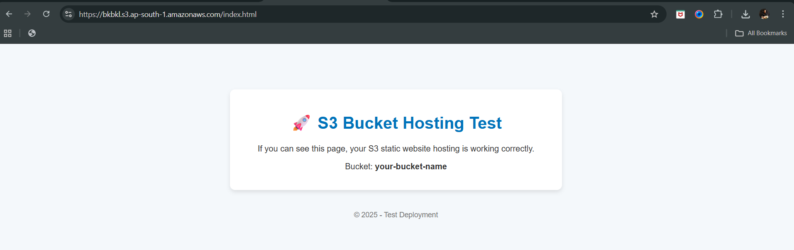
Make changes in the URL from https to http: clearly it says not secure.
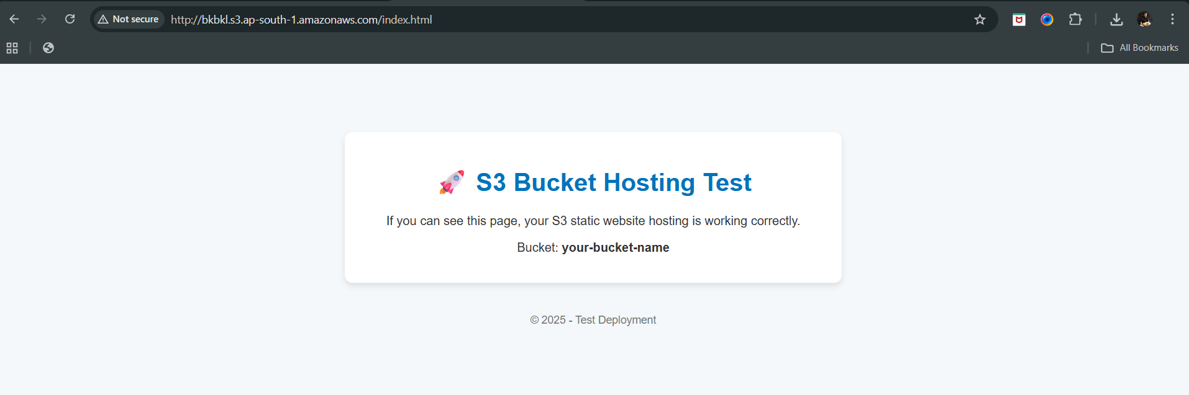
Now, we will set the secure connection for the object inside the bucket:
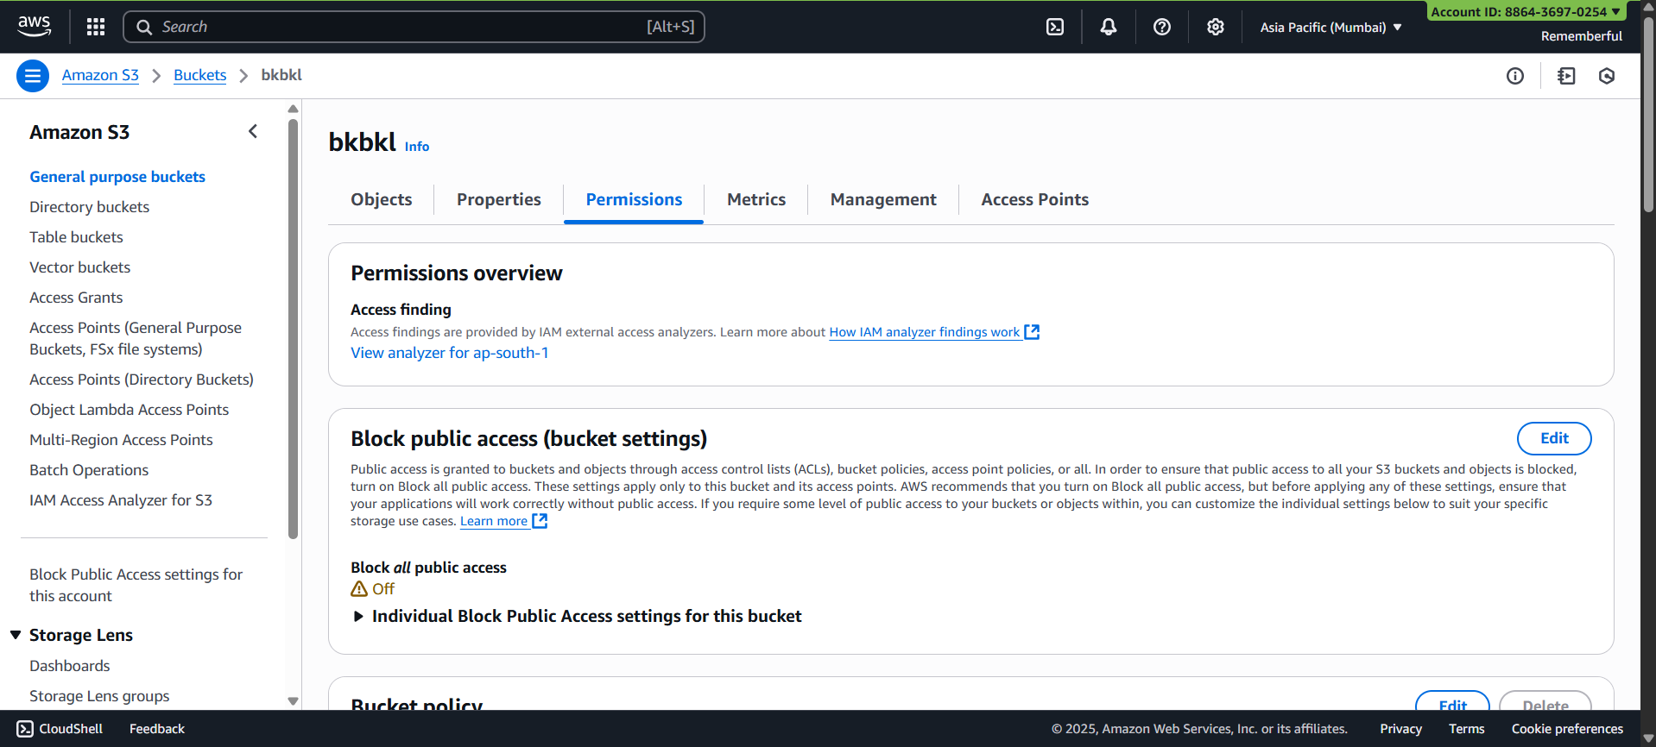
Now, click on “Edit” button:
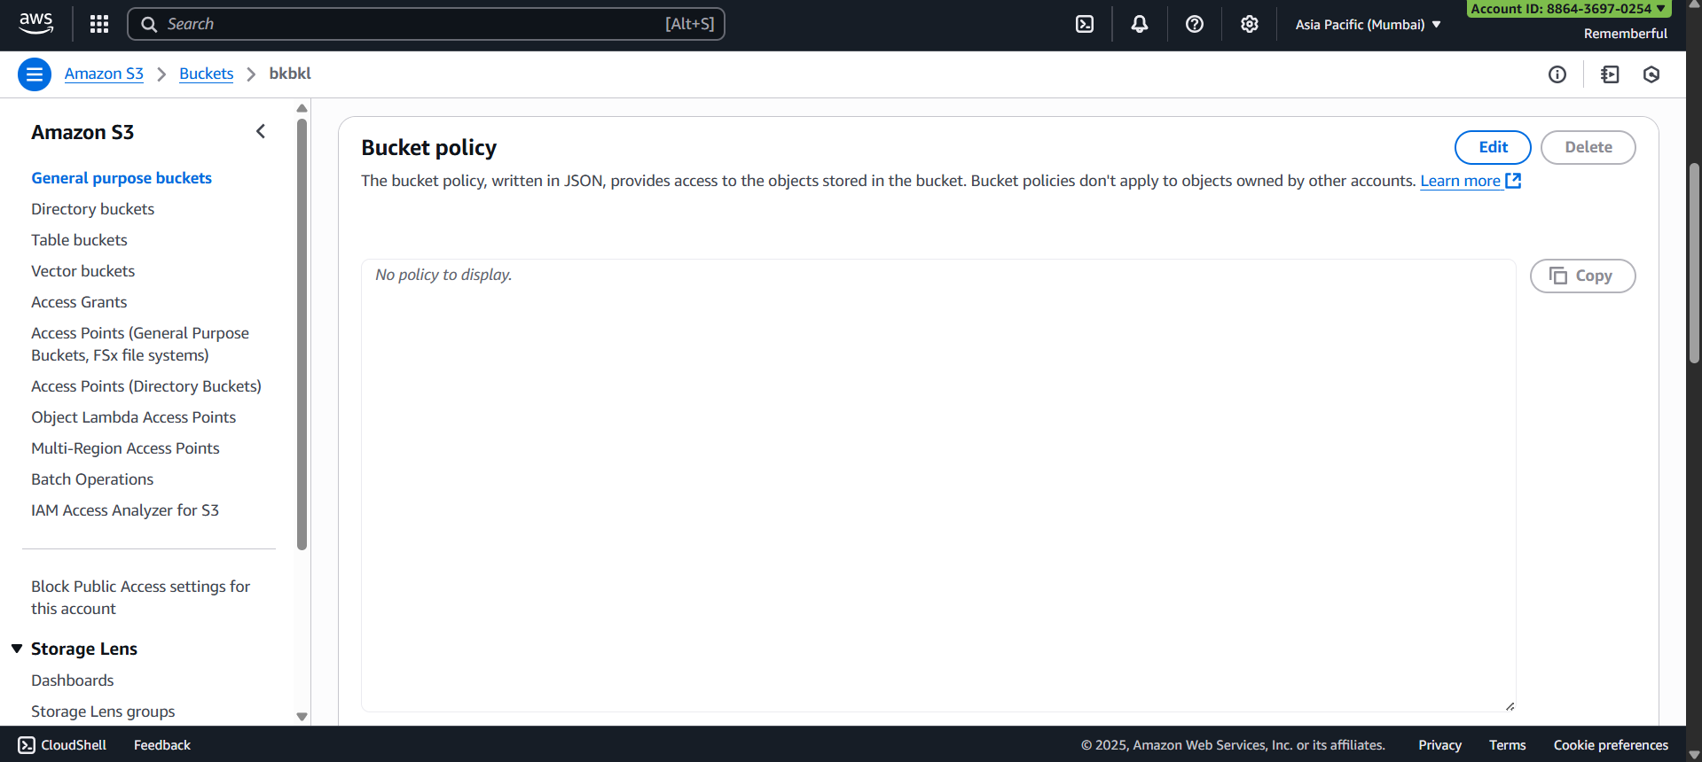

Following screen will appear:
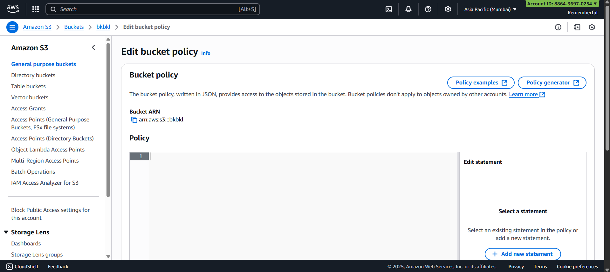
Copy paste the following policy:
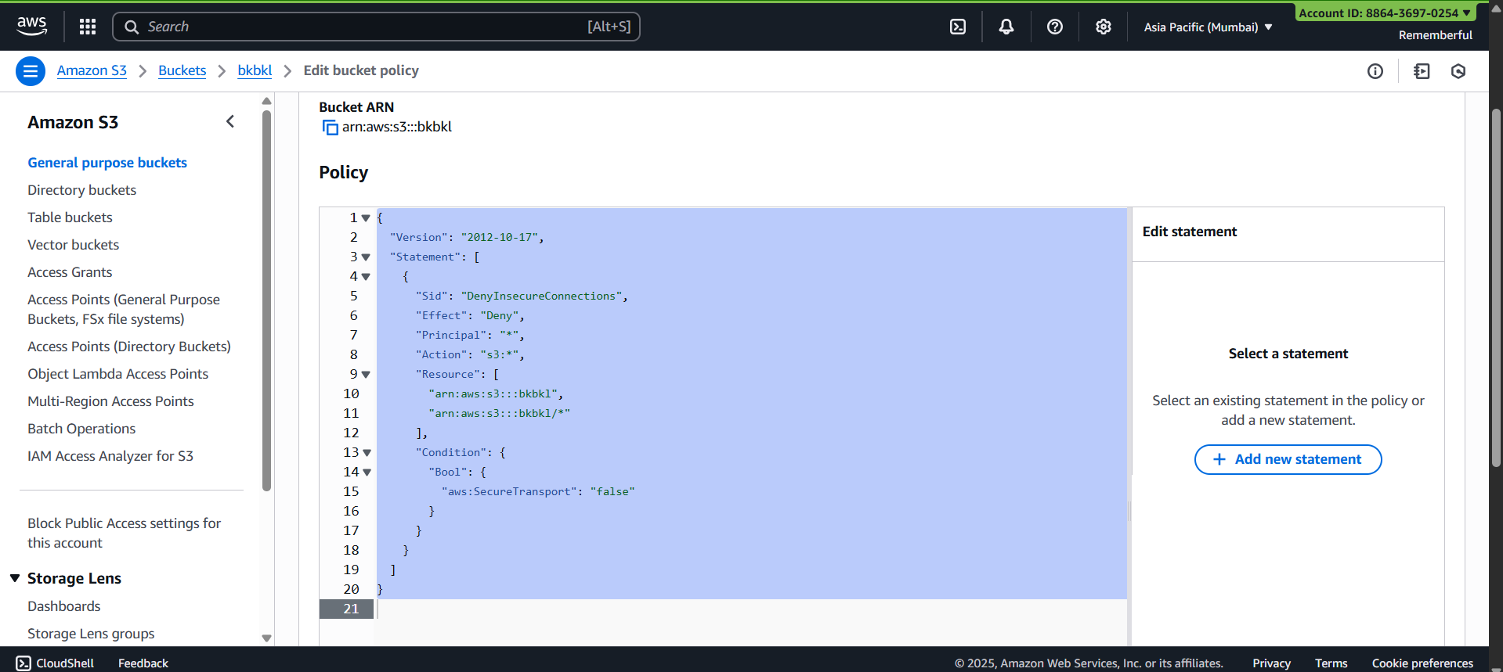
Click on “Save changes” button, following confirmation will occur:
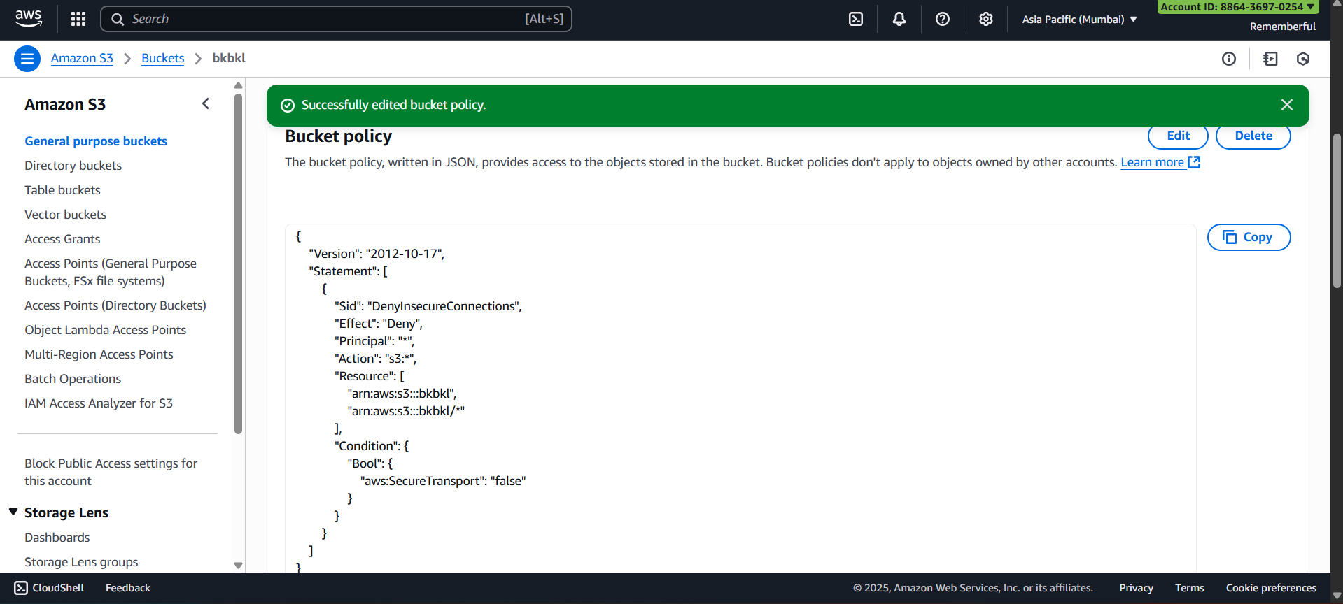
Check if it is still accessible or not:
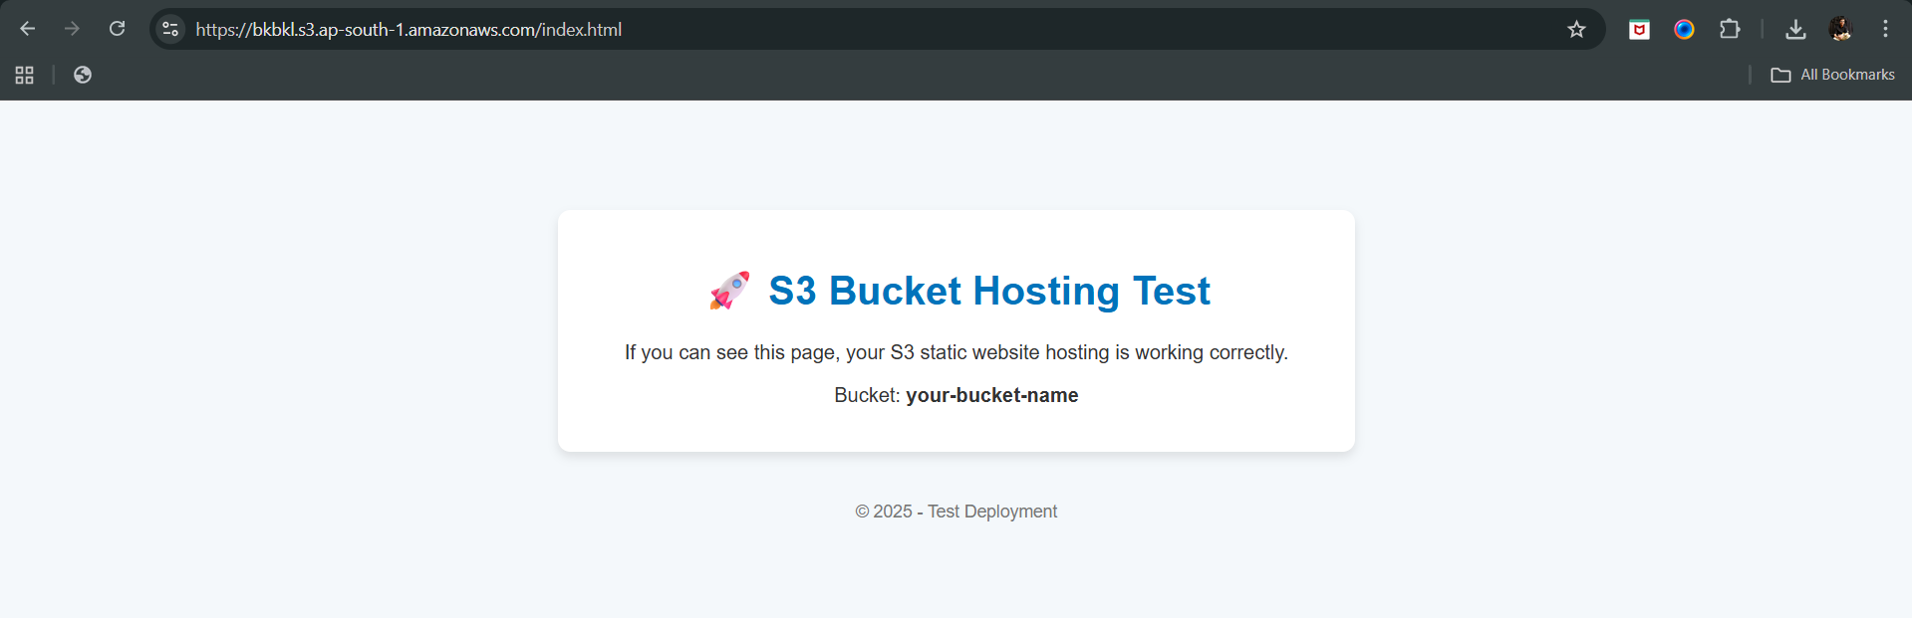
Now, again change the https to http, this time content is not visible: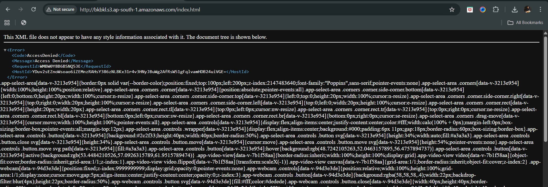
Done!
--The End--

