Day 51
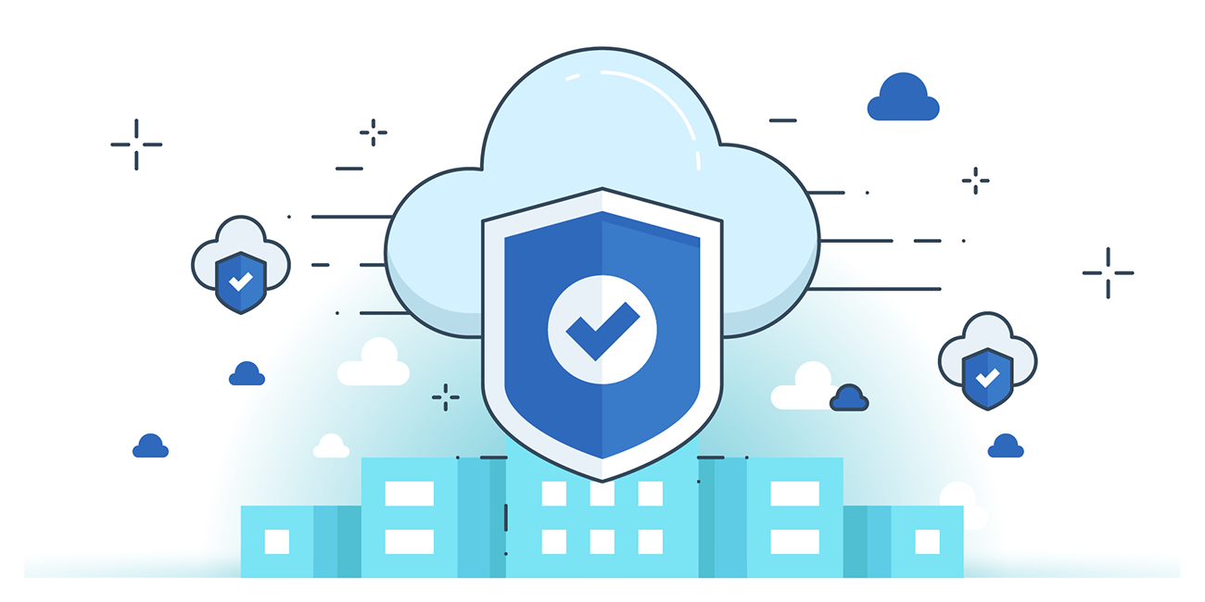

“CLOUD SECURITY”
AWS Specific Penetration Testing:
Attempt to Identify S3 Buckets:
Manual Methods:
- HTML inspection, brute-force, Google Dork, DNS caching, Bing reverse IP, GitHub, CDN object URL, Burp Suite.
Automated Tools:
- Bucket Finder, S3 Inspector, S3Scanner, Lazy S3, S3 Bucket Finder.
Check for S3 Bucket Permissions:
- Check ACLs at bucket or object level to control access.
- AWS CLI commands for testing:
- READ: aws s3 ls s3://[bucketname] --no-sign-request
- WRITE: aws s3 cp localfile s3://[bucketname]/test.txt --no-sign-request
- READ_ACP: aws s3api get-bucket-acl --bucket [bucketname] --no-sign
- WRITE_ACP: aws s3api put-bucket-acl --bucket [bucketname] --no-sign-request (test ACL changes)
Attempt to Create New Policy Version:
- Test if AWS administrator access can be obtained by creating new policy versions.
- Use the command:
aws iam create-policy-version
--policy-arn target_policy_arn
--policy-document [policy-document-name/path].json
--set-as-default
Attempt to Set an Existing Policy Version as Default:
- Test risks of inactive policy versions by setting one as default.
- Use the command:
aws iam set-default-policy-version
--policy-arn target_policy_arn
--version-id [new version-id]

Attempt to Obtain Access to EC2 Instance/Role Permissions:
- Test access to EC2 instance/service role permissions of an AWS account.
- Create an EC2 instance using an existing instance profile with iam:PassRole and ec2:RunInstances permissions.
- Login to the EC2 instance and retrieve AWS keys from instance metadata to access permissions.
- Use or import an SSH key for instance access:
aws ec2 run-instances
-image-id [image-id]
-instance-type [instance-type]
-iam-instance-profile Name=[iam-instance-profile Name]
-key-name [key-name]
-security-group-ids [security-group-ids]
Attempt to Create a New User Access Key:
- Test if privilege escalation to AWS administrator is possible.
- Attempt to create a new access key for a normal user:
aws iam create-access-key -user-name target_user
Attempt to Create a New Login Profile:
- Test if privilege escalation to AWS administrator is possible by creating a login profile with a normal user account.
- Create a JSON skeleton for the login profile:
aws iam create-login-profile --generate-cli-skeleton > create-login-profile.json
- Use the JSON file to create a new login profile for the IAM user:
aws iam create-login-profile --cli-input-json file://create-login-profile.json
- Verify that normal users cannot create login profiles that grant excessive privileges.
Attempt to Update an Existing Login Profile
- Test if a normal user can escalate privileges by updating a login profile.
- Command example:
aws iam update-login-profile --user-name John --password <password>
- Verify that regular users cannot modify login profiles to gain admin access.
Attempt to Attach a Policy to a User
  - Test privilege escalation by attaching an AWS managed policy to an IAM user.
  - Command example:
aws iam attach-user-policy --policy-arn arn:aws:iam:ACCOUNT-ID:aws:policy/AdministratorAccess --user-name John
  - Ensure normal users cannot attach admin policies to themselves.

Attempt to Attach a Policy to a Group
- Test privilege escalation by attaching an AWS managed policy to an IAM group.
- Command example:
aws iam attach-group-policy --policy-arn arn:aws:iam::aws:policy/ReadOnlyAccess --group-name Accounts
Attempt to Attach a Policy to a Role
- Test privilege escalation by attaching an AWS managed policy to an IAM role.
- Command example:
aws iam attach-role-policy --policy-arn arn:aws:iam::aws:policy/ReadOnlyAccess --role-name ReadOnlyRole
Attempt to Create/Update an Inline Policy for a User
- Test privilege escalation by creating or updating an inline policy for an IAM user.
- Command example:
aws iam put-user-policy --user-name Bob --policy-name ExamplePolicy --policy-document file://AdminPolicy.json
Attempt to Create/Update an Inline Policy for a Group
- Test privilege escalation by creating or updating an inline policy for an IAM group.
- Command example:
aws iam put-group-policy --group-name Administrator --policy-document file://AdminPolicy.json --pol
- Purpose: Verify if group members can gain unauthorized permissions on resources through inline policies.
Attempt to Create/Update an Inline Policy for a Role
- Test privilege escalation by creating or updating an inline policy for an IAM role.
- Command example:
aws iam put-role-policy --role-name RoleTest --policy-name ExamplePolicy --policy-document file://AdminPolicy.json
- Purpose: Verify if the role can gain unauthorized permissions on cloud resources through inline policies.
Attempt to Add a User to a Group
- Test privilege escalation by adding a user to an IAM group.
- Command example:
aws iam add-user-to-group --user-name John --group-name Administrators
- Purpose: Check if the user can gain the permissions of the IAM group without proper authorization.

Attempt to Update AssumeRolePolicyDocument of a Role
- Test if a user can modify the trust policy of an IAM role to assume that role and gain elevated privileges.
- Command example:
aws iam update-assume-role-policy --role-name RoleTest --policy-document file://RoleTest-Trust-Policy.json
- Purpose: Check whether unauthorized users can change role trust relationships to escalate permissions.
--The End--

