Day 54
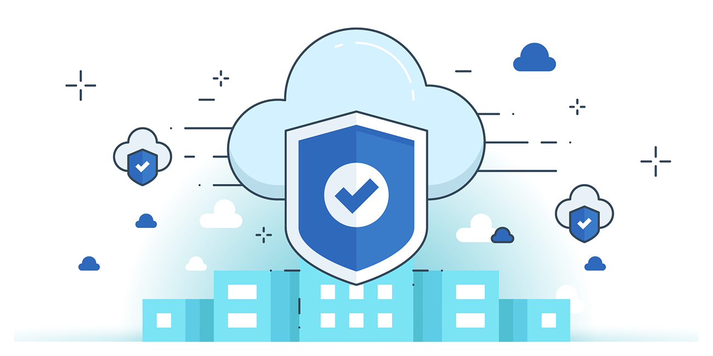

“CLOUD SECURITY”
Introduction to Cloud Forensics:
Cloud forensics is the application of digital forensic investigation in cloud environments, focusing on identifying, collecting, and analyzing data while preserving its integrity. Unlike traditional forensics, cloud forensics varies with service and deployment models. In SaaS, investigators rely on the CSP for application logs, while in IaaS, they can directly access virtual disks for analysis. In private clouds, physical access to evidence is possible, but in public SaaS models, investigations depend heavily on logs and audit reports provided by the CSP.
Uses of Cloud Forensics
- Investigation: Helps track organized cybercrime, policy violations, and suspicious activities in the cloud.
- Troubleshooting: Resolves functional, operational, and security issues in the cloud environment.
- Log Monitoring: Collects, examines, and correlates logs across endpoints, supporting auditing, compliance, and due diligence.
- Data & System Recovery: Recovers deleted or encrypted data and restores affected systems after attacks.
- Compliance: Ensures organizations follow due diligence, protect critical data, maintain audit records, and notify affected parties of data exposure.
Cloud Crimes
Cloud crimes are criminal activities where the cloud is used as a subject, object, or tool:
- Cloud as a Subject: Crime occurs within the cloud environment, such as identity theft, unauthorized data modification, or malware injection.
- Cloud as an Object: The CSP itself is targeted, e.g., DDoS attacks aimed at disrupting cloud services.
- Cloud as a Tool: The cloud is used to commit crimes against others, such as launching attacks from compromised accounts or storing/sharing crime-related evidence.

Cloud Forensics: Stakeholders and their roles:
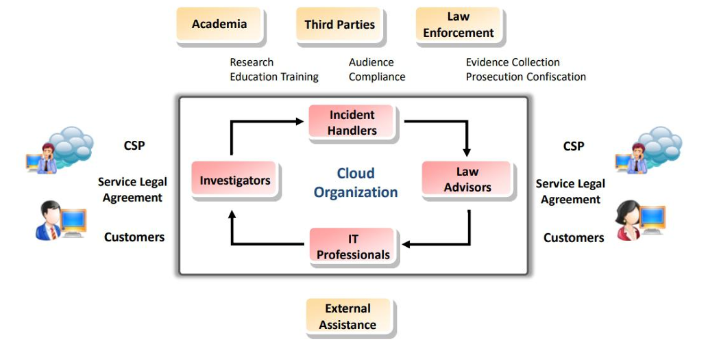

Cloud Forensics Challenges- Architecture and Identification
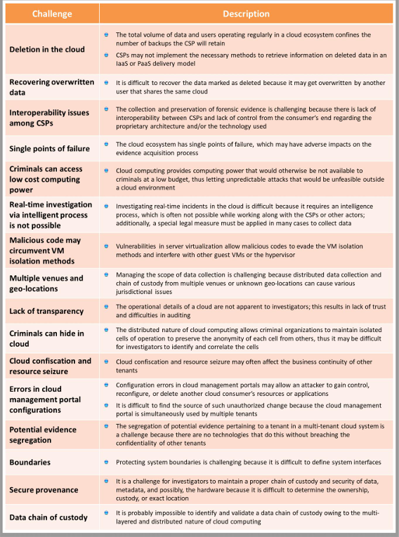

Cloud Forensics Challenges- Data Collection

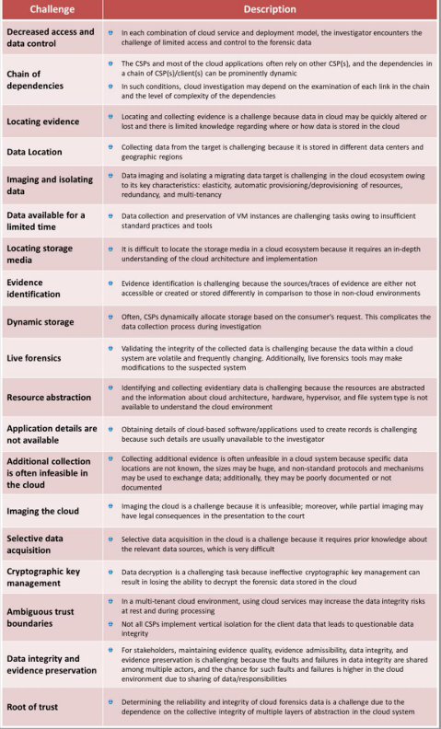

Cloud Forensics Challenges- Logs
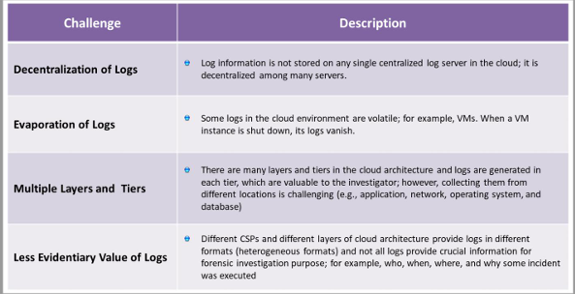

Cloud Forensics Challenges- Legal
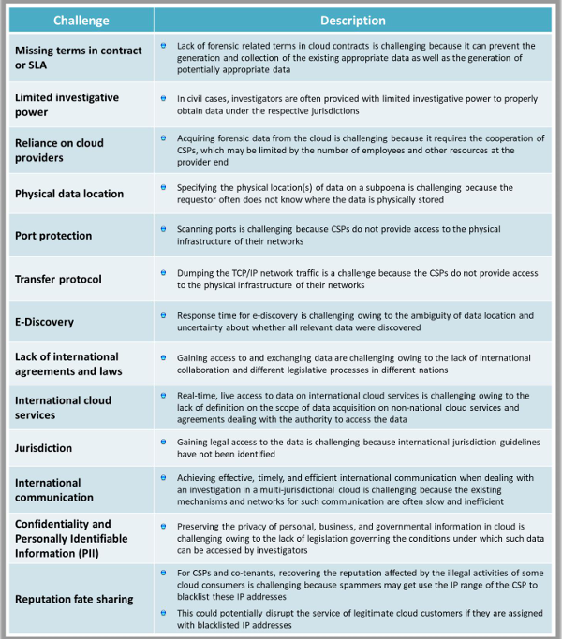

Cloud Forensics Challenges- Analysis
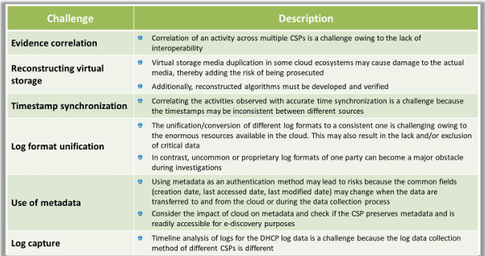
--The End--

