Day 48
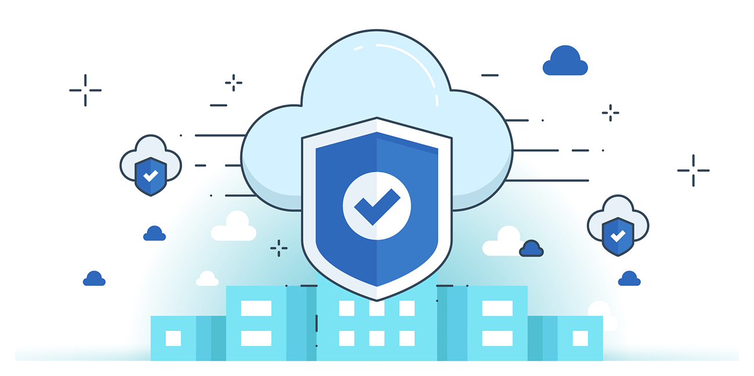

“CLOUD SECURITY”
Remote Access Security:
- Secure Authentication & Authorization – Enforce least privilege access with multi-factor authentication, strong password policies, and centralized access controls to ensure only authorized users can manage cloud hosts and applications.
- Monitoring & Logging – Implement strong logging, real-time monitoring, and alerts for suspicious activities (e.g., failed logins, unusual IPs) to preserve credentials, control sessions, and detect threats early.
- Secure Communication & Isolation – Use encrypted channels (TLS, SSH, RDP), remote desktop technologies, and network isolation to prevent malware spread and ensure data confidentiality and integrity.
Remote Access Security with Remote Desktop Protocol:
- Secure Remote Management – RDP allows administrators to manage cloud VMs remotely by transmitting encrypted keystrokes, mouse movements, and screen events over a dedicated TCP/IP channel.
- Efficient & Secure Data Handling – Provides secure data transfer without requiring a VPN and ensures data is stored securely on-premises while maintaining minimal latency.
- RDP Security Best Practices – Enforce multi-factor authentication, apply regular patches, restrict access via firewalls, and enable network-level authentication to reduce risks.
Remote Access Security with Secure Shell (SSH):
- Secure Cloud Access – SSH provides encrypted communication, authentication, and integrity for managing cloud servers securely over the internet, preventing spoofing, eavesdropping, and data manipulation.
- Authentication & Authorization – Secure session establishment relies on cryptographic authentication between client and server, with options for SSH keys and two-factor authentication to control access.
- SSH Hardening Practices – Enhance security with TCP wrappers (IP whitelisting), port knocking, single packet authorization, SSH Key Managers, and strict access controls to minimize attack risks.
OS Baseline Compliance Monitoring and Remediation:
- Automated Compliance Monitoring – Use automated scanning tools to frequently check cloud hosts for compliance with security baselines, especially after configuration changes, software installations, or patching.
- Deviation Management – Automate identification and remediation of deviations, document approved exceptions, and apply change management processes for corrections.
- Continuous Improvement – Detect unauthorized changes, identify flaws in baseline-setting tools, and refine baselines as systems and organizational policies evolve.

Cloud Patching Methodologies:
- Production Systems – Test patches in a non-production environment before applying them to production. After patching, verify that systems function as expected.
- Development Systems – DevOps teams evaluate and integrate patches before product rollout.
- Quality Assurance (QA) – Use a dedicated QA testbed to check interoperability, dependencies, and patch effectiveness in resolving organizational issues.
- Rolling Updates – Apply small, frequent updates sequentially; patch one system at a time to reduce risk.
- Blue-Green Deployment – Maintain two identical environments (Blue & Green). Apply patches to the inactive one, then switch traffic, minimizing downtime.
- Clustering and Failover – Apply patches to cluster master nodes, which distribute updates to others. If a node fails, another takes over without service disruption.
Patch Management Cycle:
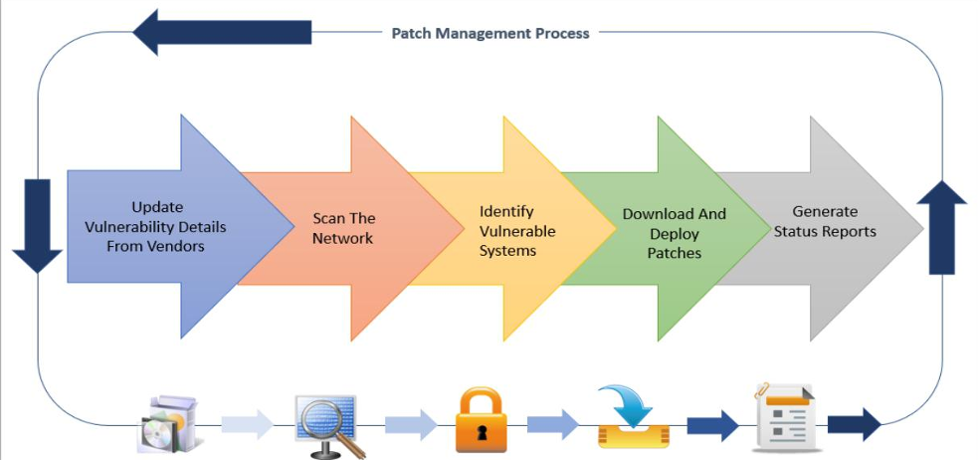
- Purpose – Regular patching fixes bugs, addresses vulnerabilities, ensures stability, and introduces new features while minimizing downtime.
- Process – Involves tracking new patches, verifying required hosts, testing patches, installing them, and validating functionality after deployment.
- Responsibility by Cloud Model
  - IaaS – Customer-managed patching.
  - PaaS – Shared responsibility between provider and customer.
  - SaaS – Provider-managed patching.
- Methods – Can be manual (slow, labor-intensive) or automated (faster, scalable with tools like Deep Freeze Cloud, Patch Manager Plus, SolarWinds).
- Automation Capabilities – Includes security patch application, change tracking and approvals, verification of patch success, and documentation of completed updates.

Patch Management Challenges in Cloud Environments:
- Scale & Complexity – Large, multi-tenant cloud environments with deep virtualization stacks make monitoring, applying, and controlling updates difficult.
- Multiple Time Zones – VMs operate worldwide, so patch scheduling must consider whether patches should be applied at the same local time (to avoid disruption) or simultaneously (to prevent mixed-mode issues like data corruption).
- VM Snapshots & Suspension – Operations like suspend, resume, snapshot, and revert can make VMs non-compliant if not integrated with compliance processes. For example, resuming a suspended VM or reverting to an old snapshot may bypass recent patches.
- Compliance Risks – Restoring VMs from outdated snapshots or failing to baseline before reverting may result in non-compliance and potential vulnerabilities.
--The End--

