Day 53
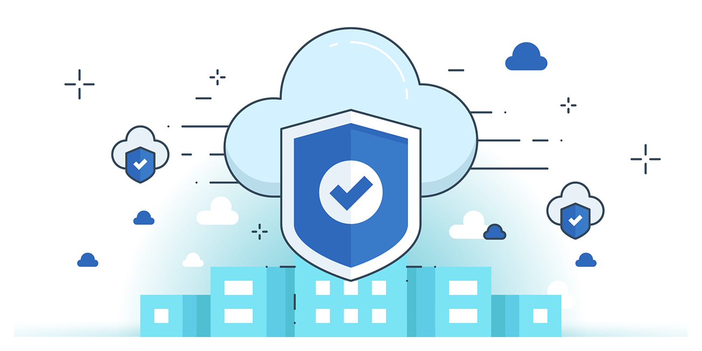

“CLOUD SECURITY”
AWS CAF – Security Perspective
Helps organizations implement suitable security controls when adopting the cloud.
Key Capabilities:
- Identity & Access Management (IAM): Manage identities, permissions, and lifecycle integration.
- Detective Controls: Provide visibility and transparency into AWS operations.
- Infrastructure Security: Apply security controls to cloud resources.
- Data Protection: Safeguard data at rest and in transit.
- Incident Response: Identify, respond, and manage incidents to minimize damage.
Approach:
- Preventative controls – stop incidents before they occur.
- Detective controls – monitor and detect suspicious activity.
- Responsive actions – automate recovery and remediation.
- Governance – enforce policies, compliance, and accountability.
AWS Incident Response Plan (IRP)
An IRP helps customers detect, handle, and minimize damage while finding and fixing the cause of incidents.
Goals:
- Identify indicators of incidents
- Classify incident types
- Find root causes
- Follow incident workflows
- Prepare for incidents
- Educate staff
Implementation Steps in AWS:
- Educate → Train staff on AWS cloud technologies.
- Prepare → Equip IR team to detect/respond quickly.
- Simulate → Run scenarios of expected/unexpected events.
- Iterate → Learn from simulations to reduce risks and response time.

Design Goals for Cloud Incident Response (CIR):
- Build Response Objectives → Work with stakeholders/legal teams to set clear goals (mitigation, recovery, forensics).
- Respond to Events → Apply response patterns where the data and incident occur.
- Preserve Evidence → Save logs, snapshots, and artifacts in a secure, centralized account.
- Adopt Redeployment Techniques → Fix misconfigurations via redeployment with correct settings.
- Implement Automation → Automate responses for recurring incidents to save time.
- Choose Scalable Solutions → Ensure IR scales with the organization’s cloud usage.
- Improve the Process → Continuously refine processes, tools, and training through simulations.
Indicators of Cloud Security Events
- Logs & Monitors → Use VPC Flow, S3 logs, CloudTrail, GuardDuty, Security Hub, Detective, Macie, CloudWatch, Route 53 health checks, and app-specific logs.
- Billing Activity → Unexpected spikes or drops in billing.
- Threat Intelligence → Correlate 3rd-party threat intel with AWS monitoring.
- Partner Tools → Leverage AWS Partner Network (APN) security solutions.
- One-time Contact → Reports from users, staff, or developers via ticketing/email/web forms.
- AWS Support → Notifications from AWS about malicious activity.
AWS Incident Detection & Response Capabilities
- Investigate Security Events → Use AWS logs (CloudWatch, CloudTrail, S3 access logs).
- Centralized Logging → Consolidate logs in S3; query with Athena.
- Partner Products → Use APN security tools for log analysis.
- AWS Services → Gain insights via GuardDuty, Security Hub, etc.
AWS Incident Response Plan – Educate
- Shared Responsibility
  - AWS → Secures infrastructure (host OS, hardware, facilities).
  - Customer → Secures OS, IAM, network configs, security groups, NACLs, etc.
  - Responsibilities differ based on chosen AWS services.
- Incident Response in Cloud (Design Goals)
- Build Response Objectives → Define goals with stakeholders (mitigation, recovery, forensics).
- Respond to Events → Apply response patterns where the event/data occur.
- Preserve Evidence → Store logs, snapshots, and evidence (central security account + retention policies).
- Adopt Redeployment → Redeploy with correct configs when misconfigurations cause issues.
- Implement Automation → Automate frequent responses to save time/effort.
- Choose Scalable Solutions → Ensure IR matches cloud scalability and reduces detection-to-response time.
AWS Incident Response Plan: Prepare
Prepare Technology
- Enable access to AWS accounts, tools, and services for detection and response.
- Create runbooks (manual and automated) for quick responses.
- Establish baseline operations to detect deviations.
Prepare People
- Define roles and responsibilities.
- Define response mechanisms.
- Build a receptive and adaptive security culture.
Cloud Provider Support
- AWS Managed Services → Infrastructure management using best practices.
- AWS Support → Tools and programs to optimize performance and reduce costs.
- DDoS Response → AWS Shield for managed protection.
- Support Escalation Path:
  - Submit support case
  - Technical Account Manager (TAM)
  - On-call Operations Manager
  - Global Enterprise Support Manager
  - Director of Support Engineering
  - VP of AWS Support
AWS Security Incident Response Plan: Simulation
Security Incident Response Simulation (SIRS):
- A method to practice the IRP in real-time scenarios.
- Helps the incident response team prepare, test, and improve their response capabilities.
Simulation Steps:
- Identify an issue of importance
- Find skilled security engineers
- Develop a realistic model
- Build and test the scenario elements
- Invite other security individuals and cross-organizational participants
- Run the simulation
- Celebrate, measure, improve, and repeat simulations

AWS Incident Response Plan: Iterate
Key Idea:
- Use the outputs from SIRS (Security Incident Response Simulation) as inputs for improving response procedures.
- Focus on building and refining runbooks.
Creation of Runbooks:
- Define manual procedures for responding to security events.
- Test and iterate on runbook patterns.
- Identify exceptions and design alternate solutions.
- Convert solutions into code-based responses for automation.
- Automate gradually so responses can be triggered by alerts or events.
- Runbooks improve the speed and efficiency of the incident response cycle.
AWS Incident Response Plan: Automate
Purpose:
- Enhance AWS cloud security by automating repetitive and routine incident response tasks.
Incident Response Automation:
- Automates handling of normal and repetitive alerts, letting the team focus on serious incidents.
- Converts the remediation steps of a security event into code logic.
- Run the code to handle incidents efficiently.
- Gradually automate more common incidents for faster response.
Event-driven Response:
  - Triggers automatic remediation when a security event occurs.
  - Reduces the time gap between detection and response.
  - Notifies responders about successful resolution.
  - Provides feedback loops to understand the cause and prevent future incidents.
  - Continuously improves the security posture of the cloud environment.
--The End--

