Day 49
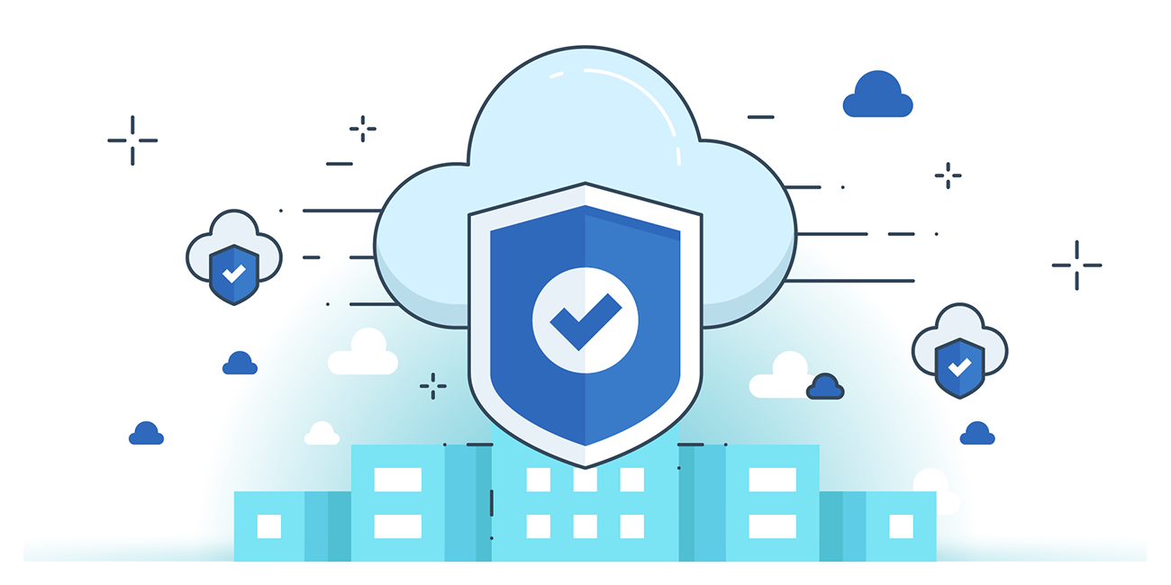

“CLOUD SECURITY”
Network Security Controls:
Cloud data centers use a defense-in-depth strategy, implementing multiple layers of security to make it difficult for attackers to penetrate systems. Single-layer protection is not enough; layered controls ensure that if one layer is breached, others still protect the network. Key network security controls include:
- Firewalls – Control incoming and outgoing traffic.
- Intrusion Detection Systems (IDS) – Monitor for suspicious activity.
- Intrusion Prevention Systems (IPS) – Actively block detected threats.
- Honeypots – Decoy systems to detect and analyze attacks.
- Vulnerability Assessments – Identify weaknesses in the network.
- Network Security Groups – Define rules for traffic segmentation and access.
Cloud Operations Management component:
- Information Security Management – Ensures confidentiality, integrity, and availability of cloud data and resources.
- Continuity Management – Maintains business operations during disruptions or disasters.
- Change Management – Controls and documents changes in the cloud environment to reduce risk.
- Continual Service Improvement Management – Continuously enhances cloud services and processes.
- Incident Management – Detects, responds to, and resolves operational incidents quickly.
- Problem Management – Identifies and addresses the root causes of recurring incidents.
- Release Management – Plans and oversees deployment of new or updated services.
- Deployment Management – Manages the rollout of applications, updates, or configurations.
- Configuration Management – Tracks and controls cloud assets, settings, and relationships.
- Service Level Management – Ensures cloud services meet agreed-upon performance and quality metrics.
- Availability Management – Guarantees resources and services are accessible when needed.
- Capacity Management – Monitors and plans cloud resource usage to meet current and future demands

--The End--

