Day 55
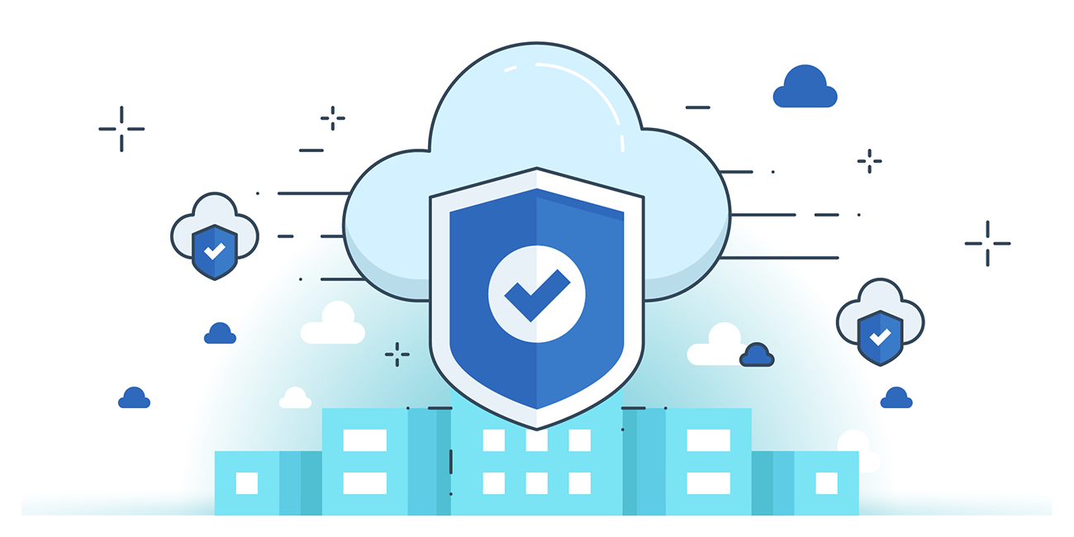

“CLOUD SECURITY”
Forensic Acquisition of Amazon EC2 Instance: Methodology:
When an EC2 instance is suspected to be compromised, forensic acquisition involves:
- Isolate the compromised EC2 instance from production.
- Snapshot the EC2 instance for preservation.
- Provision & Launch a forensic workstation.
- Create Evidence Volume from the snapshot.
- Attach the evidence volume to the forensic workstation.
- Mount the evidence volume for forensic analysis.
Logs in AWS useful for forensics:
- AWS CloudTrail → Records AWS API calls (who, when, where, what). Helps track changes to resources, user activity, and policy updates. Retains logs for 90 days by default; can be stored longer in S3.
- Amazon CloudWatch → Centralized monitoring of system/app logs in real time. Supports queries (Logs Insights), troubleshooting, and integration with CloudTrail/Route 53 logs.
- S3 Server Access Logs → Capture all requests (GET, PUT, DELETE) on buckets. Useful to trace missing objects, requester identity, and request details.
- VPC Flow Logs → Record network traffic in/out of VPCs. Provide source/destination IPs, ports, protocol, packets, and action (ACCEPT/REJECT). Helps detect suspicious connections.
Investigating Log Files: CloudWatch Logs
During a security incident, CloudWatch logs are valuable for forensic investigators since they collect logs from multiple sources into a centralized location. In the CloudWatch console, log groups and filtered events can reveal suspicious activity.
Investigating Log Files: S3 Server Access Logs
S3 server access logs help investigators trace object-level activities when sensitive files are modified or deleted. In the sample log entry, an object important.txt was deleted from the impfiles bucket by IAM user Bob, using the AWS CLI from IP 203.202.117.91.
If this deletion was unauthorized, it could indicate either:
- Insider attack – Bob intentionally deleted the file.
- Compromised credentials – An attacker used Bob’s IAM credentials to perform the action.
Additional log details (timestamp: 19 July 2020, client: Windows machine, tool: AWS CLI) provide investigators with evidence to confirm malicious activity and guide further forensic steps.
--The End-

