Day 40
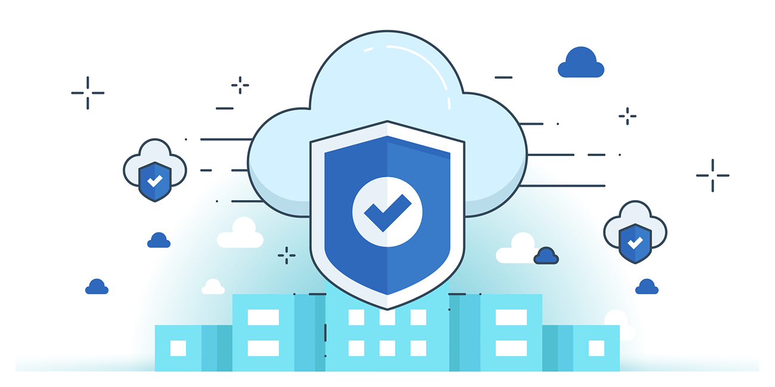

“CLOUD SECURITY”
Securing Amazon RDS from Accidental Deletion:
Steps:
Look for RDS:
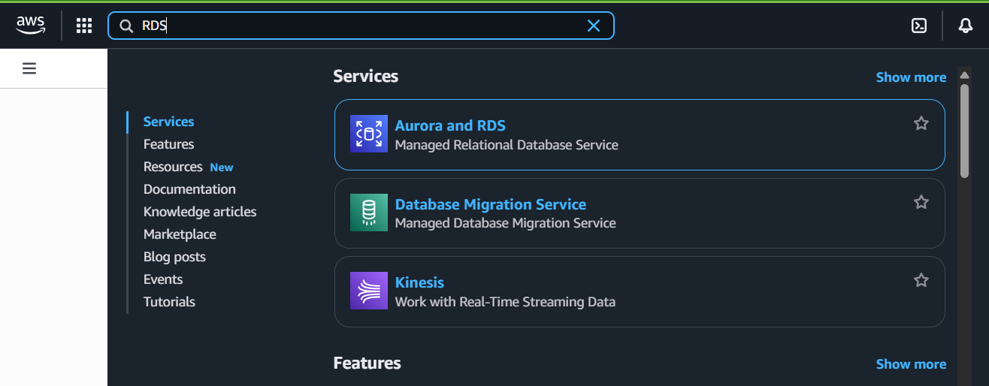
Open the “Aurora and RDS”: following window will appear.
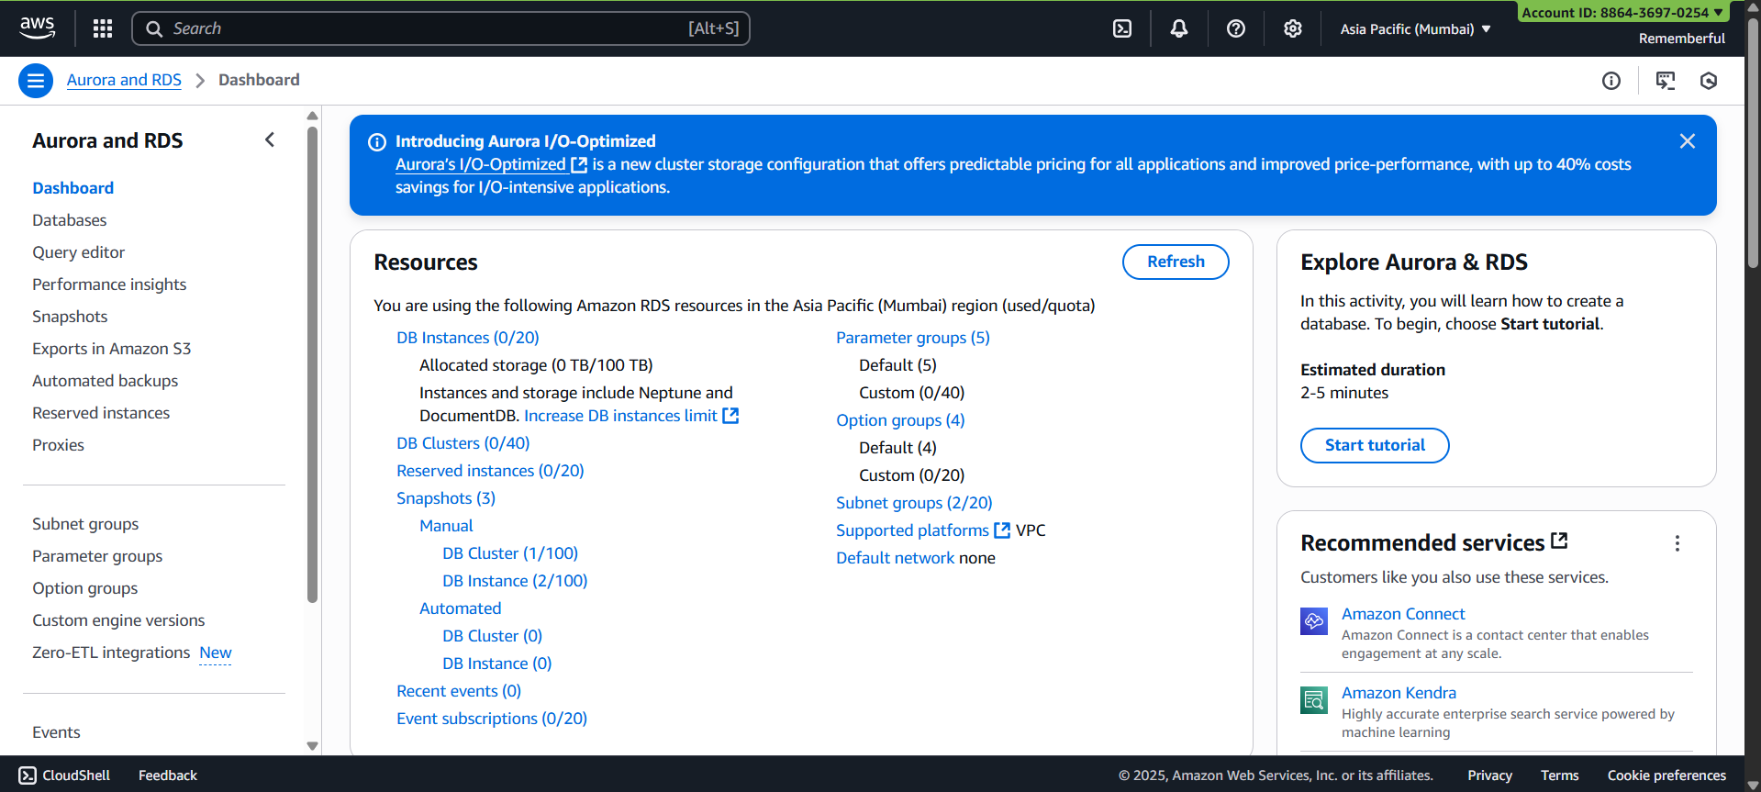

Scroll down and click on “create a database” button: following window will appear.
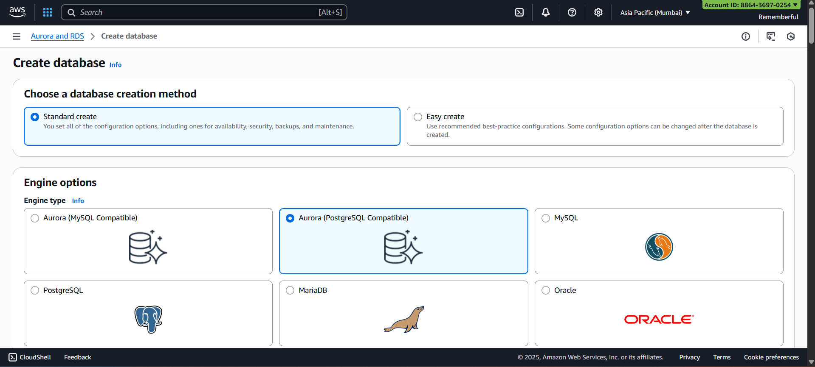
Change Engine option to “My Sql”:
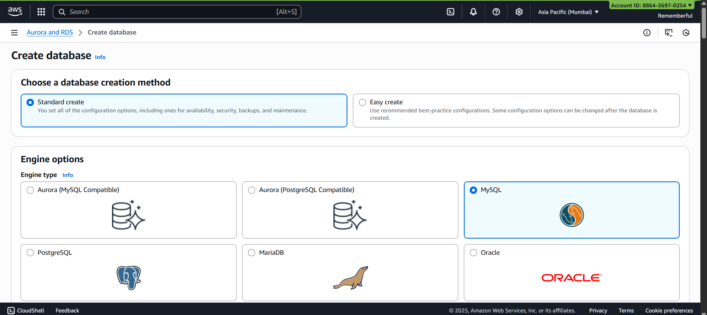
Scroll down to templates section and select “free tier”:
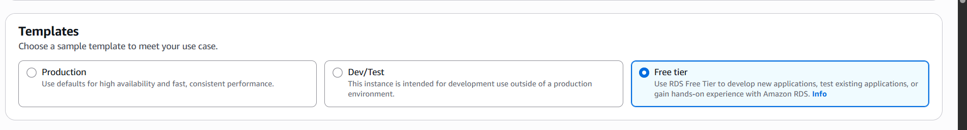

Scroll down and enter the password:
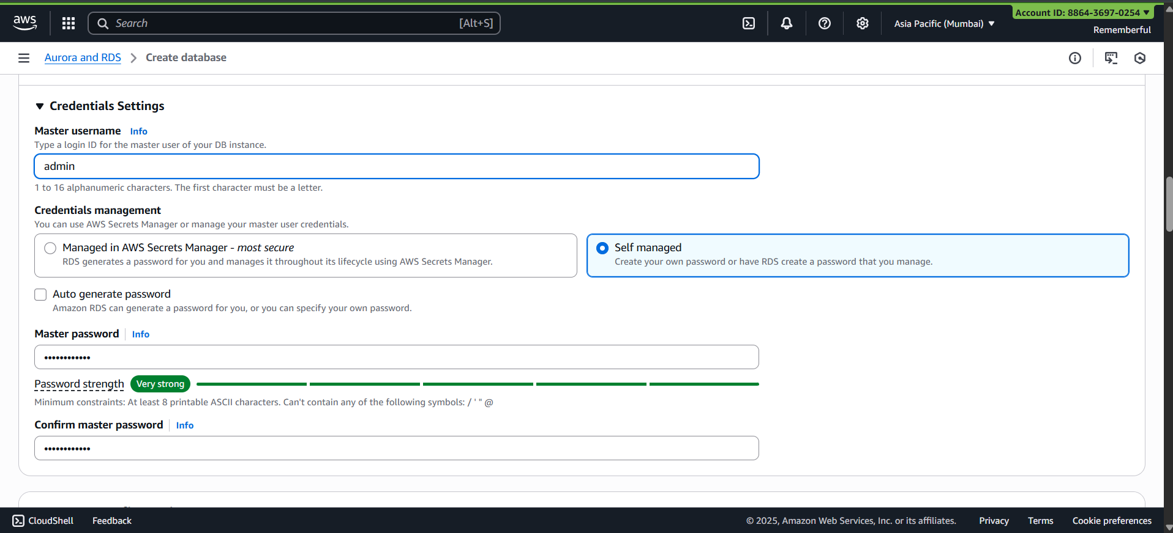
Now, to disable public access from the database, make sure that it is “No”: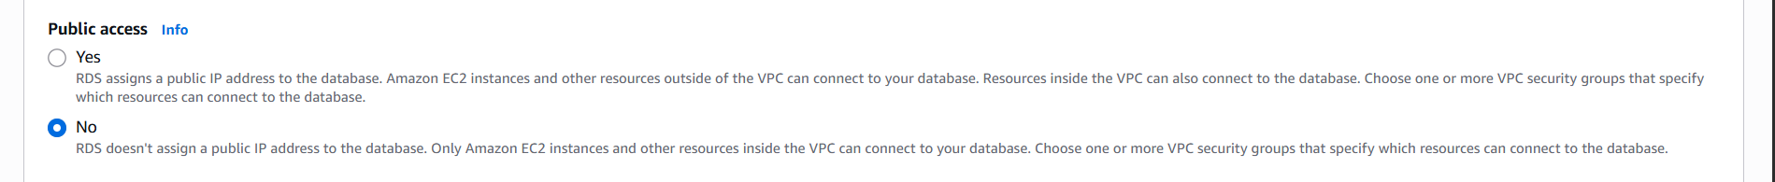
Now, create a new VPC: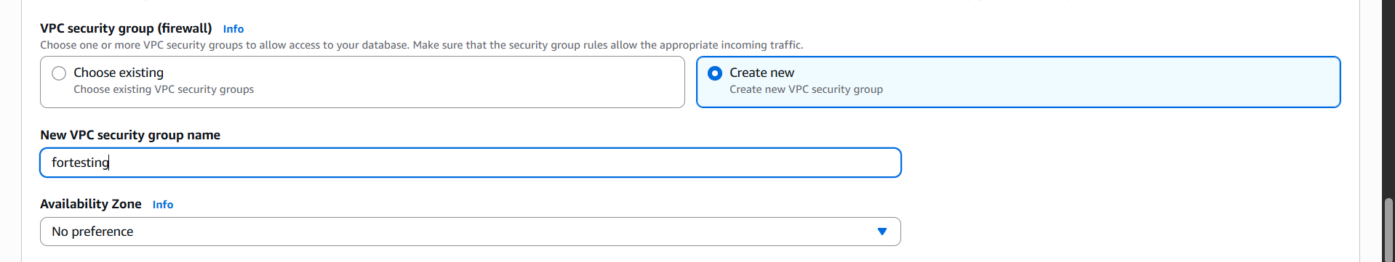
Scroll down to “additional configuration” and make sure that checkbox is checked:
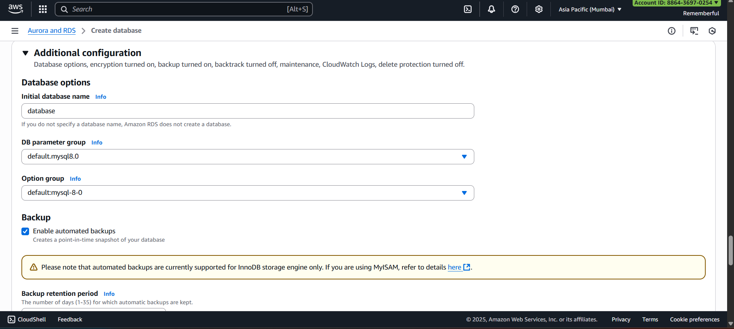

Scroll down and click on “create database” button: following confirmation will show.
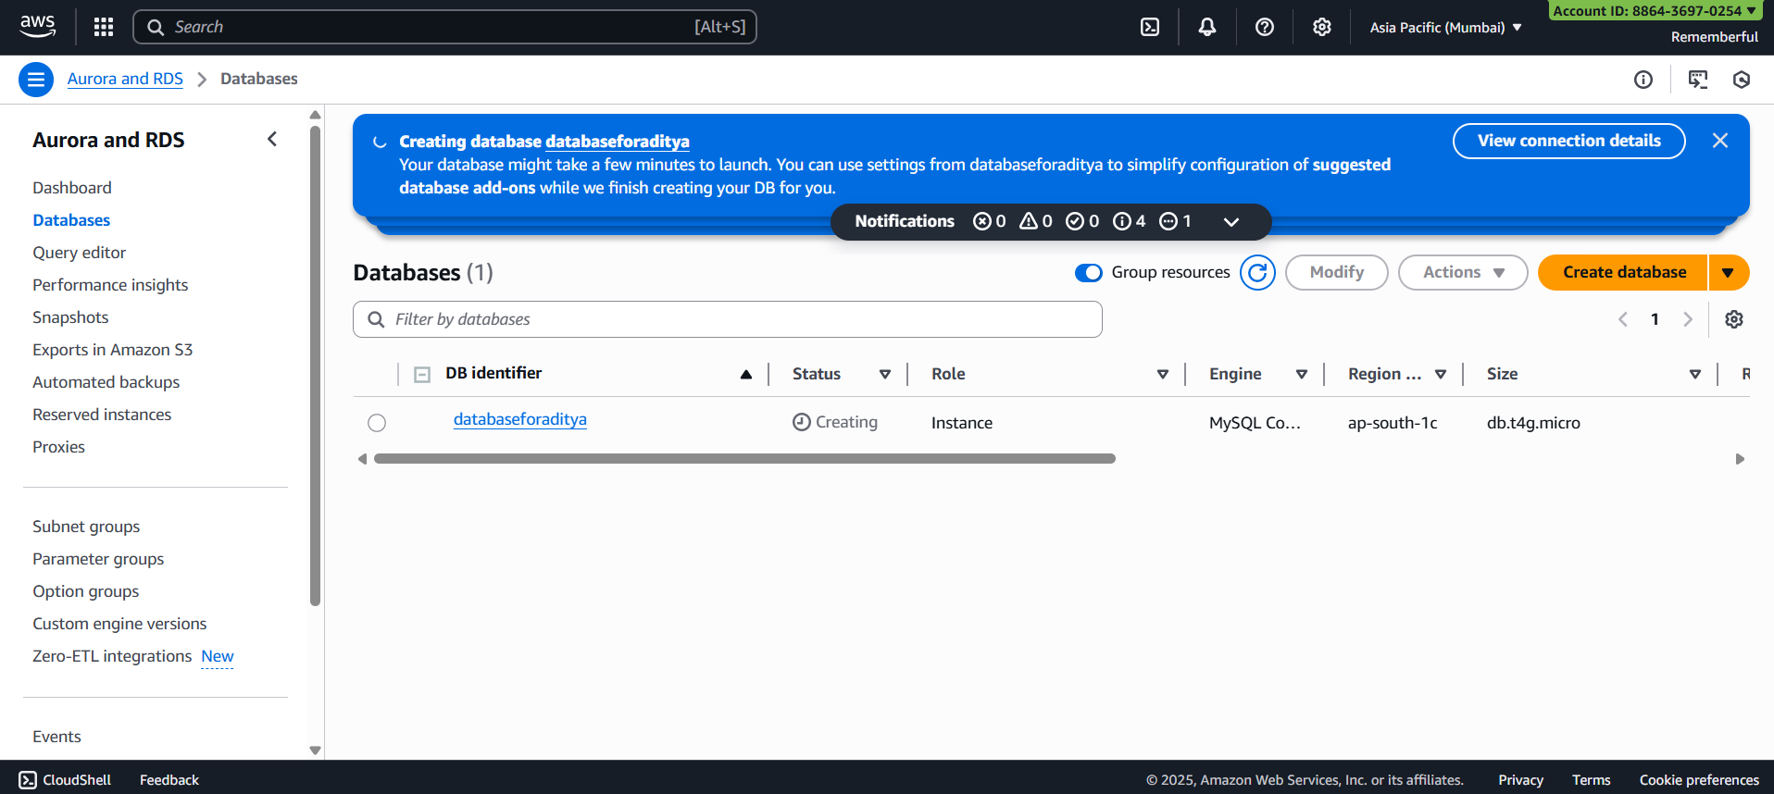
When it get created, select it and then click on ‘actions’: select ‘take snapshot’.
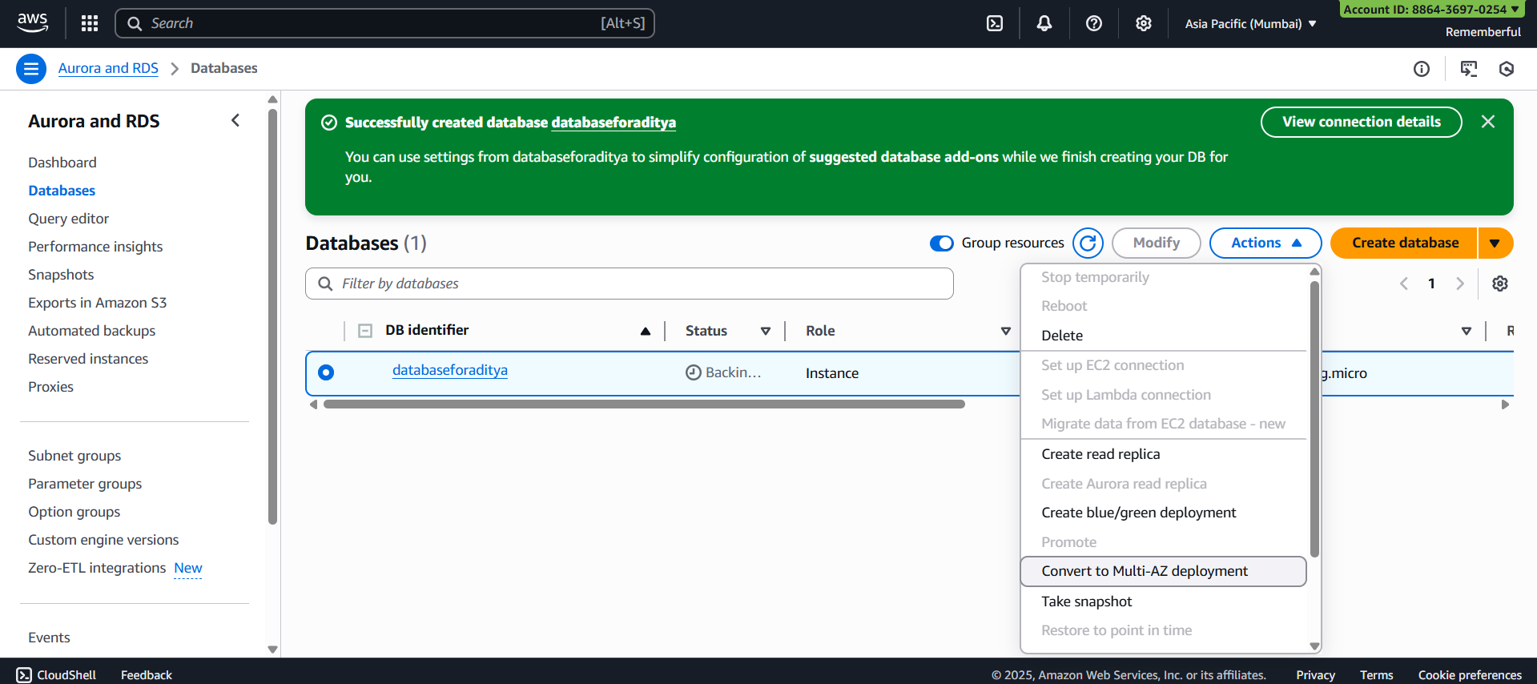
Following window will appear:
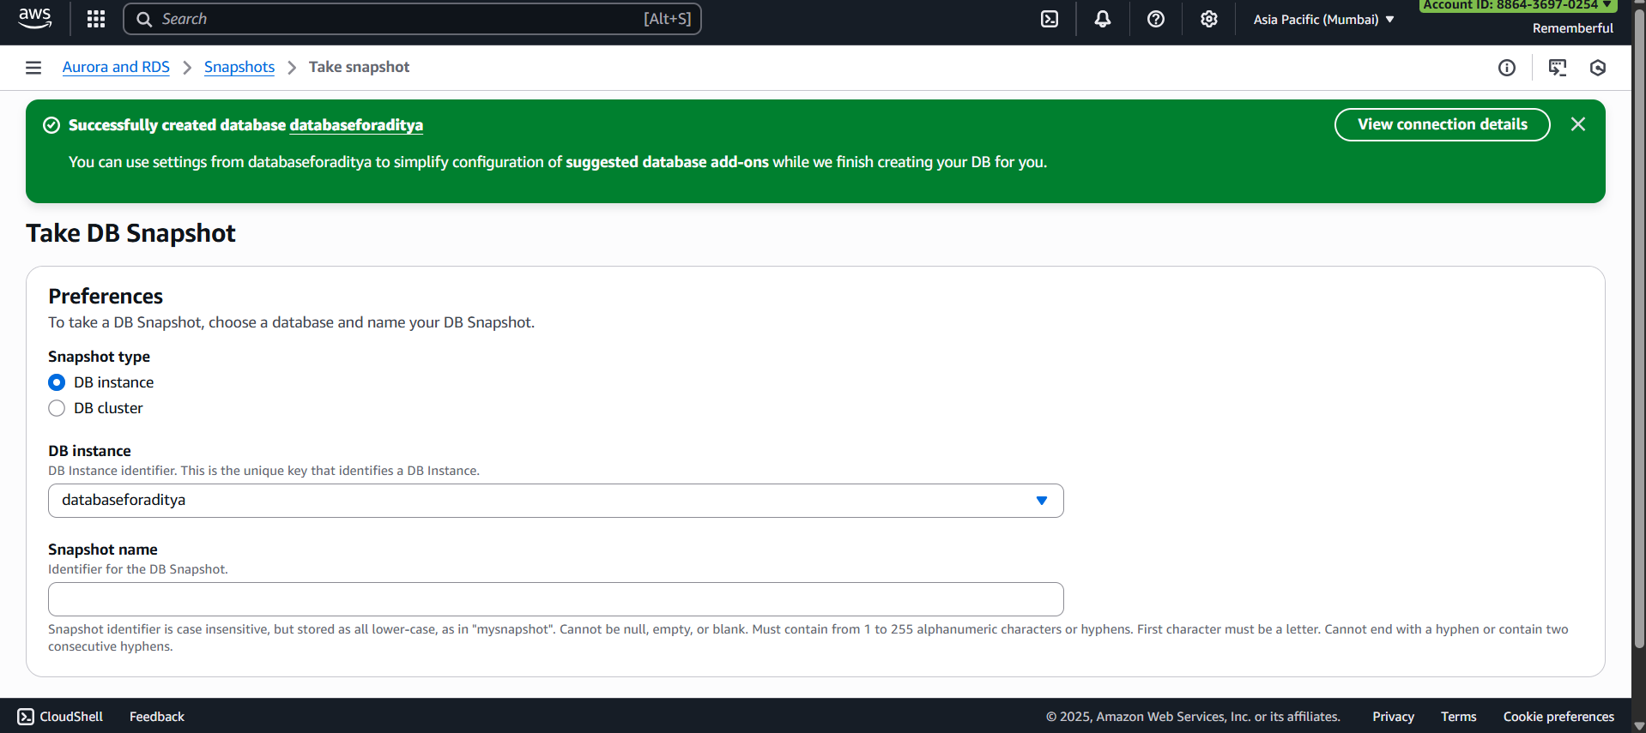
Mention snapshot name:
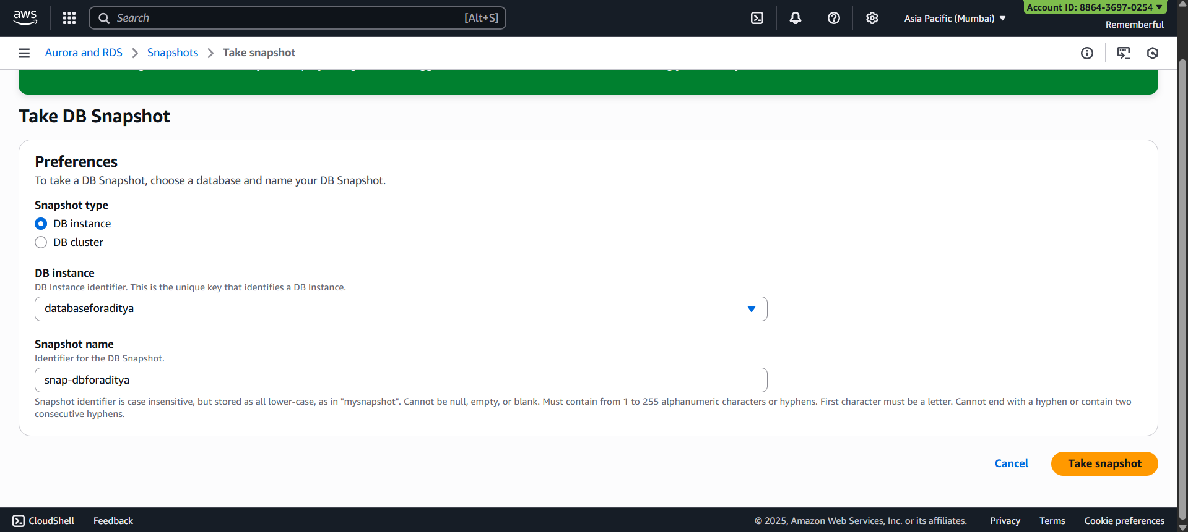
Following confirmation will occur:
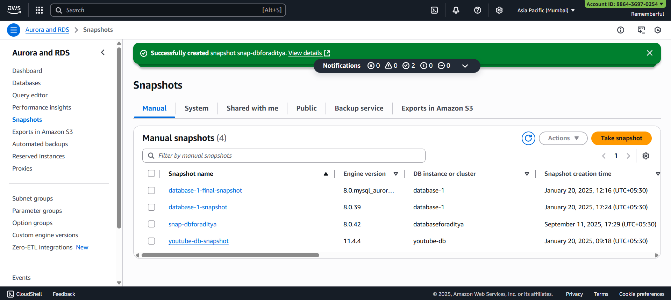
We may create a copy of this snapshot:
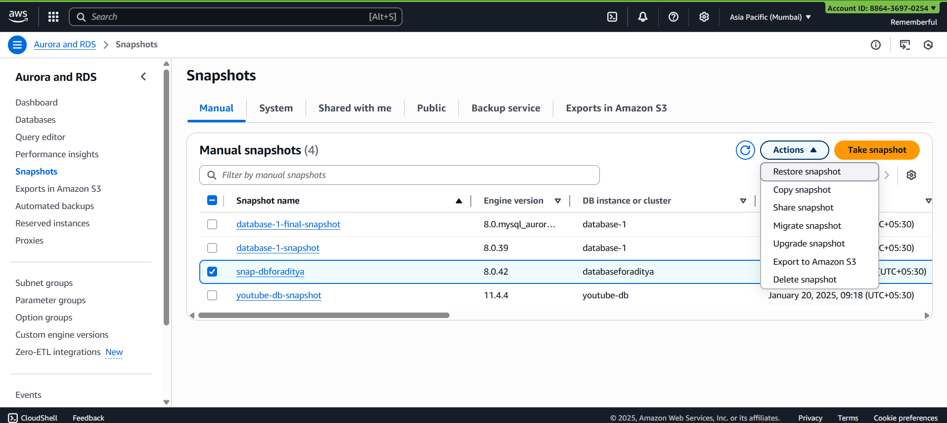
Following screen will appear:
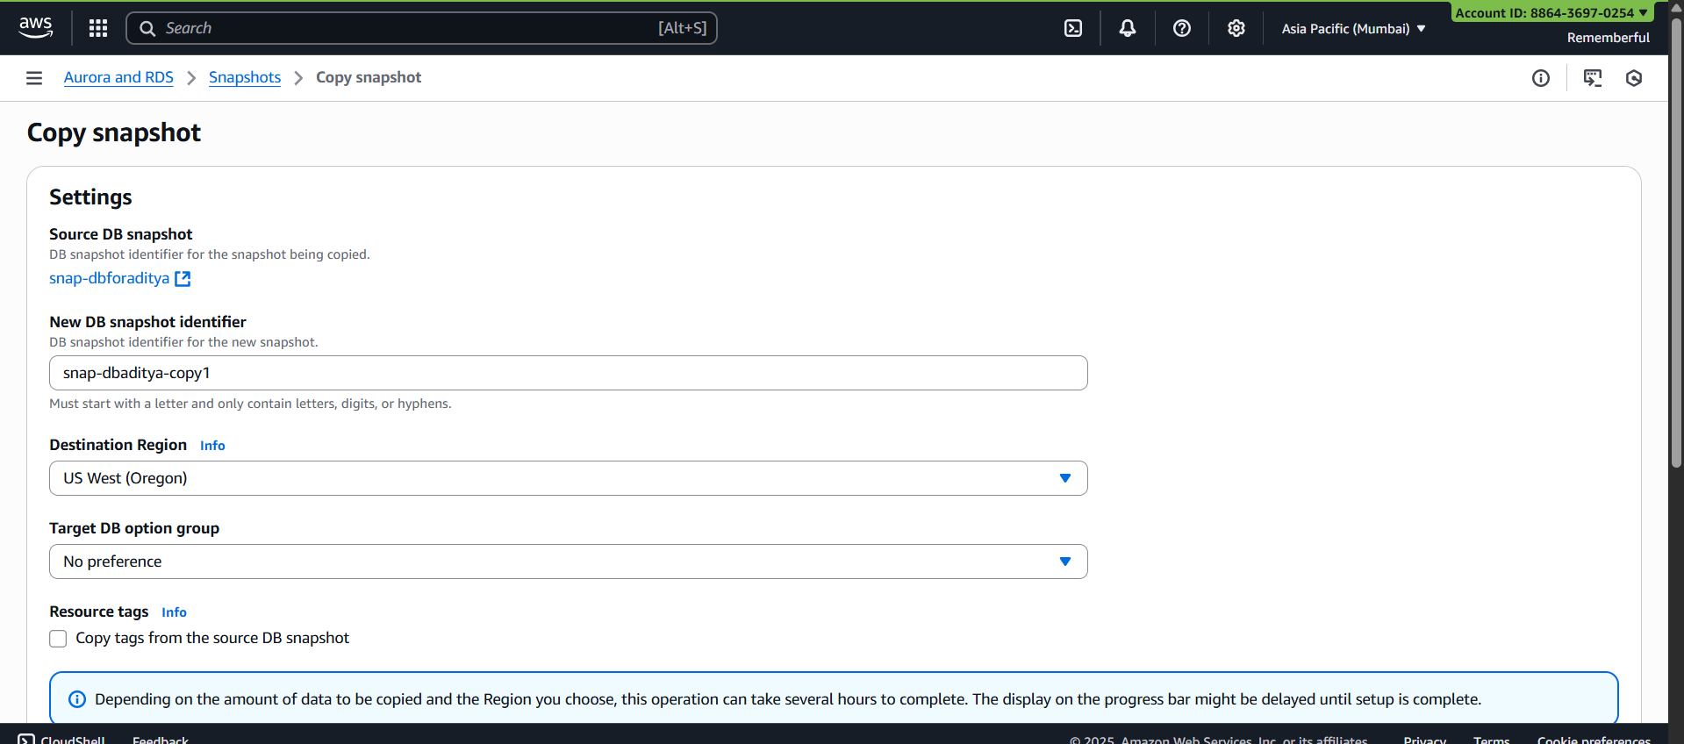
Click on “copy snapshot” button at bottom: this will show.
Done !
--The End--

