Day 36
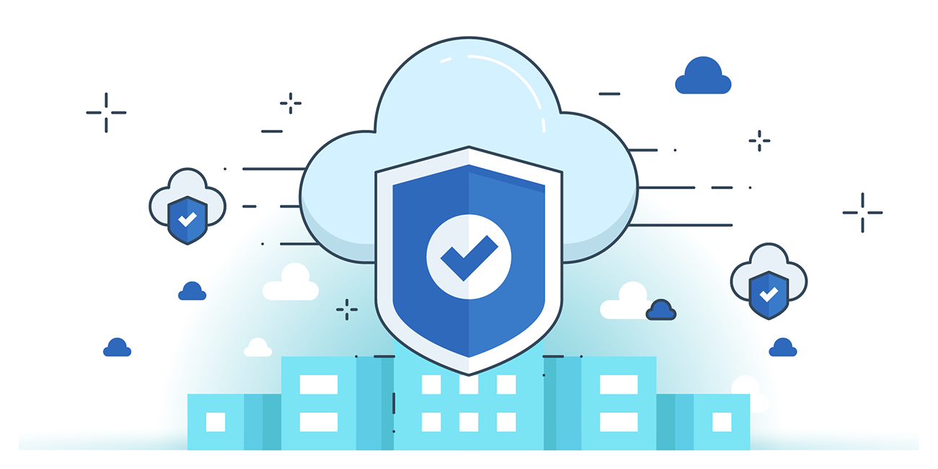

“CLOUD SECURITY”
AWS Storage:
- It is a service provided by Amazon to the customers for storing, accessing, governing, and analysing the data.
AWS storage services are listed below.
- Object storage: Amazon Simple Storage Service (S3)
- File storage: Amazon Elastic File System, Amazon FSx for Windows File Server, Amazon FSx for Lustre
- Block storage: Amazon Elastic Block Store
- Backup: AWS Backup
- Data transfer: AWS Storage Gateway, AWS DataSync, AWS Transfer Family, AWS Snow Family
- Edge computing and storage: AWS Snow Family
Amazon S3 (Simple Storage Service)
Object storage for scalable, durable, and secure data. Stores any amount of unstructured data like backups, media, or logs. Offers lifecycle policies, versioning, cross-region replication, and storage classes (Standard, Glacier). Ideal for big data, analytics, and application content delivery with virtually unlimited capacity.
Amazon EBS (Elastic Block Store)
Block storage for Amazon EC2 instances. Provides persistent, high-performance volumes that behave like raw disks. Supports SSD and HDD types for transactional or throughput workloads. Snapshots enable backup and restore. Ideal for databases, file systems, and applications requiring consistent low-latency access and durable storage.
Amazon EFS (Elastic File System)
Scalable, serverless file storage automatically growing and shrinking as files are added or removed. Fully managed NFS (Network File System) for Linux-based workloads. Provides shared access across thousands of EC2 instances. Best for big data, machine learning, container storage, and enterprise applications needing concurrent file access.
Amazon FSx
Fully managed file systems built for specific workloads. Options include FSx for Windows File Server (SMB protocol, Active Directory integration) and FSx for Lustre (high-performance computing, ML). Provides scalability, encryption, and backup support. Ideal for enterprises migrating on-premises file storage or running compute-intensive workloads seamlessly on AWS.
Amazon S3 Glacier & Glacier Deep Archive
Low-cost archival storage for long-term data retention. Optimized for infrequent access with retrieval times ranging from minutes to hours. Provides secure, durable storage at minimal cost, ideal for compliance archives, backups, and digital preservation. Lifecycle policies help move data automatically from S3 to Glacier for savings.
--The End--

