**Day 15**

**Exploitation Analyst**

**HTTP protocol:**

**What is HTTP? ‘Hypertext Transfer Protocol’**HTTP is a stateless, application-layer protocol used for transferring web content (HTML, CSS, JS, etc.) between a client (browser) and a web server. It is a connectionless protocol.

**Key Features of HTTP:**

| Feature | Description |
| --- | --- |
| Protocol | Text-based request-response protocol (part of the TCP/IP suite) |
| Port | Uses port 80 by default |
| Stateless | Each request is independent, server does not remember previous requests |
| Client-Server Model | Browser sends requests, server sends responses |
| Application Layer | Works at Layer 7 of the OSI Model |

**What is HTTP header?**

YouTube: <https://youtu.be/qgZiUvV41TI?si=lV1h5zfH-qW0wo_q>

HTTP headers are key-value pairs sent in both HTTP requests and HTTP responses that carry metadata about the communication between the client (browser) and the server. They do not contain the actual content (like HTML or images), but instead describe how the content is sent, processed, cached, secured, etc.

Some standard headers:

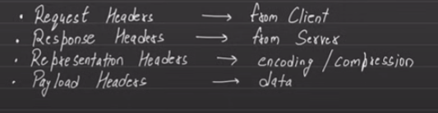

Security-Related Headers:

| **Header** | **Use** |
| --- | --- |
| Strict-Transport-Security | Enforces HTTPS only |
| Content-Security-Policy | Prevents XSS by restricting sources |
| X-Frame-Options | Prevents clickjacking |
| X-Content-Type-Options | Blocks MIME sniffing |
| Referrer-Policy | Controls how much referrer info is shared |

Some more header:

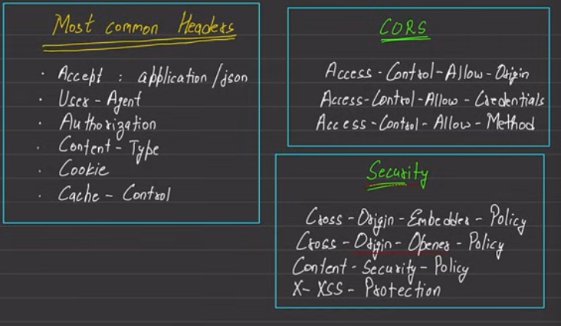

**What are HTTP methods?**

These are basic set of operations that can be used to interact with server.

| **Method** | **Used For** | **Body** | **Idempotent** | **Safe** |
| --- | --- | --- | --- | --- |
| GET | Read data | ❌ | ✅ | ✅ |
| POST | Send/Create data | ✅ | ❌ | ❌ |
| PUT | Replace resource | ✅ | ✅ | ❌ |
| DELETE | Remove resource | ❌ | ✅ | ❌ |
| HEAD | Headers only | ❌ | ✅ | ✅ |
| OPTIONS | Capabilities check | ❌ | ✅ | ✅ |
| PATCH | Partial update | ✅ | ❌ | ❌ |

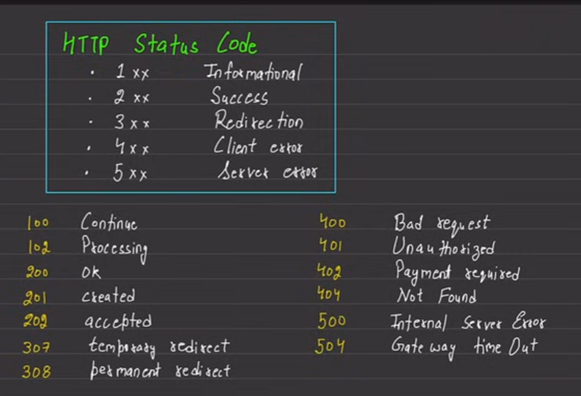

--The End--