**Day 19**

**Exploitation Analyst**

**ICMP Protocol:**

**What is ICMP?**

ICMP (Internet Control Message Protocol) is a core protocol of the Internet Protocol (IP) suite. It is primarily used for sending error messages, diagnostics, and network status information between network devices — like routers, switches, and hosts.

It is not used to send application data like HTTP or SSH but to report network issues (e.g., unreachable hosts or timeouts). It operates at the network layer (Layer 3) of the OSI model and is defined in RFC 792.

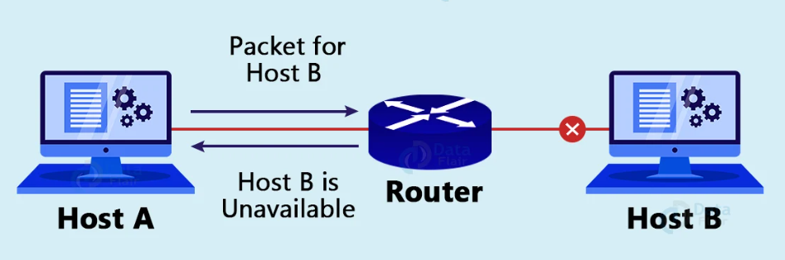

**ICMP (Internet Control Message Protocol) does not use ports like TCP or UDP.**

**How ICMP Works?**

ICMP (Internet Control Message Protocol) is a network layer protocol used primarily for sending error messages and operational information in IP networks. It does not carry data like TCP or UDP but supports network diagnostics and error reporting.

**ICMP Working Mechanism**

**1. Embedded in IP Packets**

* ICMP is not a transport layer protocol (like TCP/UDP); instead, it is encapsulated inside IP packets.
* IP Header → ICMP Header → ICMP Payload

**2. Triggered by Network Events**

ICMP messages are **automatically generated** by networking devices (like routers or hosts) in response to:

* Packet delivery issues (e.g., unreachable destination)
* TTL (Time to Live) expiry
* Network congestion or redirection
* Diagnostic requests (ping, traceroute)

Example:

When your computer sends an IP packet (like trying to reach 8.8.8.8), it includes a TTL (Time To Live) value, which limits how many routers the packet can pass through. If the TTL starts at 1, the very first router it hits will decrease it to 0. Once TTL reaches 0, the router understands that the packet has been in the network too long (to prevent infinite loops), so it drops the packet. But before doing so, it generates an ICMP "Time Exceeded" message (Type 11) to notify the sender. This ICMP message is wrapped inside a new IP packet and includes part of the original packet’s header and data. The ICMP packet is then sent back to your computer, telling you exactly where the packet expired. This is how tools like traceroute map the path packets take across the network.

**Why is ICMP Important in Computers?**

* Troubleshooting and diagnostics: Tools like ping, traceroute, and pathping rely on ICMP to test connectivity and path reliability.
* Network discovery: Helps identify live hosts during reconnaissance.
* Error handling: Routers use ICMP to notify source devices when:
  + A destination is unreachable
  + A route has changed
  + TTL (Time To Live) has expired

**Uses of ICMP:**

| **Use Case** | **Description** |
| --- | --- |
| Ping | Sends ICMP Echo Request to check if host is reachable. |
| Traceroute | Maps the path packets take across the network (using TTL-exceeded ICMP responses). |
| Error messages | ICMP delivers messages like Destination Unreachable, Time Exceeded, Redirect, etc. |
| OS fingerprinting | Tools like Nmap analyze ICMP replies to infer operating system types. |
| Firewall testing | ICMP behavior reveals filtering rules, blocked ports, or dropped packets. |

**In which layer does ICMP work?**

ICMP operates at the Network Layer (Layer 3) of the OSI model — the same layer as IP. It does not use TCP or UDP for transmission; instead, it is encapsulated directly within IP packets.

**How does ICMP use the support of IP?**

ICMP relies on IP for delivery. Specifically:

* An ICMP message is embedded within an IP packet.
* The IP header’s protocol field is set to 1 to indicate that the payload is ICMP.
* Routers and hosts process ICMP messages just like other IP packets.

So, ICMP doesn't have ports like TCP/UDP. It is simply treated as data by IP, but it's a protocol "within" IP designed for messaging, not data delivery.

**Which packets have the highest chance of being discarded by routers: ICMP, IGMP, UDP, or TCP?**

| **Protocol** | **Chance of Discarding** | **Why** |
| --- | --- | --- |
| **ICMP** | High | Often blocked by firewalls/security policies (e.g., ICMP Echo Request to prevent ping sweeps or DDoS) |
| **IGMP** | High | Not needed for most networks; multicast is often disabled or unsupported |
| **UDP** | Medium | Stateless; if no service is listening on the destination port, packet may be dropped silently |
| **TCP** | Low | Connection-oriented; usually prioritized and monitored for session integrity |

**Why can ICMP/IGMP be discarded?**

* **ICMP**:
  + Can be used for scanning or tunneling (covert channels).
  + Firewalls often block Echo Requests to prevent reconnaissance.
* **IGMP**:
  + Used for managing multicast groups; often disabled in secure networks.
  + IGMP isn't needed unless multicast is explicitly configured.

**Rule Clarification: ICMP Discards and Feedback**

**Rule**:

If an IP packet is discarded, an ICMP error is generated.  
But if an ICMP packet is discarded, no ICMP error is sent in response.

Why is this the rule?

If routers started sending ICMP errors in response to other ICMP errors, it could create an infinite loop:

1. Router A sends ICMP.
2. Router B discards it and sends ICMP error to Router A.
3. Router A discards that and sends error to Router B.
4. Loop continues...

To prevent this endless error-chaining, ICMP errors are never generated in response to:

* ICMP error messages
* Broadcast/multicast IP addresses
* Fragmented packets (except first fragment)

This makes ICMP more efficient and avoids unnecessary traffic congestion.

**How Safe is ICMP?**

ICMP is essential but not inherently secure. It was designed for diagnostics, not for authentication or encryption. Hence, while it's useful, it can be abused if not properly managed.

--The End--