**Day 25**

**Exploitation Analyst**

**Some Basic Yet Important Linux Commands:**

Pwd: to see the present working directory.

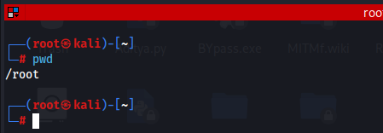

Cd: to change the directory.



Ls: to list the files present in the folder/directory.

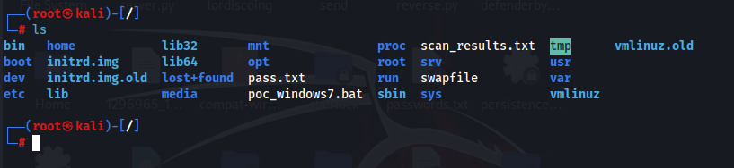

Cd .. : to go to the one directory outside.

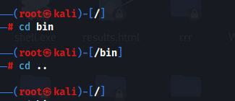

Cd /filepath: to directly reaches the file path.

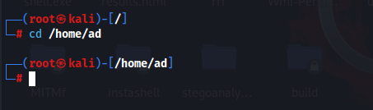

Mkdir folder_name: to create a new folder.

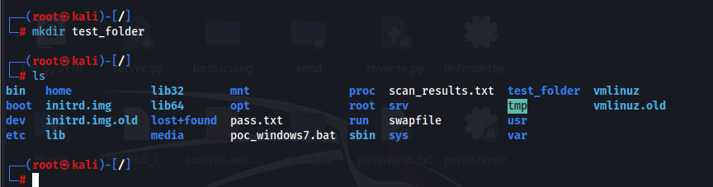

Rmdir folder_name: to remove the folder.

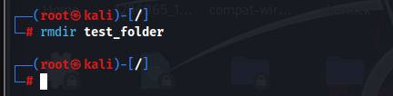

Cp old_file new_file:To copy one file to another file.

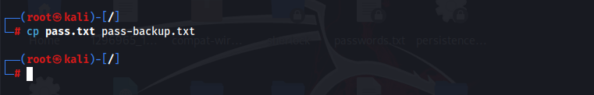

mv file_name new_location: to move or rename the file.

