**Day 26**

**Exploitation Analyst**

**Some Basic Yet Important Linux Commands:**

Touch file_name: to create a particular file.

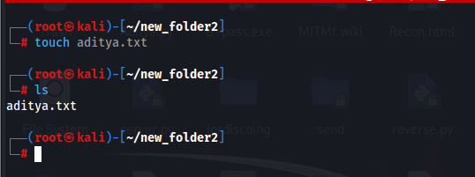

Cat file_name: to concatenate and display the content of file.

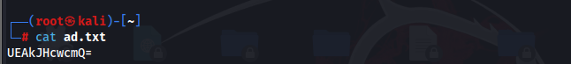

Man command_name: to get the manual for that command.

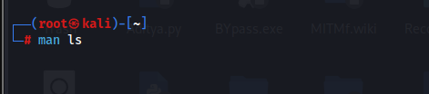

Htop: an interactive process viewer.

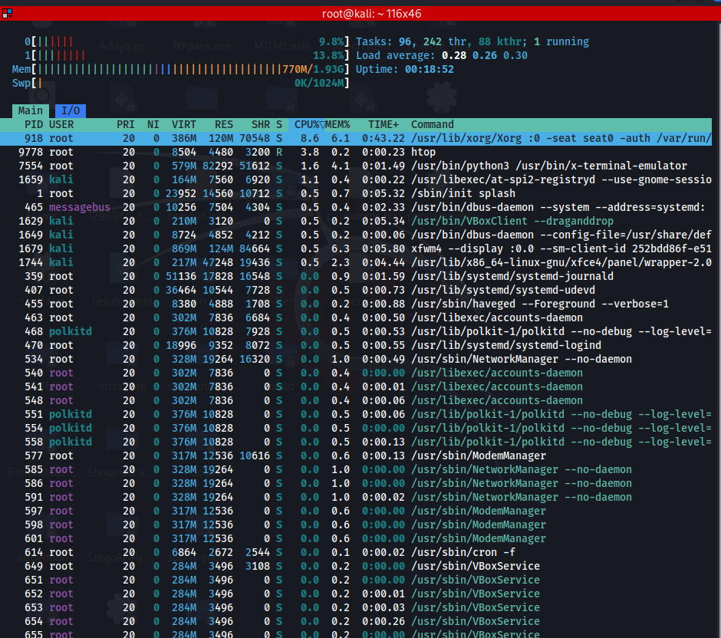

Chmod:

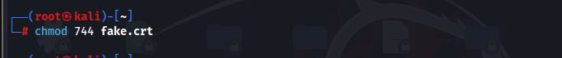

Chown: to change the owner of a file.

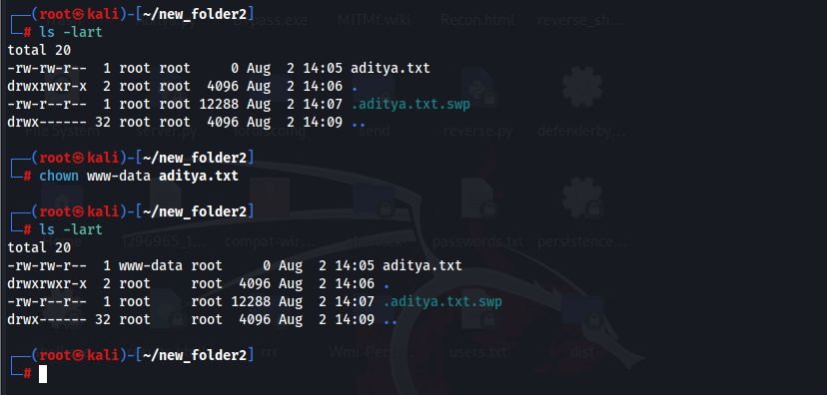

Gzip: compress file.

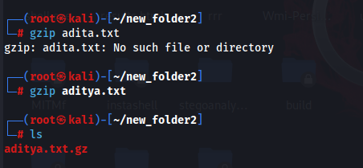

Ping: to test network connectivity.

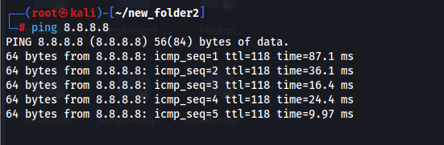

Ifconfig: to get the IP.  
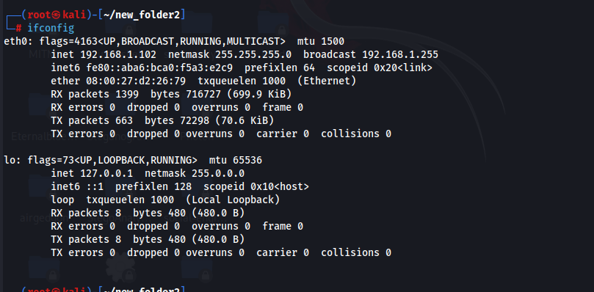

Netstat: to get the network monitoring.

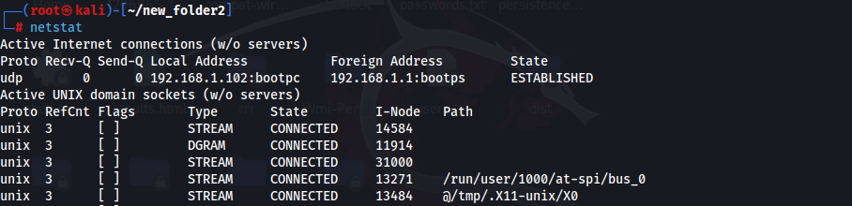

Route: to view of configure the network routing tables.

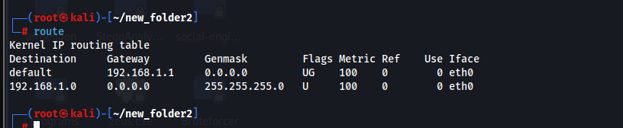

Top: for checking the usage by pc.

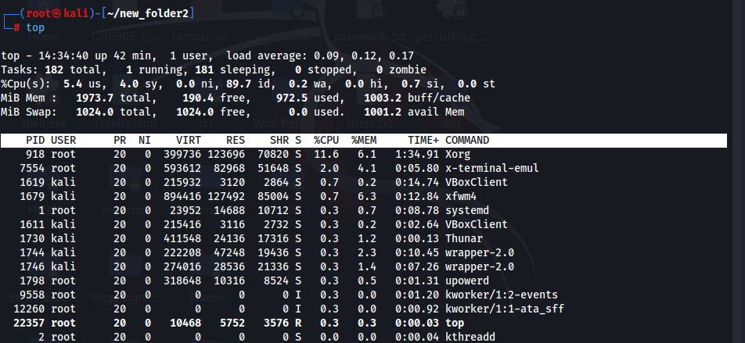

Ps: to get the list of current processes running.

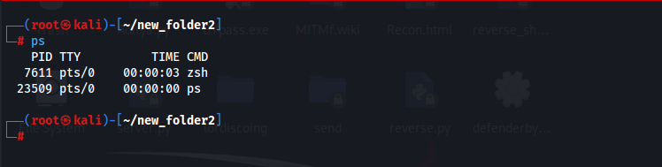

Systemctl: to get the controls system services and settings.

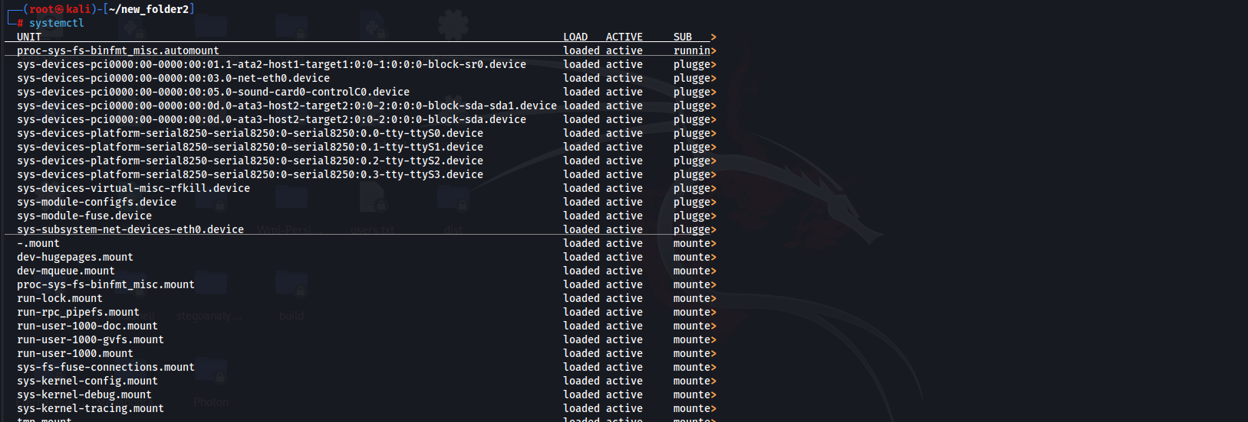

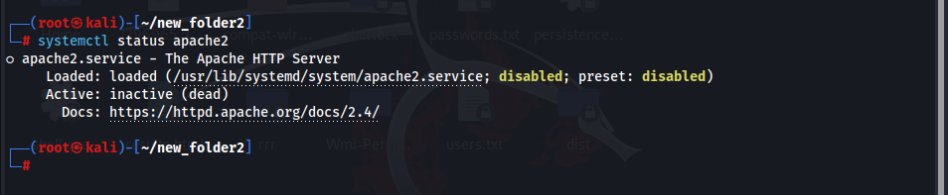

Useradd user_name: to add the new user.

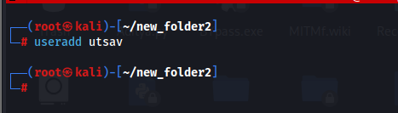

Uptime: to get the uptime.

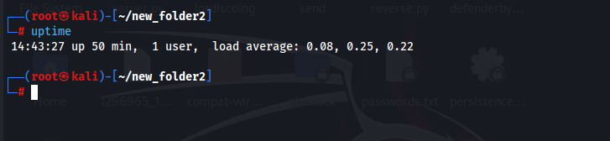

Df: to get the storage details.

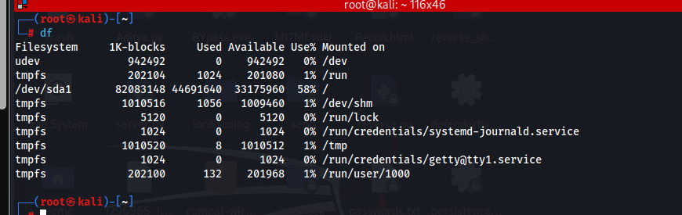

Whoami: to get the logged in user id name.

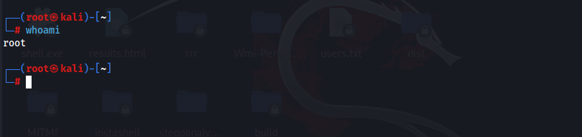

Finger user_idName: to get the information about the user.

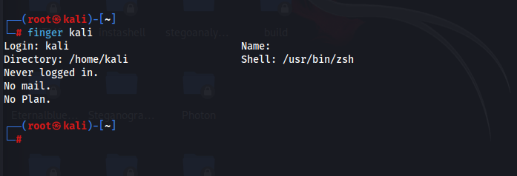

Uname: to display the system information.

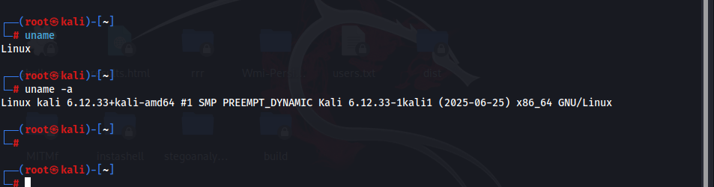

--The End--