**Day 27**

**Exploitation Analyst**

**Linux Security:**

**Some basic tips and tricks:**

**1. nano logrotate.conf**

* Opens the file logrotate.conf in the nano text editor.
* Standard usage.
* No cursor position is shown by default.

**2. nano -c logrotate.conf**

* Opens the same file but with the -c flag.
* -c stands for "constant cursor position display."
* It shows the line and column number of the cursor at all times in the status bar (at the bottom).

**3. mc**

The mc command refers to Midnight Commander, a text-based file manager for Unix-like systems. It gives you a powerful, dual-pane interface in the terminal to manage files easily — sort of like a graphical file explorer, but in text mode.

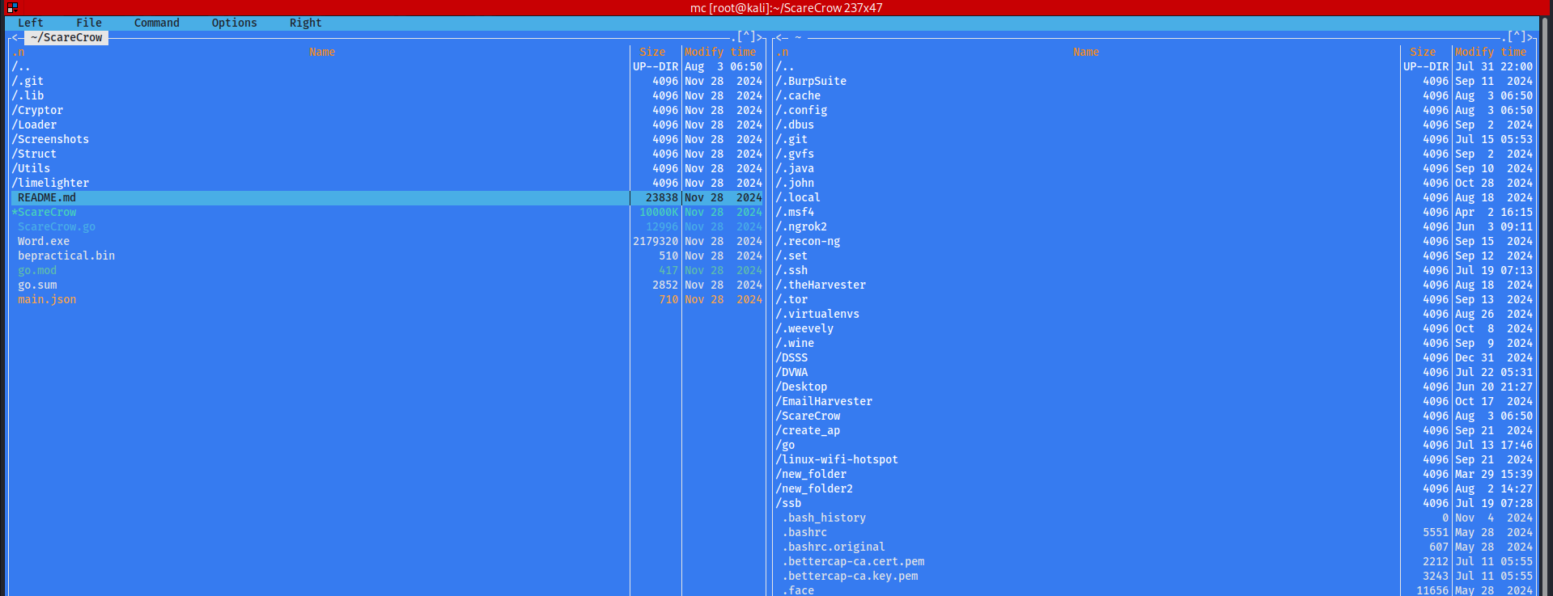

**4. Ctrl + R**

Start typing part of a previous command, e.g., ssh, and it will auto-fill the most recent matching command:

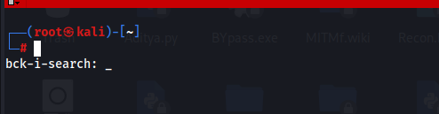

--The End--