**Day 28**

**Exploitation Analyst**

**GRUB protection and Security:**

**What is GRUB in Linux?**

GRUB stands for GRand Unified Bootloader. It’s the default bootloader for most Linux distributions.

**What Does It Do?**

GRUB is responsible for:

1. Loading the Linux kernel (or other OS kernels) into memory.
2. Presenting a boot menu if there are multiple OSes or kernels.
3. Passing boot-time arguments to the kernel (like single-user mode).
4. Supporting recovery options, initrd, etc.

**Why Should GRUB Be Kept Secure?**

Because if GRUB is compromised, an attacker can:

1. Bypass system security by booting into:
   1. Single-user mode (root access without password)
   2. A custom/initramfs shell
2. Modify kernel parameters (e.g., init=/bin/bash or disabling SELinux/AppArmor)
3. Boot their own malicious OS from USB/ISO
4. Install a rootkit via kernel-level tampering

**Where to find this GRUB?**

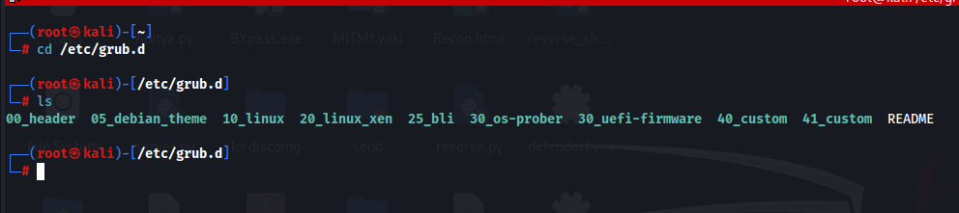

**How to protect the GRUB?**

GRUB is not insecure by mistake, it's insecure by assumption — the assumption that you are in control of physical access and security settings. That’s why, in cybersecurity, you must explicitly secure it.

**So What Should a Cybersecurity Professional Do?**

1. Set a GRUB password → to prevent editing boot options.
2. Use Full Disk Encryption → GRUB can't access real content without a key.
3. Disable USB boot + Set BIOS password → avoid physical bypass.
4. Use Secure Boot (if supported) → bootloader & kernel verification.
5. Monitor /boot and GRUB files → integrity check (Tripwire, AIDE).

**Protecting GRUB:**

**Set a GRUB password:**

**What Is Vulnerable by Default?**

By default, anyone with physical access can:

* Press e at the GRUB menu → edit boot parameters.
* Add:

init=/bin/bash

gain **root access** without a password.

This means they can:

* Reset root passwords.
* Disable security modules (e.g., selinux=0).
* Access encrypted volumes (if not fully protected).

**Steps to protect:**

Generate a Secure GRUB Password Hash: use the command “grub-mkpasswd-pbkdf2”

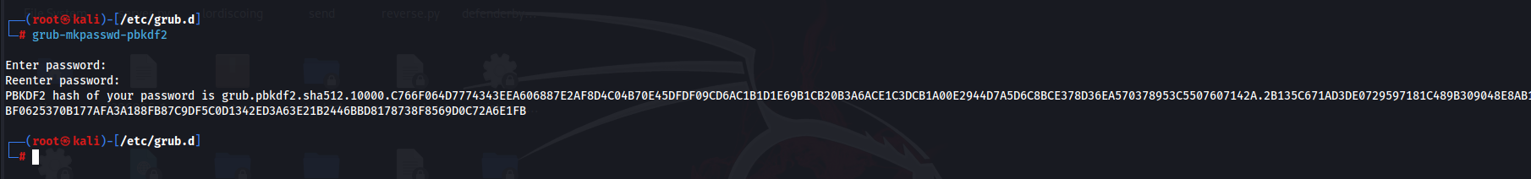

Edit GRUB’s Custom Script File: use sudo nano /etc/grub.d/40_custom, following screen will appear:

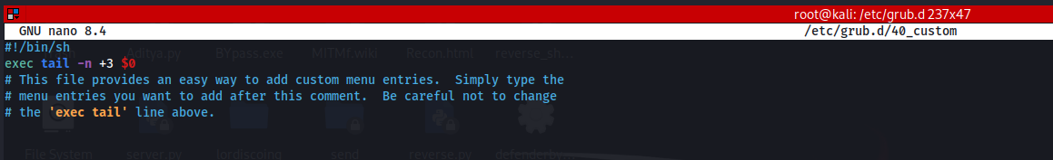

Add these lines there:

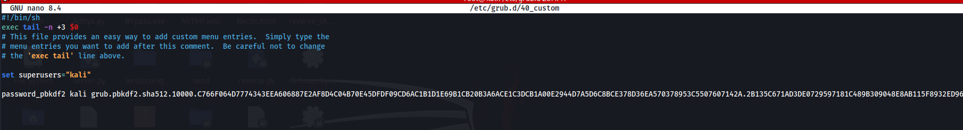

Then update the GRUB: use the command “update-grub”

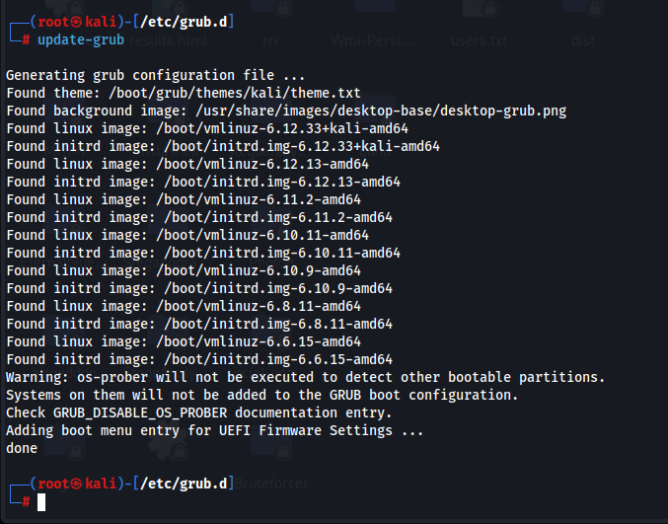

--The End--