**Day 29**

**Exploitation Analyst**

**Security Patching:**

**What is Security Patching in Ubuntu?**

Security patching means applying security updates released by Ubuntu to fix vulnerabilities in packages like OpenSSL, Apache, kernel, etc.

* These updates are published in dedicated security repositories.
* Keeping them enabled and up to date is essential for hardening a system against known exploits (e.g., buffer overflows, privilege escalation)

**Role of /etc/apt/sources.list**

This file tells apt where to fetch updates/packages from — including:

| **Repo Type** | **Purpose** |
| --- | --- |
| main | Official supported packages |
| universe | Community-maintained packages |
| security | Security patches for core packages |
| updates | Bug fixes and minor updates |

To enable security patching, your /etc/apt/sources.list must include the security repo.

To decide what to add we need to know the codename for the ubuntu. For which we can use the command: lsb_release -c

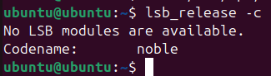

Clearly the code name is ‘noble’. Now, we can configure it further to make things happened smoothly.

**Sample /etc/apt/sources.list With Security Patching:**

Open the sources.list using the “nano” command:



Following screen will appear:

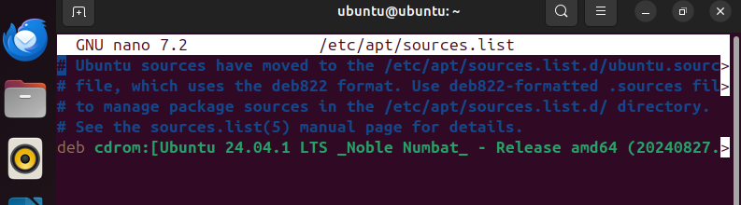

Paste the text as shown below: then save the buffer and exit.

# Main Ubuntu repository

deb http://archive.ubuntu.com/ubuntu noble main restricted universe multiverse

# Updates (non-security)

deb http://archive.ubuntu.com/ubuntu noble-updates main restricted universe multiverse

# Security updates

deb http://security.ubuntu.com/ubuntu noble-security main restricted universe multiverse

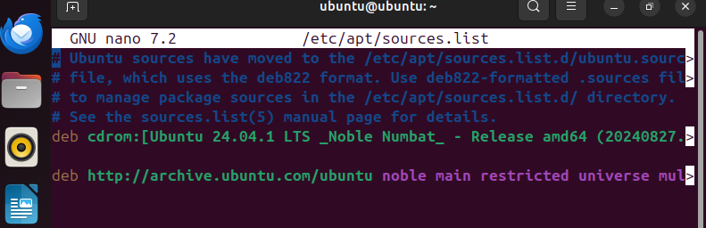

Then update and apply the patches:



**What we changed above?**

Before editing the /etc/apt/sources.list, your system was getting general updates but not guaranteed security patches. By adding the noble-security entries, you enabled a dedicated security channel that delivers faster and targeted fixes for vulnerabilities. This ensures your system stays protected from known threats and follows proper cybersecurity hardening practices.

--The End--