**Day 34**

**Exploitation Analyst**

**User Management and PAM:**

**Enforce strong password:**

**Why Enforcing strong password is important?**

Enforcing strong passwords is important because it significantly reduces the risk of unauthorized access to systems and sensitive data. Weak passwords can be easily guessed, cracked through brute force, or obtained via phishing, giving attackers direct entry into accounts. Strong passwords—long, complex, and unique—make such attacks far more difficult and time-consuming, increasing overall security, protecting user privacy, and helping organizations comply with security regulations and best practices.

**Working to enforce the strong password:**

Steps:

Install this library: libpam-pwqualty

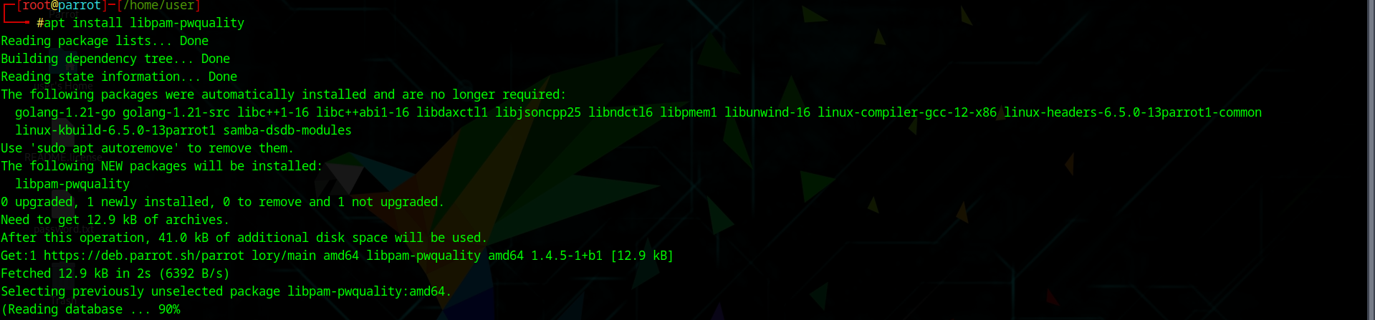

Once it get installed open the /etc/security/pwquality.conf using the nano editor:

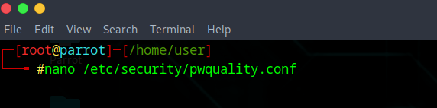

Following screen will appear: Edit as per the policy.

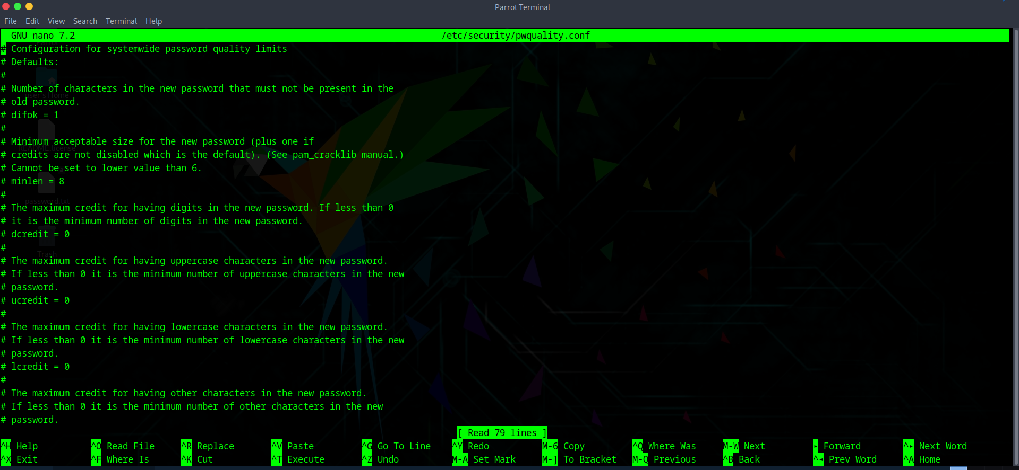

Then open the /etc/pam.d/common-password using the nano text editor:

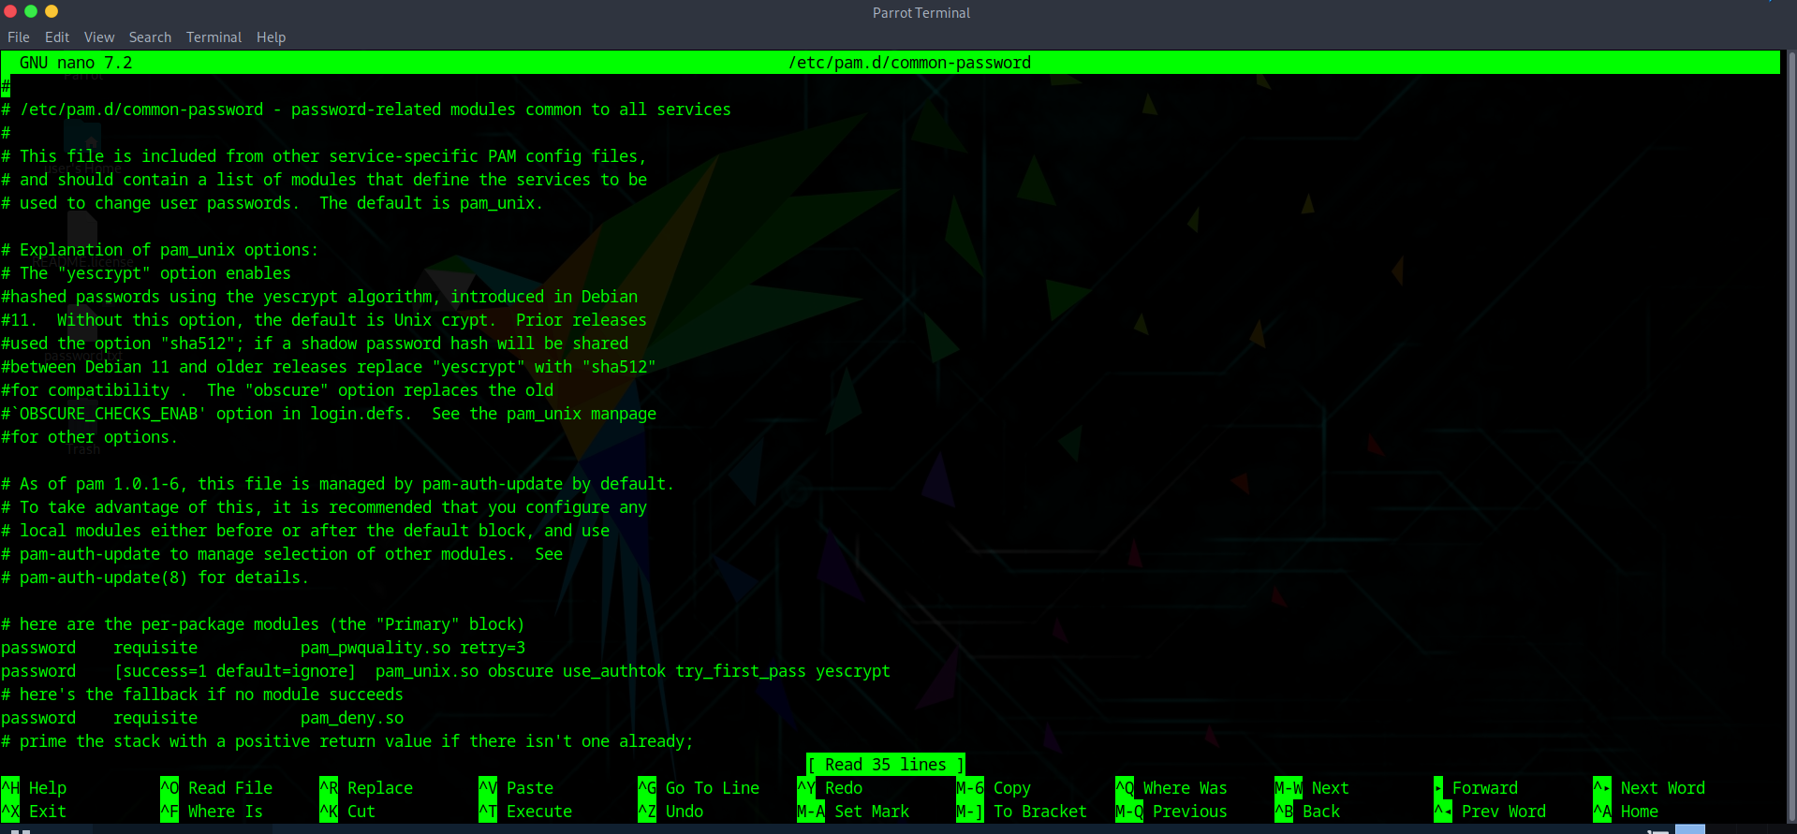

You can see this, line there telling that to change password maximum number of tries allowed is 3 only.



Then, just try to change the a user password and test:

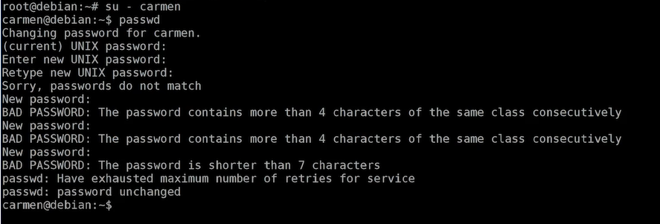

**But what actually happens in the background?**

When you edit **/etc/security/pwquality.conf** and **/etc/pam.d/common-password**, you are configuring how PAM (Pluggable Authentication Modules) enforces password strength during creation or change. When a user sets a password, PAM runs the common-password stack, which calls the pam_pwquality.so module. This module reads global rules from pwquality.conf and any inline settings in common-password, then checks the password for length, character variety, blacklist words, similarity to the username, and patterns like sequences or repetitions. If the password meets all criteria, it’s passed to the hashing module (pam_unix.so), salted, hashed, and stored in /etc/shadow; if not, PAM rejects it and prompts the user to retry. Without common-password referencing pam_pwquality.so, the rules in pwquality.conf are ignored.

--The End--