**Day 37**

**Exploitation Analyst**

**User Management and PAM:**

**/etc/securetty – Root Login Control**

* **Purpose:**  
  Defines which TTY (terminal devices) the root user is allowed to log in from.
* **Before Editing:**  
  Contains entries like tty1, tty2, etc. → Root can log in locally at those consoles (e.g., physical console or Ctrl+Alt+F1..F6).
* **After Editing (empty file or removed):**  
  Root cannot log in directly from any console.  
  Root can still be accessed indirectly via su or sudo from another account.
* **Important Notes:**
  + Does not affect SSH logins (that is handled by /etc/ssh/sshd_config).
  + Removing or commenting out entries disables root login on those specific terminals.

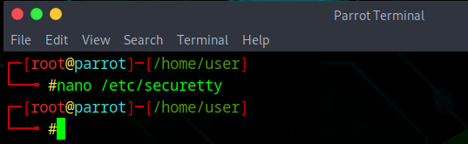

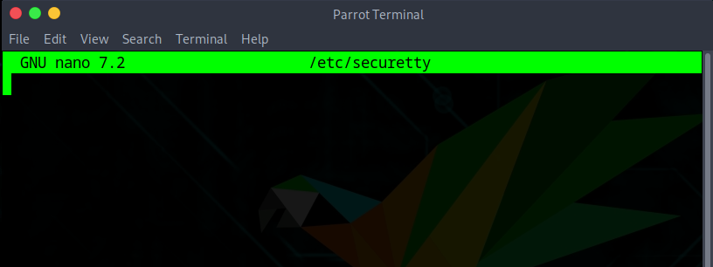

**Why keeping /etc/securetty empty is a good idea**

* **Security Principle:** Prevents root from logging in directly on any local terminal (console).
* **Benefit:**
  + Forces administrators to log in as a normal user first and then elevate with sudo or su.
  + Adds an extra barrier against unauthorized access if someone gains physical access to the machine.
* **Impact:**
  + Reduces attack surface by removing direct root logins.
  + Root account is still usable indirectly via privilege escalation, so system management is not blocked.
* **Conclusion:** Keeping /etc/securetty empty enforces the **principle of least privilege** and improves security by disabling direct root console access.

--The End--