**Day 44**

**Exploitation Analyst**

**Firewalls and TCP wrappers:**

**Fail2ban client command:**

**What is Fail2ban-client?**

fail2ban-client is the command-line tool used to interact with the Fail2ban service. It lets you check status, manage jails, and control bans without directly editing configs or restarting services. For example:

* fail2ban-client status → shows all active jails.
* fail2ban-client status sshd → shows details of the SSH jail (like banned IPs).
* fail2ban-client set sshd banip <IP> → manually ban an IP.
* fail2ban-client set sshd unbanip <IP> → unban an IP.
* fail2ban-client reload → reload rules without restarting Fail2ban.

**Exploring Fail2ban client command:**

Steps:

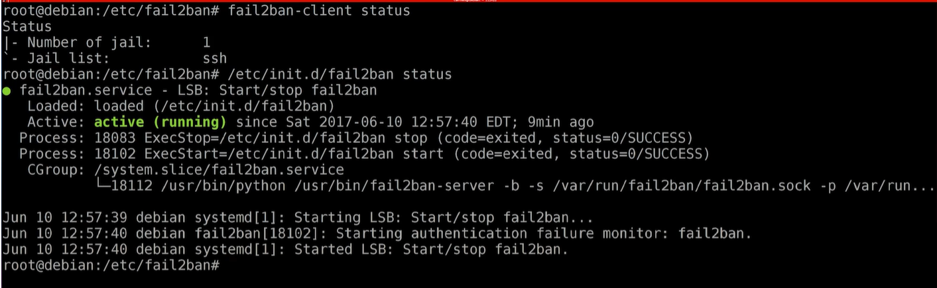

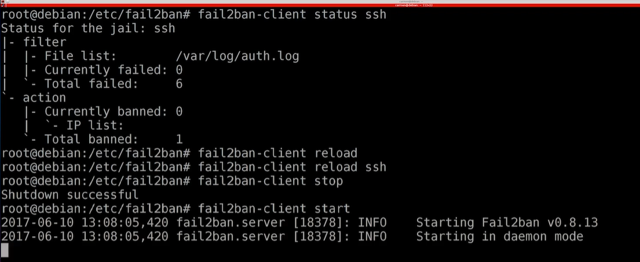

--The End--