**Day 46**

**Exploitation Analyst**

**Firewalls and TCP wrappers:**

**Lynis Audit Tool:**

**What is Lynis Audit tool?**

Lynis is an open-source security auditing tool for Linux and Unix systems. It scans the system to check for misconfigurations, vulnerabilities, and compliance issues. Lynis evaluates things like:

* Installed software and packages
* File permissions and authentication settings
* Firewall, SSH, and logging configuration
* Security hardening opportunities

It’s useful for penetration testers, system administrators, and auditors to quickly assess a system’s security posture and get recommendations for hardening.

**Exploring Lynis Audit Tool:**

Steps:

Command:

sudo lynis audit system

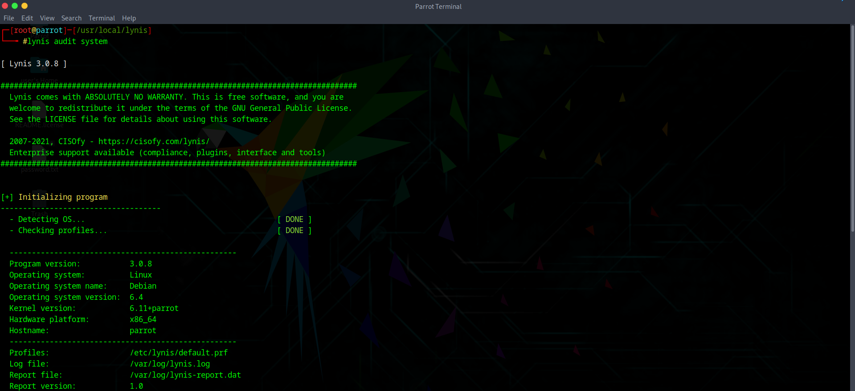

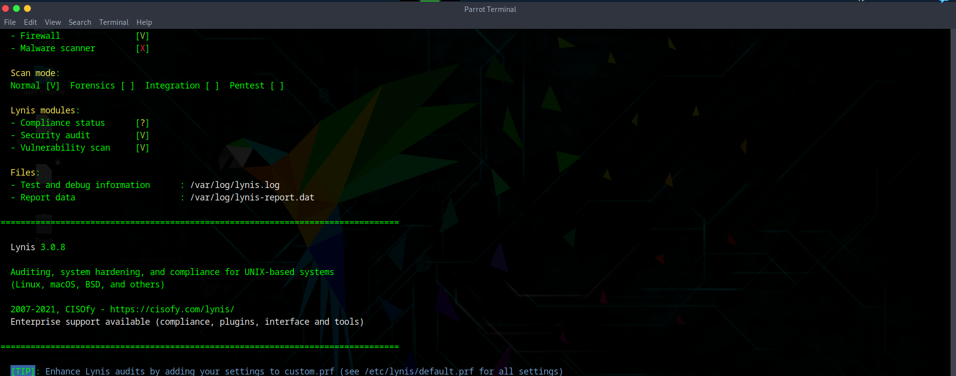

This will scan your machine and generate a report with warnings, suggestions, and hardening tips.

Now, open the report:

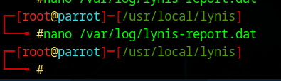

Following screen will appear: the report is ready.

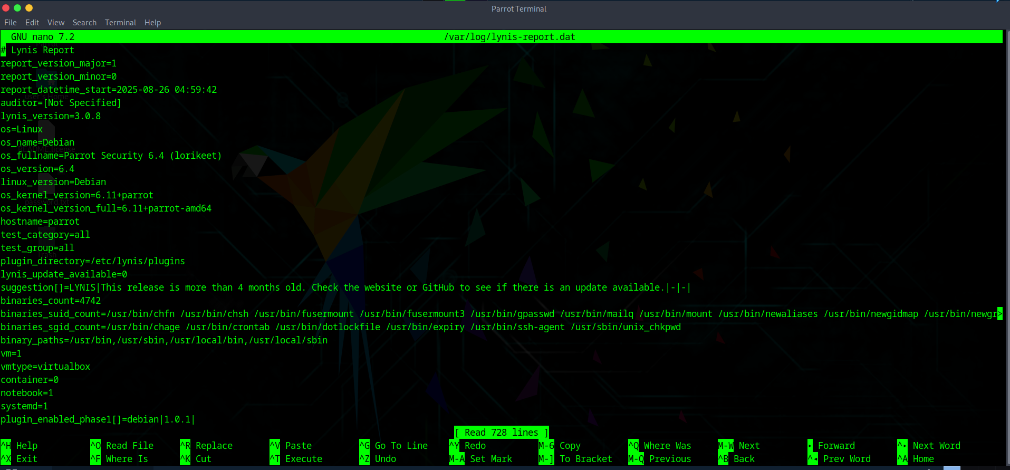

--The End--