**Day 47**

**Exploitation Analyst**

**Auditing and Virus Scan:**

**Virus Scanning - Clamav:**

**What is Clamav?**

ClamAV is an open-source antivirus engine used to detect malware, viruses, trojans, and other malicious threats on Linux and Unix-like systems.

* It provides on-demand scanning of files and directories.
* It can also be used for email gateway scanning (checking attachments).
* Signature databases are updated regularly with freshclam.
* It’s widely used because it’s lightweight and integrates easily with mail servers and security tools.

**Where can we find this?**

Command: aptitude search clamav

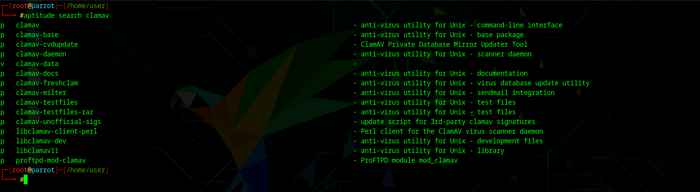

**Exploring Virus Scanning - Clamav:**

Steps:

Command : clamscan /path/to/file

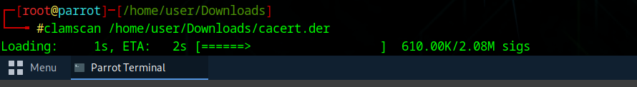

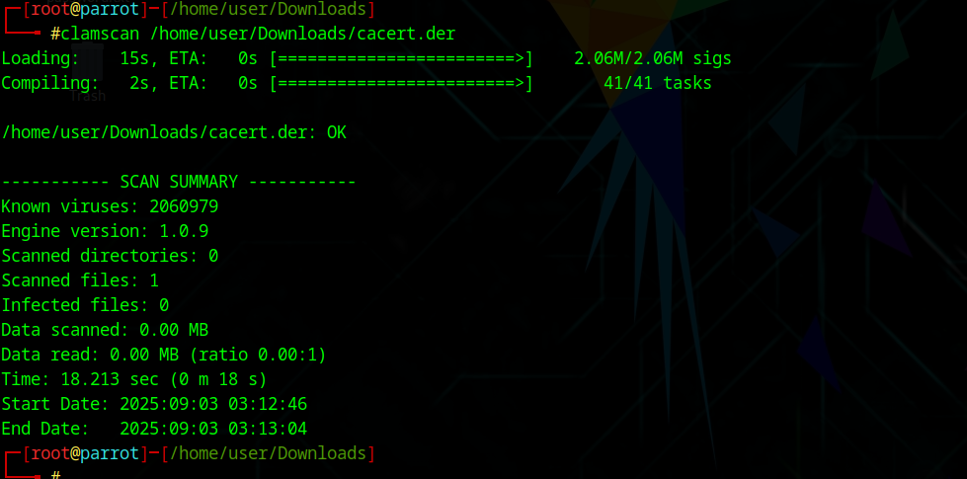

That output means your file cacert.der is clean

* ClamAV loaded ~2 million virus signatures.
* It scanned your .der file and found no infection.
* "OK" means nothing suspicious was detected.

--The End--