**Day 54**

**Exploitation Analyst**

**Patch/Update Deployment Analysis:**

AI can greatly improve Patch/Update Deployment Analysis by automating risk assessment and decision-making. It can:

* Prioritize patches by analyzing severity, exploitability, and system criticality.
* Predict impact on performance, downtime, and compatibility using past deployment data.
* Recommend scheduling by learning normal system usage to minimize disruption.
* Detect anomalies after patching (e.g., unusual logs, failed services).
* Simulate outcomes in test environments using digital twins before applying to live systems.

Steps:

Visit the Microsoft update catalog:

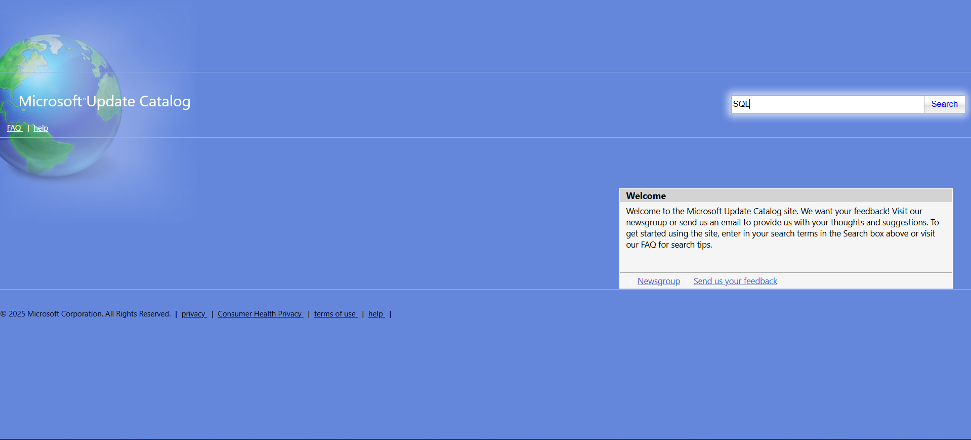

Search for any services, say SQL:

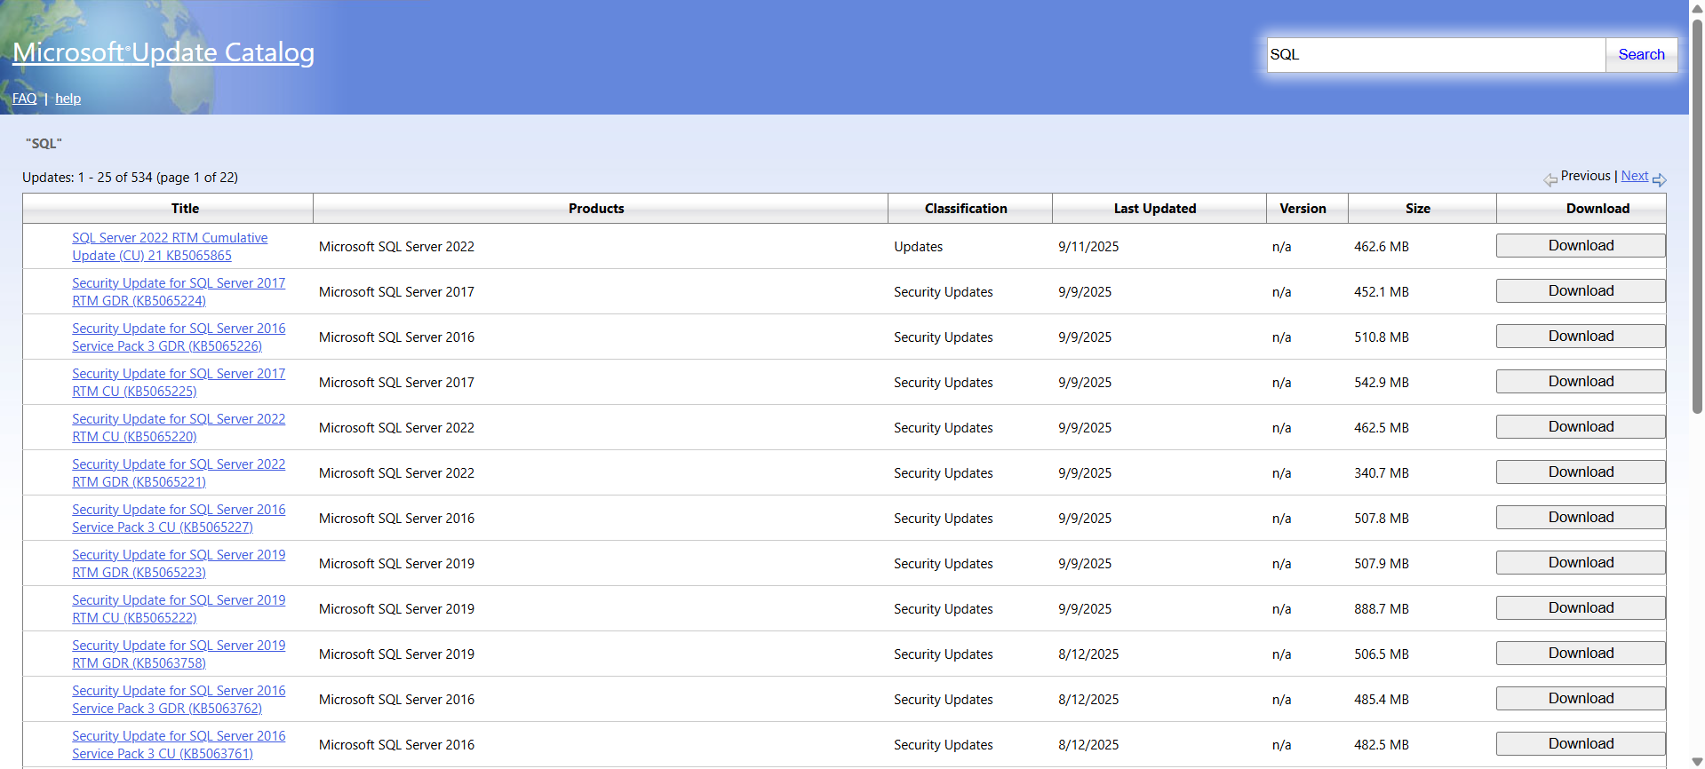

Take snap of a part of it and paste in the ChatGPT with prompt:

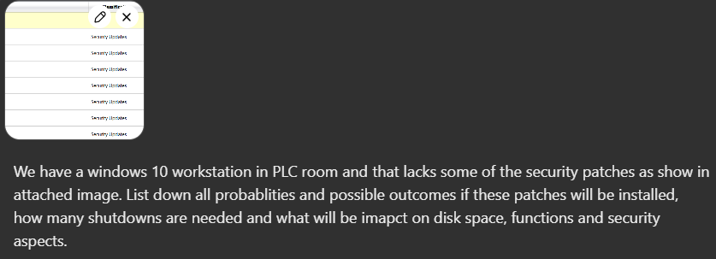

Prompt:

*We have a windows 10 workstation in PLC room and that lacks some of the security patches as show in attached image. List down all probablities and possible outcomes if these patches will be installed, how many shutdowns are needed and what will be imapct on disk space, functions and security aspects.*

Output:

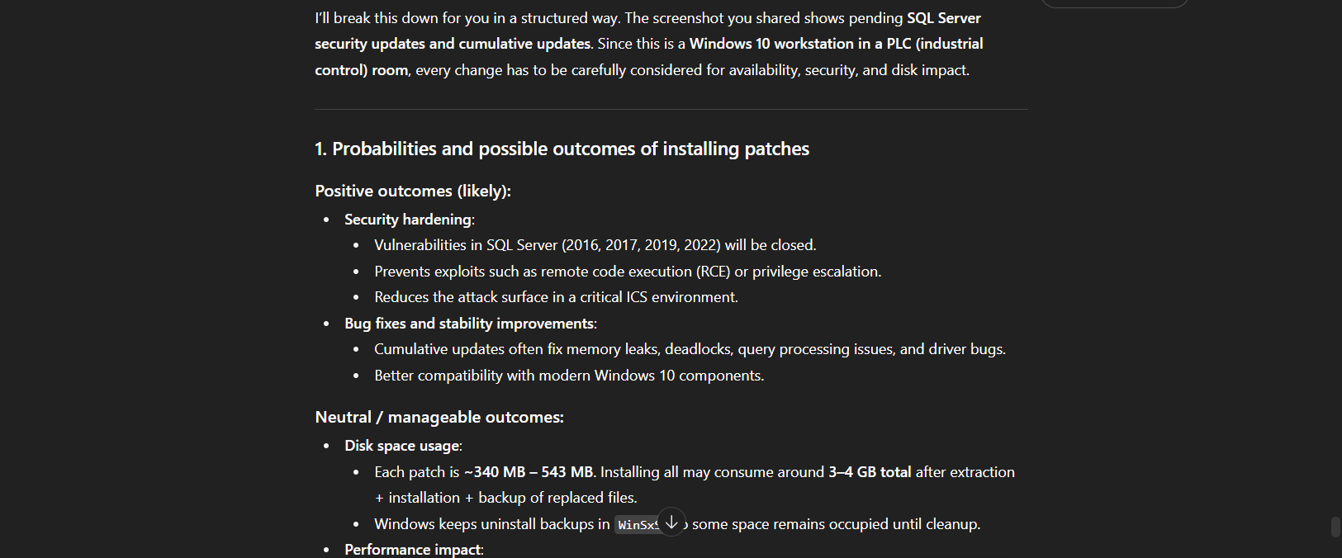

--The End--