**Day 1**

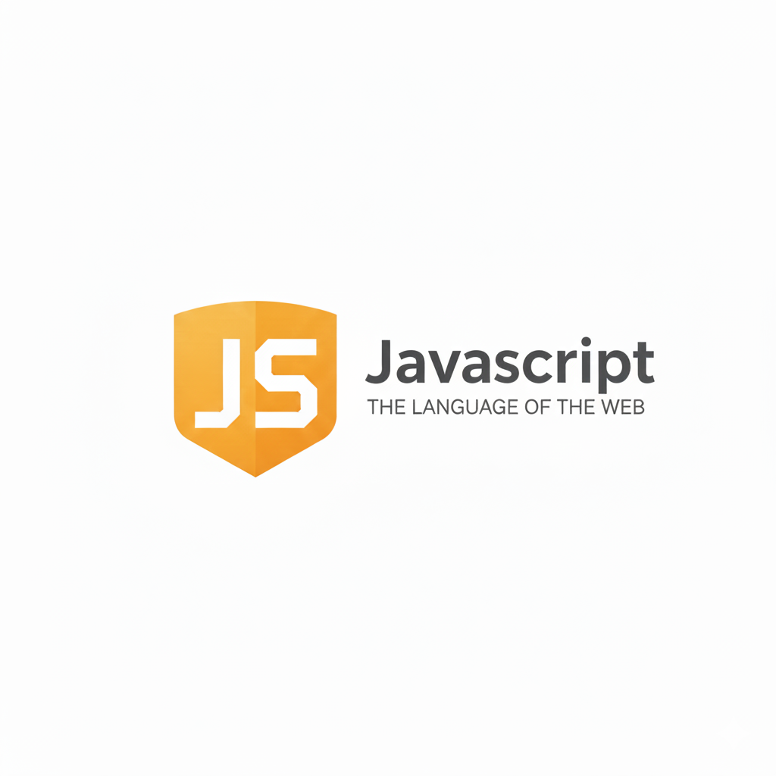

**Programming:**

**What is programming?**

Programming is the process of creating instructions that a computer can follow to perform specific tasks. It involves writing code using programming languages to solve problems, automate processes, and build applications or systems. Programmers design, test, and maintain software to make computers perform desired functions efficiently and accurately.

**JavaScript:**

**What is JavaScript?**

JavaScript is a high-level, interpreted programming language used to make web pages interactive and dynamic. It runs directly in web browsers, enabling features like animations, form validation, and real-time updates. Along with HTML and CSS, JavaScript is one of the core technologies of web development, powering both frontend and backend applications.

Here are the main features of JavaScript:

1. Lightweight and Interpreted – Executes directly in the browser without compilation.
2. Object-Oriented – Supports objects, inheritance, and encapsulation.
3. Dynamic Typing – No need to declare variable types.
4. Event-Driven – Responds to user actions like clicks or keypresses.
5. Platform Independent – Runs on any device with a browser.
6. Asynchronous and Single-Threaded – Uses callbacks, promises, and async/await for non-blocking operations.
7. Client-Side and Server-Side Support – Works in browsers and with Node.js on servers.
8. Prototype-Based – Inheritance is achieved through prototypes, not classes.

**What is Node.js?**

Node.js is an open-source, cross-platform runtime environment that allows developers to run JavaScript outside of a web browser. It uses the V8 JavaScript engine (from Google Chrome) to execute code efficiently. Node.js is widely used for building fast, scalable server-side applications, APIs, and real-time web services like chat apps.

**Variables in JavaScript:**

**What is a variable?**

A variable lets you store, use, and modify data in your code.

**Syntax:**

let name = "Aditya";

**Ways to Declare Variables:**

1. **var** – old method (function-scoped)
2. **let** – modern way (block-scoped, recommended)
3. **const** – for values that shouldn’t change

| **Feature / Keyword** | **var** | **let** | **const** |
| --- | --- | --- | --- |
| **Scope** | Function-scoped | Block-scoped | Block-scoped |
| **Redeclaration** | Allowed | Not allowed in the same scope | Not allowed |
| **Reassignment** | Allowed | Allowed | **Not allowed** (value fixed) |
| **Hoisting** | Yes (initialized as undefined) | Yes (but not initialized) | Yes (but not initialized) |
| **Default Value** | undefined | undefined | Must be initialized at declaration |
| **Use Case** | Older code, or function-wide variables | Modern code, variables that change | Constants or values that never change |
| **Example** | var x = 10; | let y = 20; | const z = 30; |

**Rules for writing the variable:**

| **Rule** | **Explanation** | **Example** |
| --- | --- | --- |
| **1. Must start with a letter, underscore (_), or dollar sign ($)** | Variable names cannot start with a number. | let name = "Aditya";, let _age = 20;, let $price = 100;, let 1name = "John"; |
| **2. Can contain letters, numbers, underscores, or dollar signs** | But cannot include spaces or special characters. | let user1 = "Aman";, let user-name = "Aman"; |
| **3. Case-sensitive** | age and Age are treated as two different variables. | let age = 18;, let Age = 25; |
| **4. Cannot use JavaScript reserved keywords** | Words like var, let, for, if, function etc. cannot be variable names. | let for = 10; |
| **5. Should be meaningful** | Choose names that describe the stored value clearly. | let userName = "Aditya";, let x = "Aditya"; |
| **6. Use camelCase for multi-word names** | Common JavaScript naming convention. | let totalAmount = 500; |

Example: first code/ declaring variables

