**Day 2**



**Operators and Expressions:**

**What Are Operators and Expressions?**

* Operators are symbols that perform operations on values and variables.
* Expressions are combinations of values, variables, and operators that produce a result

**Types of operators:**

| **Category** | **Description** | **Example** |
| --- | --- | --- |
| **1. Arithmetic Operators** | Perform mathematical operations. | +, -, *, /, %, **, ++, -- |
| **2. Assignment Operators** | Assign values to variables. | =, +=, -=, *=, /=, %= |
| **3. Comparison Operators** | Compare two values and return a boolean. | ==, ===, !=, !==, >, <, >=, <= |
| **4. Logical Operators** | Combine or invert conditions. | &&, ` |
| **5. Bitwise Operators** | Work on binary representations. | &, ` |
| **6. String Operators** | Used to combine strings. | +, += |
| **7. Ternary Operator** | Short form of if-else condition. | condition ? value1 : value2 |
| **8. Type Operators** | Used to check or convert types. | typeof, instanceof |

Arithmetic operator:

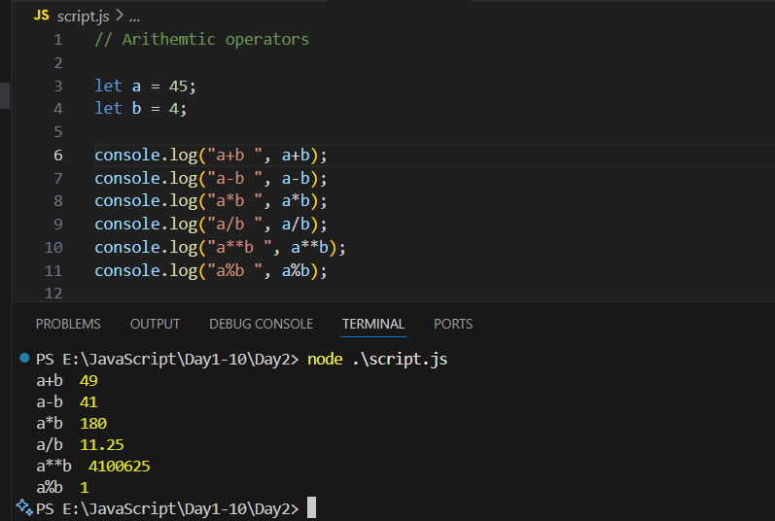

Increment operator and decrement operator:

Example: a++

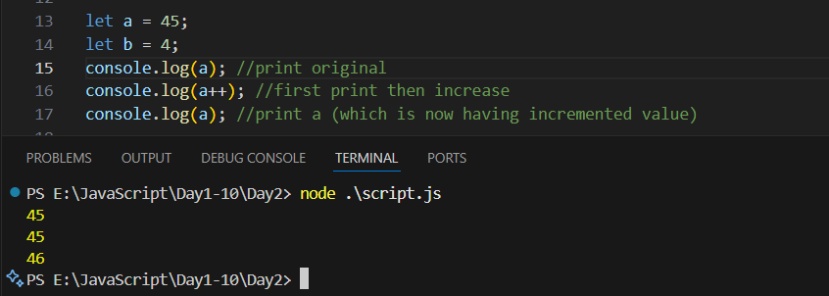

Example: ++a  
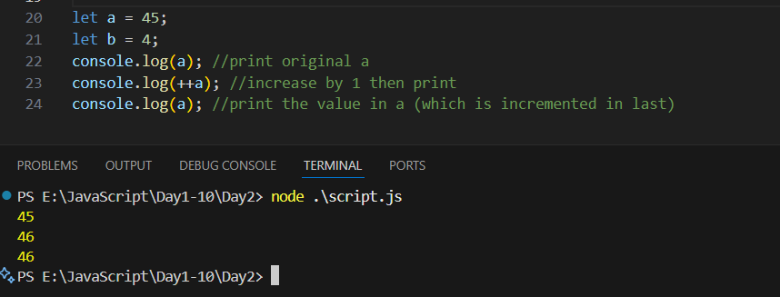

Example: b—

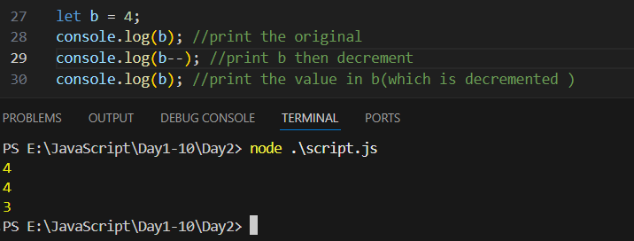

Example: --b

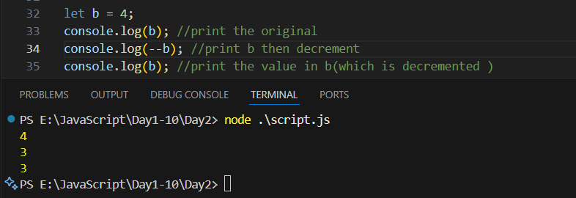

So, basically:

| **Type** | **Syntax** | **Meaning** | **Example** |
| --- | --- | --- | --- |
| **Pre-increment** | ++x | Increases the value **before** using it in an expression. | let y = ++x; |
| **Post-increment** | x++ | Increases the value **after** using it in an expression. | let y = x++; |
| **Pre-decrement** | --x | Decreases the value **before** using it. | let y = --x; |
| **Post-decrement** | x-- | Decreases the value **after** using it. | let y = x--; |

Assignment operator:

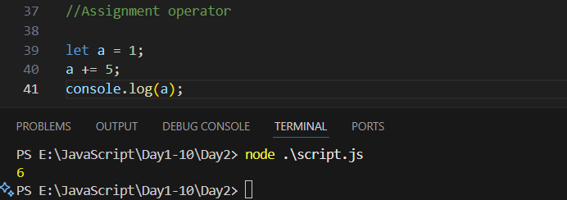

Comparison operator:

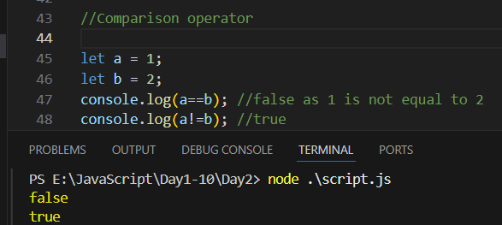

Comparison operator: === (strict equality) and !== (strict inequality)

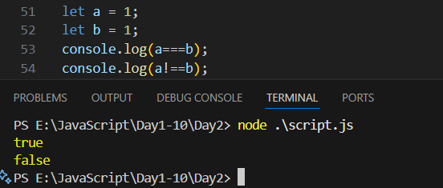

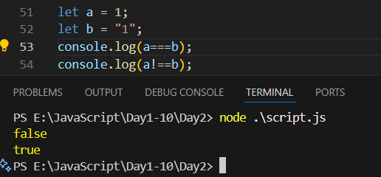

Logical operator:

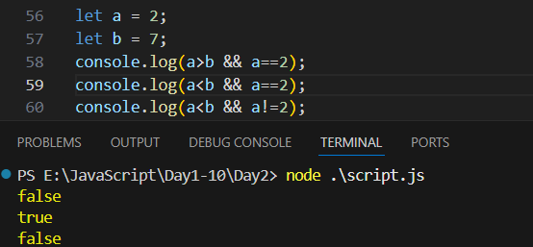

**What are Comments in JavaScript?**

Comments are notes written inside the code that the JavaScript engine ignores during execution.  
They are used to explain code, make it readable, or temporarily disable parts of code.

**Types of Comments in JavaScript**

| **Type** | **Syntax** | **Description** | **Example** |
| --- | --- | --- | --- |
| **Single-line Comment** | // | Used for short notes on a single line. | // This is a single-line comment |
| **Multi-line Comment** | /* ... */ | Used for longer explanations or to comment multiple lines. | /* This is a multi-line comment */ |

Example:

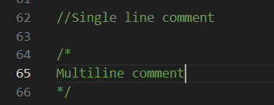

--The End--