**Day 3**

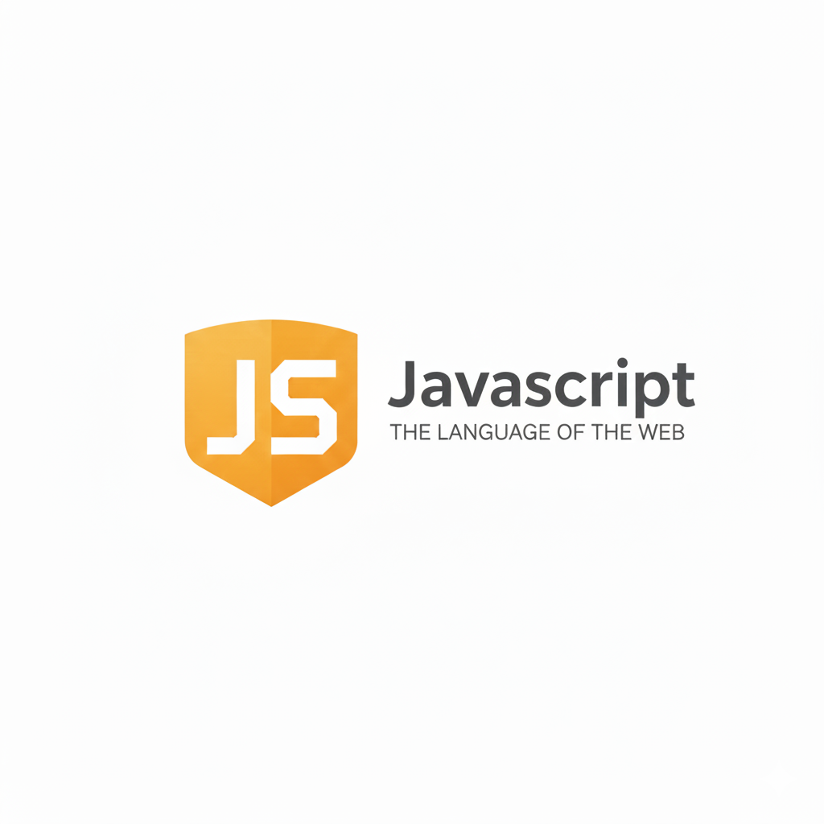

**Conditional expressions in JavaScript:**

**What are Conditional Expressions in JavaScript?**

Conditional expressions are used to make decisions in a program. They allow your code to execute different actions based on conditions (true or false).

**Basic Conditional Statements**

| **Statement** | **Description** |
| --- | --- |
| if | Executes a block of code if a condition is true. |
| if...else | Executes one block if true, another block if false. |
| if...else if...else | Tests multiple conditions, runs the first one that’s true. |
| Ternary Operator (?:) | Short form of if...else. |
| switch | Used to test one value against multiple cases. |

**Difference Between if and switch**

| **Feature** | **if / else** | **switch** |
| --- | --- | --- |
| **Use Case** | For range or complex conditions | For fixed, specific values |
| **Data Type** | Can compare any expressions | Works best with fixed values |
| **Speed** | Slower with many conditions | Faster for fixed comparisons |
| **Example** | if (x > 5) | switch(x) |

Example: how to take user input? We will use “Prompt” to do so.

Code:

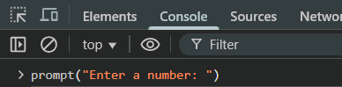

Output:

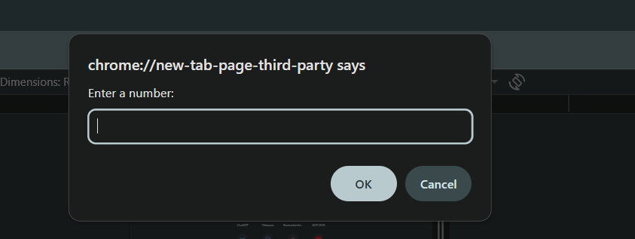

By default, value entered in the prompt will be treated as a string. We can prove it using the “typeof” as shown below:

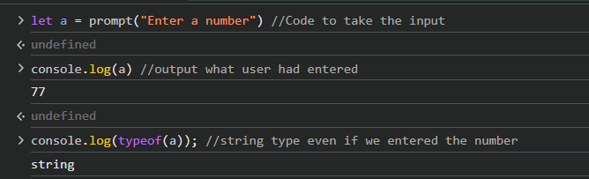

Now, we want to convert this string to numberic type then we will use “parseInt” as shown below:  
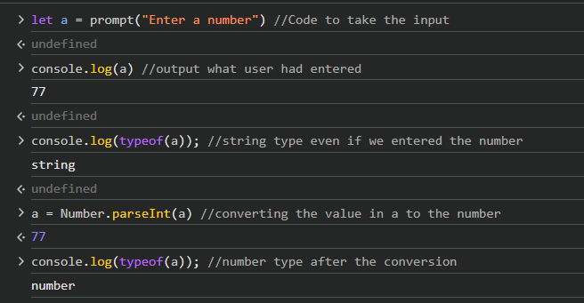

Now, coming to the conditionals:

Example: if statement

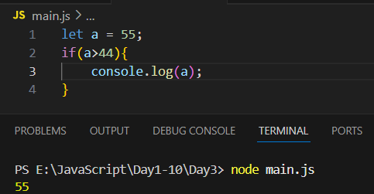

Example: if else statement

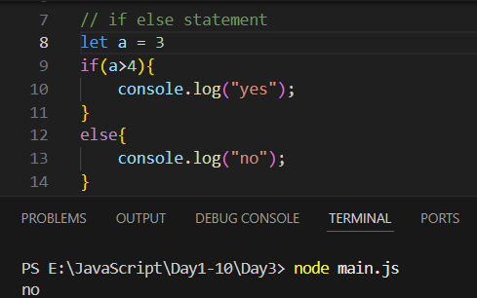

Example: if else if else statement

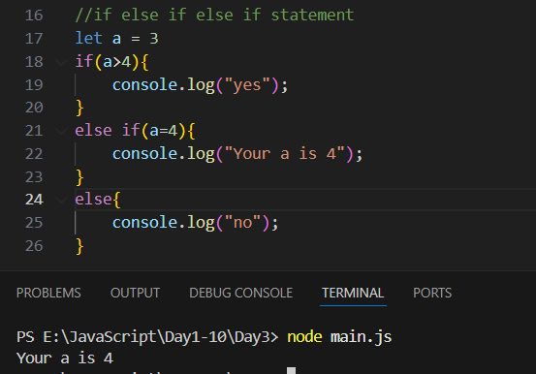

Example: ternary operator

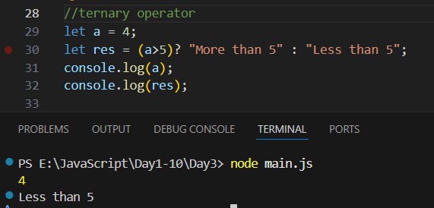

Example: switch and prompt and parseInt

