**Day 4**

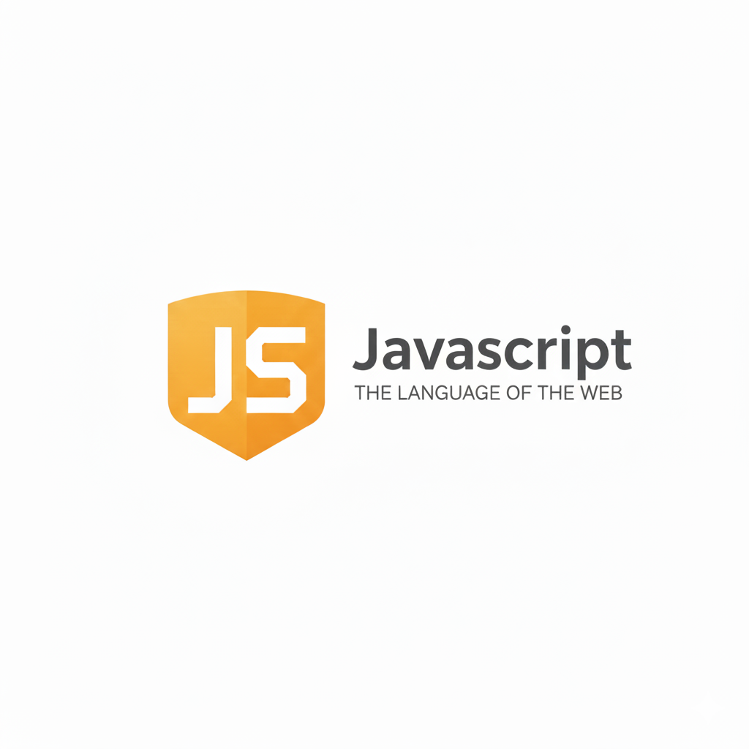

**For loops in JavaScript:**

**What are Loops in JavaScript?**

Loops are used to repeat a block of code as long as a specific condition is true.  
They help reduce repetition and make code more efficient.

**Types of Loops in JavaScript**

| **Loop Type** | **Description** | **Common Use Case** |
| --- | --- | --- |
| for | Runs a block of code a specific number of times. | When you know how many times to loop. |
| while | Repeats code while a condition is true. | When you don’t know how many times to loop. |
| do...while | Runs code once, then repeats while condition is true. | When you want to run the loop at least once. |
| for...in | Loops through object properties (keys). | Used with objects. |
| for...of | Loops through iterable values (arrays, strings, etc.). | Used with arrays or strings. |

**What is a for Loop in JavaScript?**

A for loop is used to run a block of code multiple times — automatically and efficiently.  
It is one of the most common looping structures in JavaScript.

Syntax:

*for (initialization; condition; update) {*

*// code to be executed repeatedly*

*}*

Example: a basic for loop to print 0 to 4

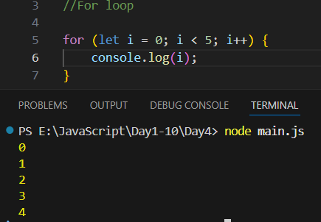

Example: a basic for loop to print from 0 to 5 with the same above code

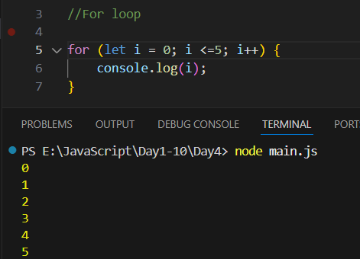

Example: to print from 1 to 5

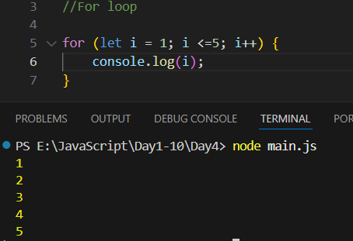

Example: what if we wrote i+1 in 6th line and i = 0 in 5th?

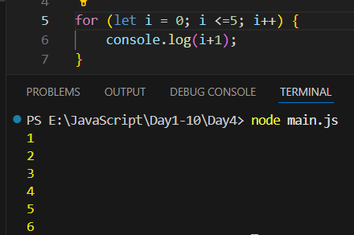

Example: sum of n natural number

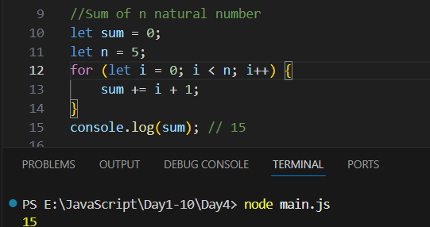

Example: sum of n natural number where n is the input from the user (say he entered 5)

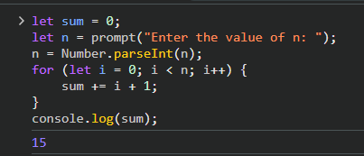

Example:

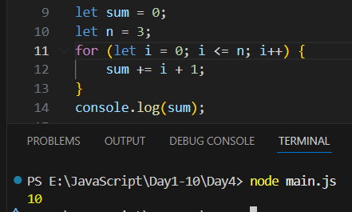

Example:

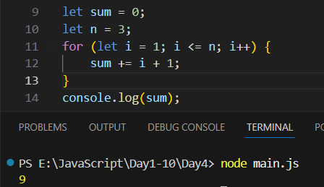

Example:

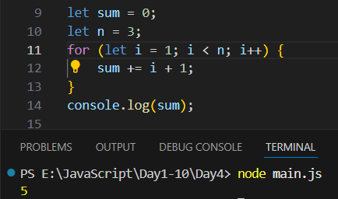

Example: factorial of 5

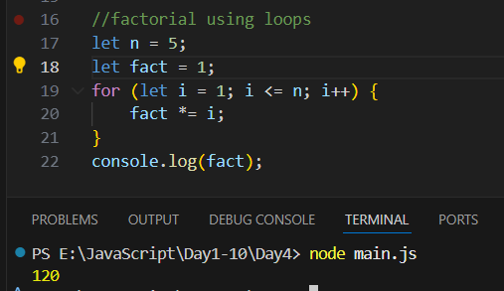

Example: for… in loop

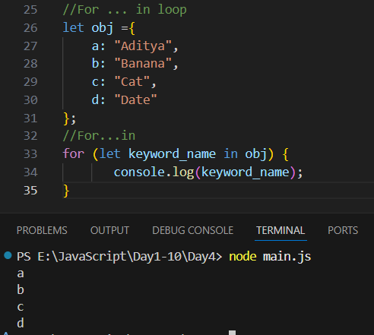

Example: to print both key and value using the for ... in loop

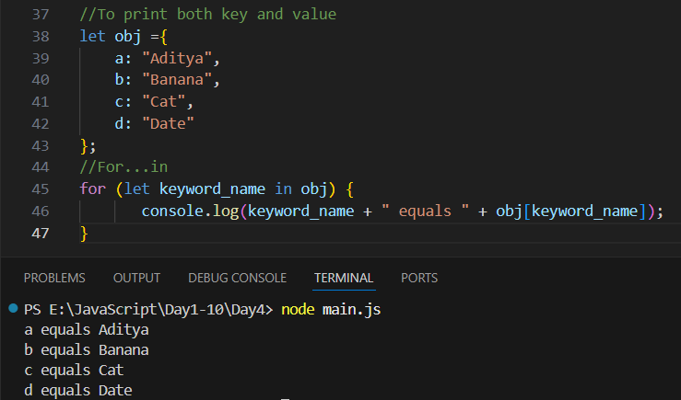

Example: for…of loop

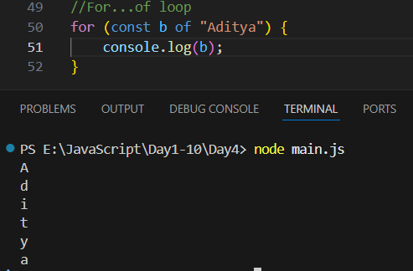

**Difference between for…in and for… of:**

| **Feature** | **for...in** | **for...of** |
| --- | --- | --- |
| Iterates over | Object keys | Iterable values |
| Works on | Objects | Arrays, Strings, Maps, Sets |
| Example | for (key in obj) | for (value of arr) |

**Best Practices**

1. Use for when the number of iterations is known.
2. Use while when the number of iterations depends on a condition.
3. Use do...while when you need at least one execution.
4. Use for...in for objects, and for...of for arrays or strings.
5. Always include a condition that stops the loop — avoid infinite loops!

--The End--