**Day 5**

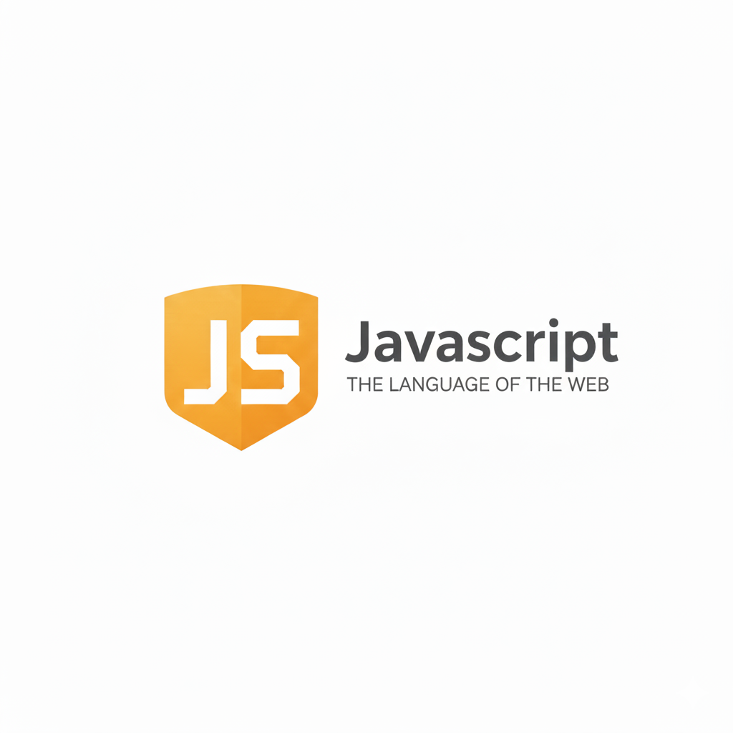

**While loops in JavaScript:**

**What is a while Loop?**

A while loop in JavaScript is used to run a block of code repeatedly as long as a given condition is true. If the condition becomes false, the loop stops running.

**Syntax**

*while (condition) {*

*// code to execute repeatedly*

*}*

| **Part** | **Meaning** |
| --- | --- |
| **condition** | The loop keeps running as long as this condition is true |
| **code block** | The statements inside {} run each time before checking the condition again |

Example: using while loop prints number from 0 to n-1

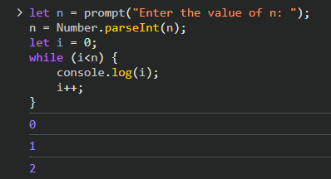

Example: to print from 0 to n

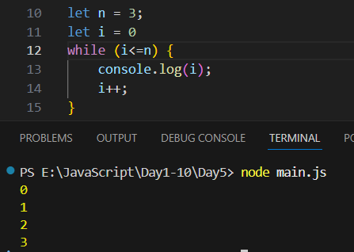

**While loops in JavaScript:**

**What is a do...while Loop?**

A do...while loop is a type of loop that executes the code block at least once, and then repeats it as long as the given condition is true.

***Note: The main difference from a while loop is that: do...while checks the condition after running the code once***.

**Syntax**

*do {*

*// code to execute*

*} while* *(condition);*

Example: printing 0 to n-1

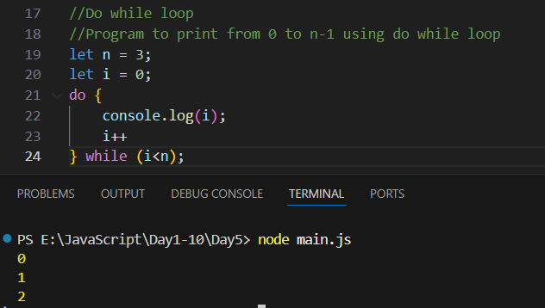

Example: printing 0 to n

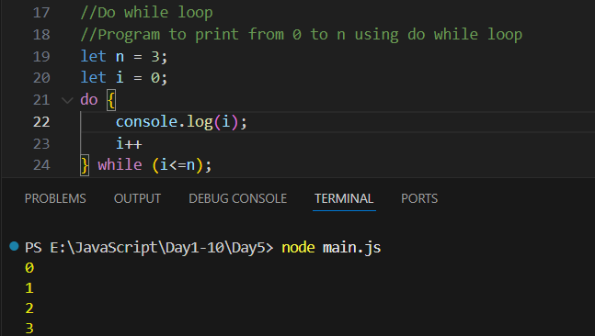

Example: here the condition doesn’t meet, so ran at least for once.

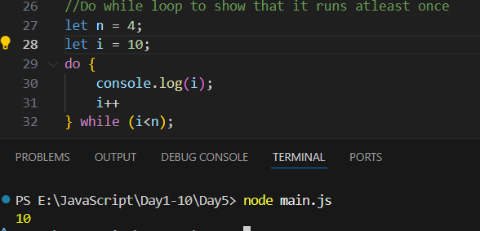

--The End--