**Day 6**

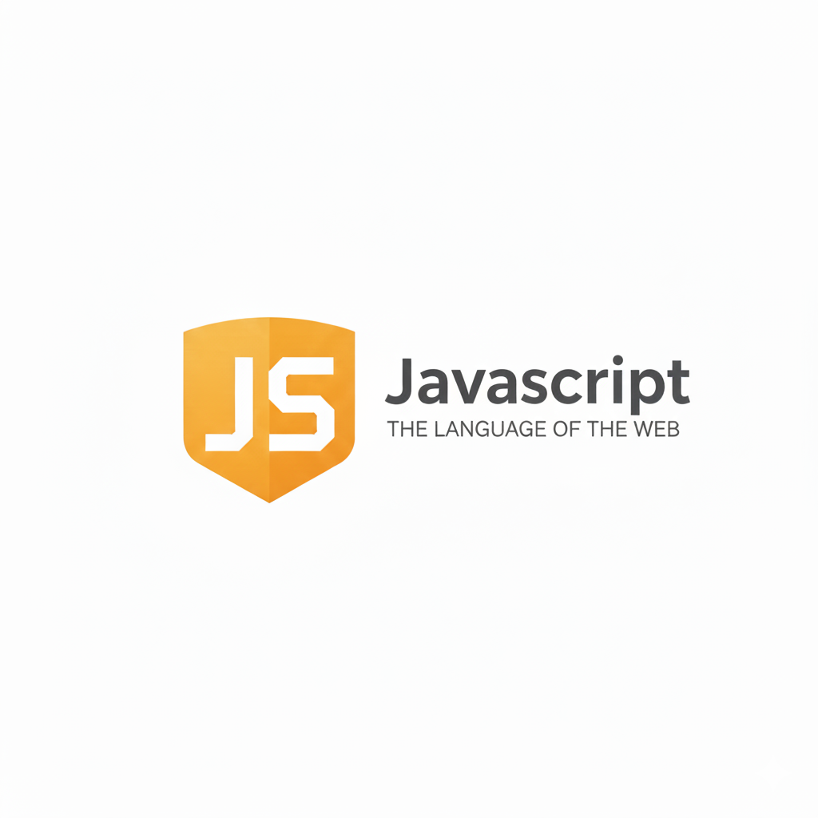

**Functions in JavaScript:**

**What is a Function?**

A function in JavaScript is a block of code designed to perform a specific task. It allows you to reuse code, make it organized, and reduce repetition.

**Syntax of a Function**

*function functionName(parameters) {*

*// code to execute*

*return value; // optional*

*}*

| **Part** | **Description** |
| --- | --- |
| function | Keyword to declare a function |
| functionName | The name of the function |
| parameters | Input values the function can take (optional) |
| return | Sends a value back to the caller (optional) |

**Types of Functions**

| **Type** | **Example** | **Description** |
| --- | --- | --- |
| **Named Function** | function add(a,b){} | Regular declared function |
| **Anonymous Function** | function(a,b){} | No name, often used in variables or callbacks |
| **Function Expression** | let sum = function(a,b){} | Function stored in variable |
| **Arrow Function** | let sum = (a,b)=>a+b | Short and modern syntax |
| **IIFE** | (function(){})() | Immediately executed once |

Example: functions with parameters

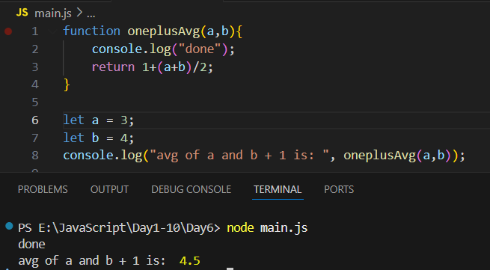

Example: functions where we passed the exact values instead of variables.

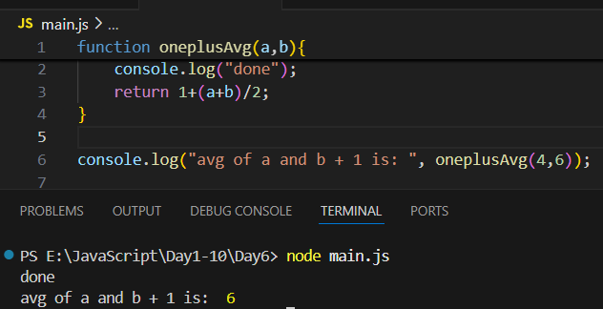

Example: use functions to print the round off for the same above code, for that we will use Math.round() as shown below

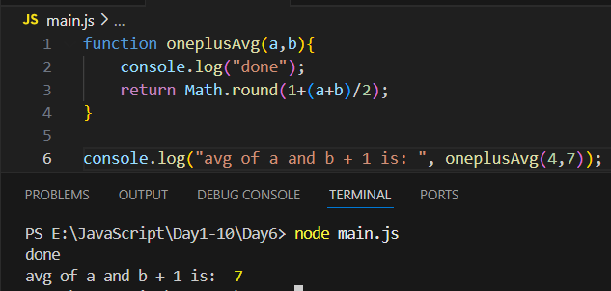

Example: now in case we don’t invoke the function, it will remain as it is, no output:

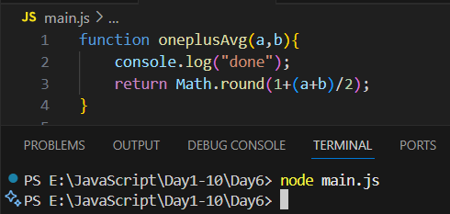

Example: functions without parameters

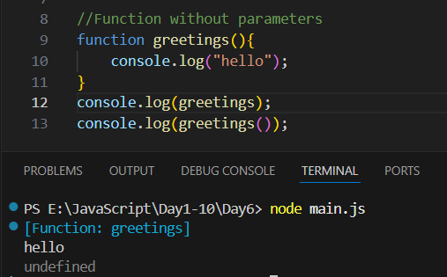

Example: functions without parameters but with return

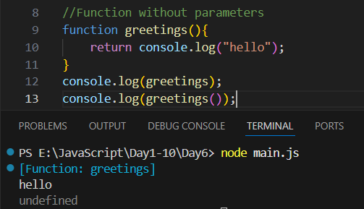

Example: same function but with parameters

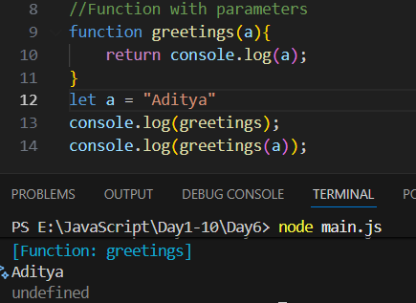

Example: same function with parameters

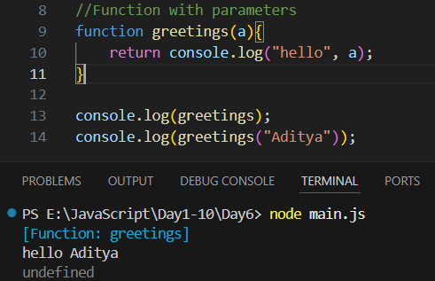

Example:

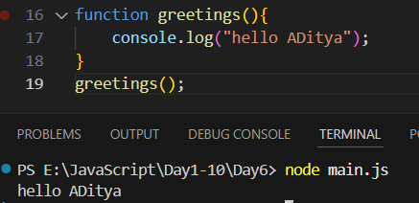

Example:

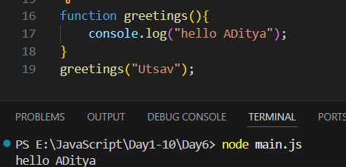

Example:

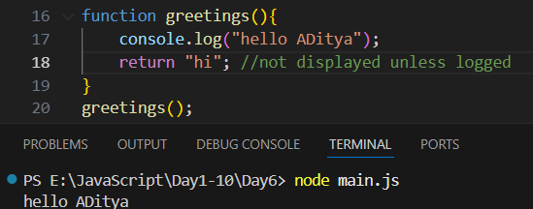

Example: arrow function in JS without any parameters

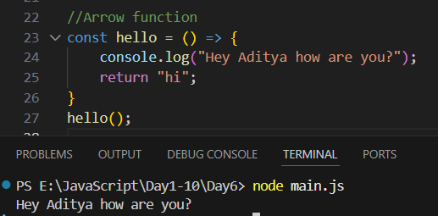

Example: arrow function with parameters

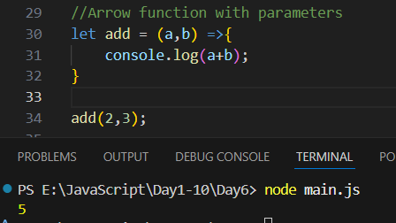

Example: arrow function with return and parameters

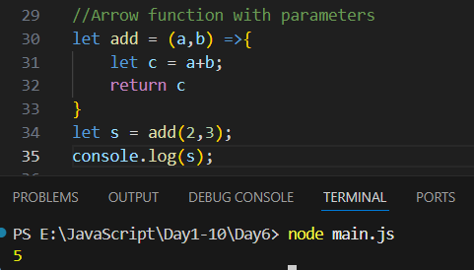

Example: arrow function with return and no parameters

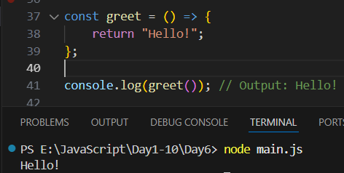

--The End--