**Day 7**

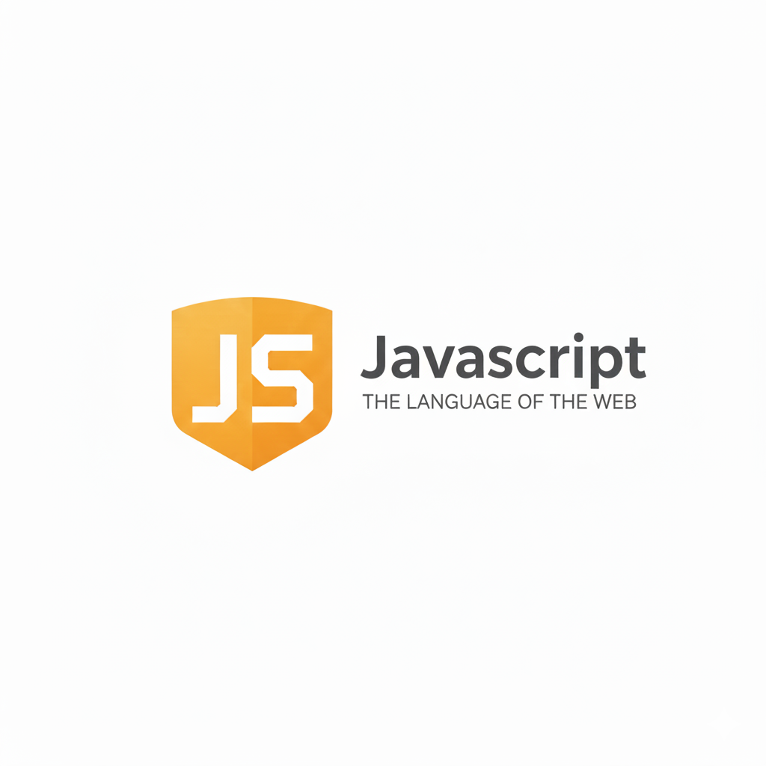

**Strings in JavaScript:**

**What is a String?**

A string in JavaScript is a sequence of characters enclosed in quotes. Strings can include letters, numbers, symbols, or spaces.

**Syntax**

*let str1 = "Hello"; // Double quotes*

*let str2 = 'World'; // Single quotes*

*let str3 = `JS`; // Backticks (Template literals)*

**Key Points**

1. Strings can be enclosed in single (') or double (") quotes.
2. Backticks ` allow template literals — embedding variables and expressions.
3. Strings are immutable — cannot change individual characters directly.

**String Methods (Basics)**

| **Method** | **Description** | **Example** |
| --- | --- | --- |
| toUpperCase() | Converts to uppercase | "hello".toUpperCase() → "HELLO" |
| toLowerCase() | Converts to lowercase | "HELLO".toLowerCase() → "hello" |
| trim() | Removes spaces from both ends | " hi ".trim() → "hi" |
| includes() | Checks if substring exists | "Hello".includes("He") → true |
| indexOf() | Returns first index of substring | "Hello".indexOf("l") → 2 |
| slice() | Extracts part of a string | "Hello".slice(1, 4) → "ell" |
| replace() | Replaces part of the string | "Hello".replace("H","J") → "Jello" |

Example: a very basic example of string, also 3 ways to declare and initialize

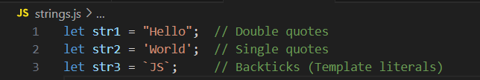

**Indexing in string:**

The string "Hello" has 5 characters: H, e, l, l, o.

| Character | H | e | l | l | o |
| --- | --- | --- | --- | --- | --- |
| Index | 0 | 1 | 2 | 3 | 4 |

Now, to get the length of the string, we uses .length:

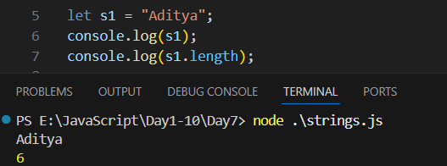

Now, to get the character as per the index value:

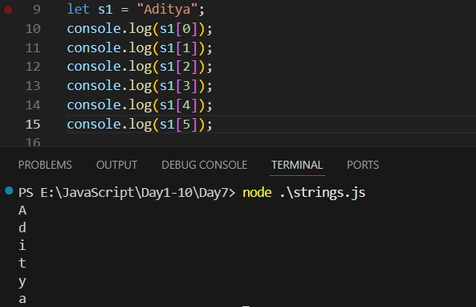

Example: index to be printed is 1 more than the length of string, then undefined is returned.

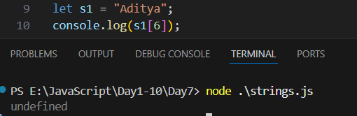

Example: string using backtick

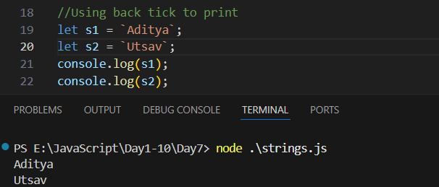

Example: printing variable in backtick, called string interpolation

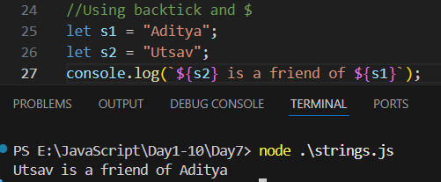

Example: template literal and quotes

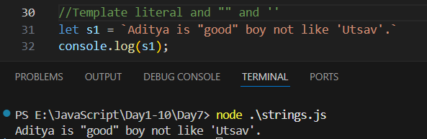

**Common Escape Sequences**

| **Escape Sequence** | **Meaning** | **Example** |
| --- | --- | --- |
| \' | Single quote | 'It\'s nice' → It's nice |
| \" | Double quote | "He said \"Hi\"" → He said "Hi" |
| \\ | Backslash | "C:\\Users\\Admin" → C:\Users\Admin |
| \n | Newline | "Hello\nWorld" → |

Example: valid writing of double and single quotes in JS without using escape sequence character

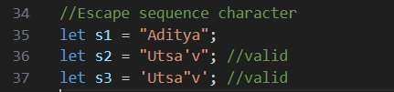

Example: using the escape sequence character

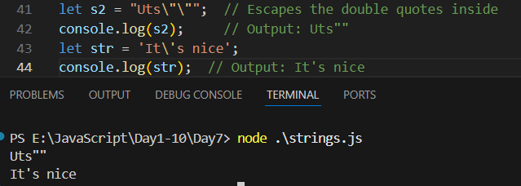

Also,

* Template literals are ES6 feature.
* Strings are 0-indexed.
* Strings are immutable.
* + operator can concatenate numbers as strings if one operand is a string.
* Multi-line strings cannot be created with single or double quotes.

Example: using + on strings

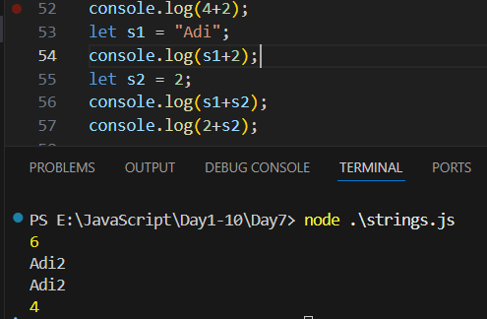

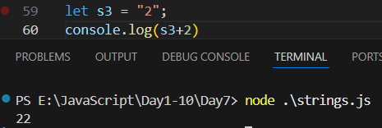

Example: strings are immutable

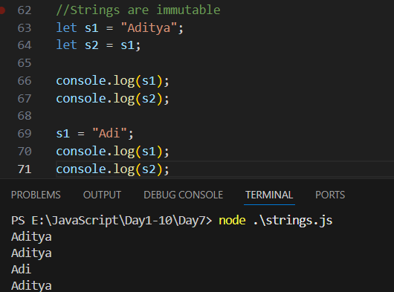

--The End--