**Day 8**

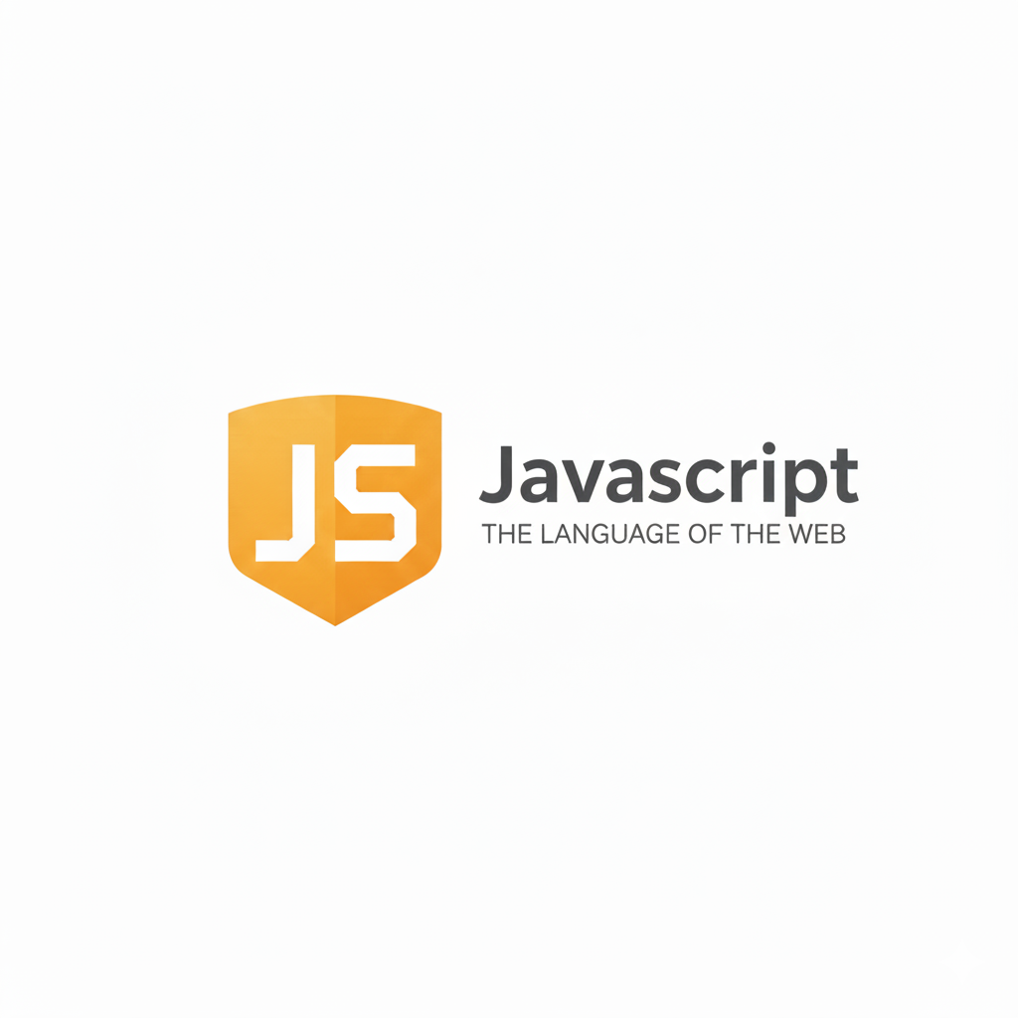

**JavaScript String Methods:**

**String Methods in JavaScript**

JavaScript provides built-in methods to work with strings. All these methods return new strings — because strings are immutable.

Example: .length -> to get the length of the string

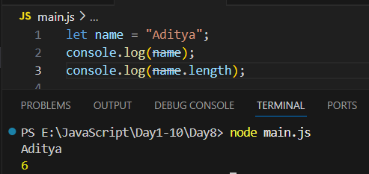

Example: escape sequence character are treated as 1 character

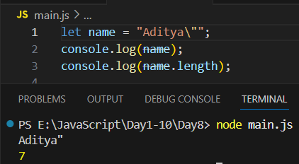

Example: .toUpperCase() to convert all characters to Upper case

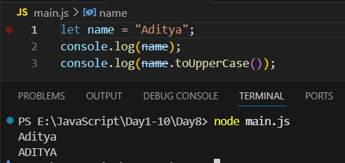

Example: .toLowerCase() to convert to lower case.

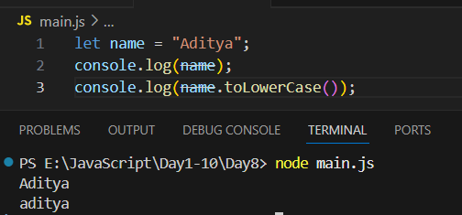

Example: .slice() -> to get the part of string

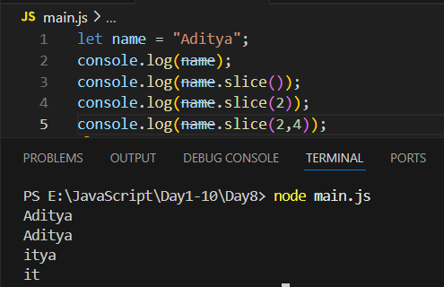

Example: .replace(old,new)

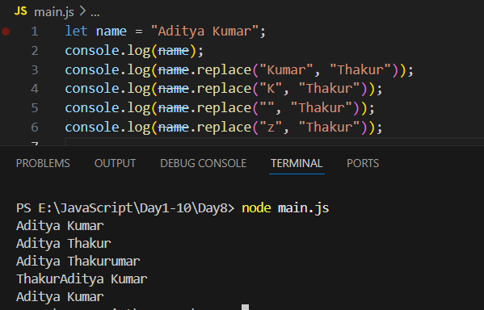

Example: .trim()

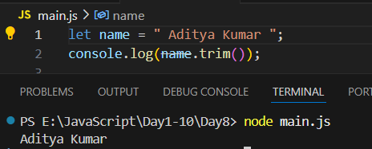

Example: .concat()

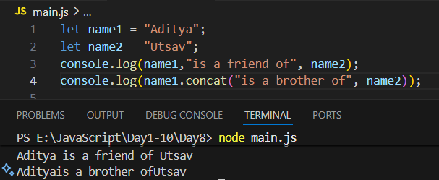

Example: using for…of loop to print character of strings

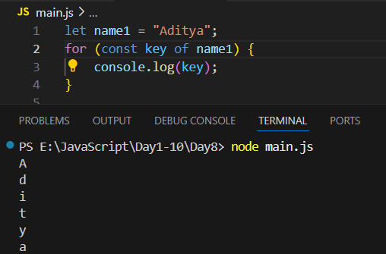

**Introduction to Arrays:**

**What is an Array?**

An Array is a special variable that can store multiple values in a single variable. Each value in an array is called an element, and each element has an index (starting from 0).

**Ways to Create Arrays**

| **Method** | **Example** | **Description** |
| --- | --- | --- |
| Array Literal (recommended) | *let arr = [1, 2, 3];* | Easiest and most common way |
| Array Constructor | *let arr = new Array(1, 2, 3);* | Less common, but valid |
| Empty Array + Push | *let arr = []; arr.push(10);* | Create first, fill later |

**Array Indexing**

* Index starts from 0
* Last element index = array.length - 1

**Important to remember:**

| **Concept** | **Explanation** |
| --- | --- |
| Arrays are zero-indexed | First element at index 0 |
| Arrays can store mixed data types | [1, "Hello", true] |
| Arrays are mutable | You can change elements |
| Strings are immutable, Arrays are mutable | Important difference |
| Use for...of for arrays | Simpler iteration |
| length is dynamic | Changes as you add/remove items |

Example: basic arrays

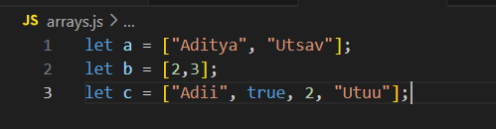

Example: another way to create an array, as well as we are printing

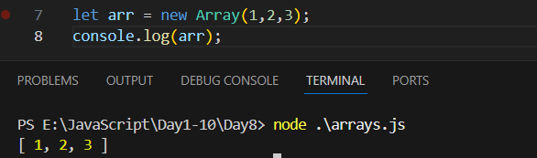

Example: accessing values of arrays

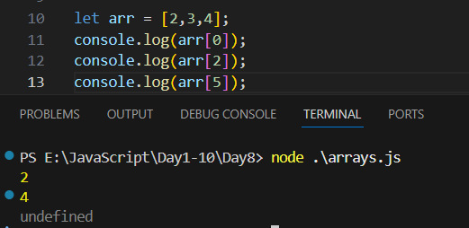

Example: to get the length of the array

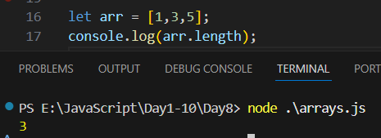

Example: arrays are mutable

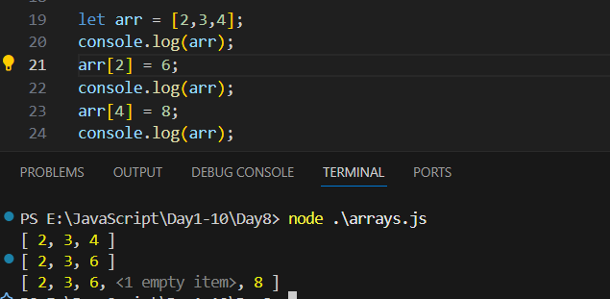

--The End--