**Day 9**



**JavaScript Array Methods:**

**JavaScript Array Methods**

Arrays in JavaScript come with many built-in methods to add, remove, search, and manipulate elements easily.

Example: .toString()

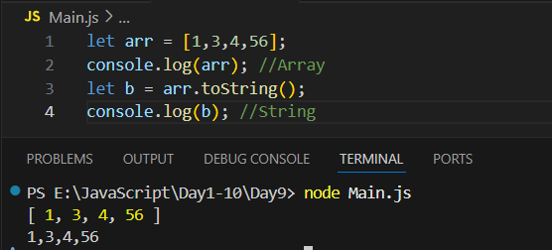

Example: .join()

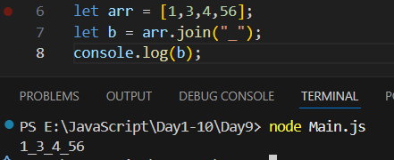

Example: .pop()

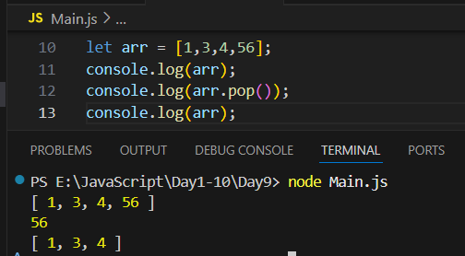

Example: .push()

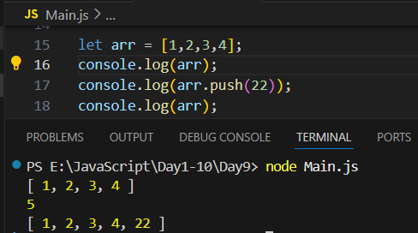

Example: .shift()

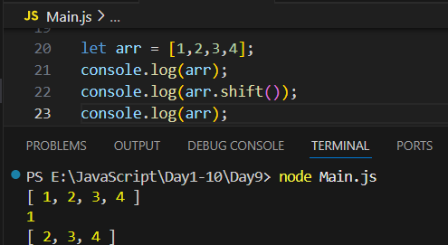

Example: .unshift()

