**Day 11**

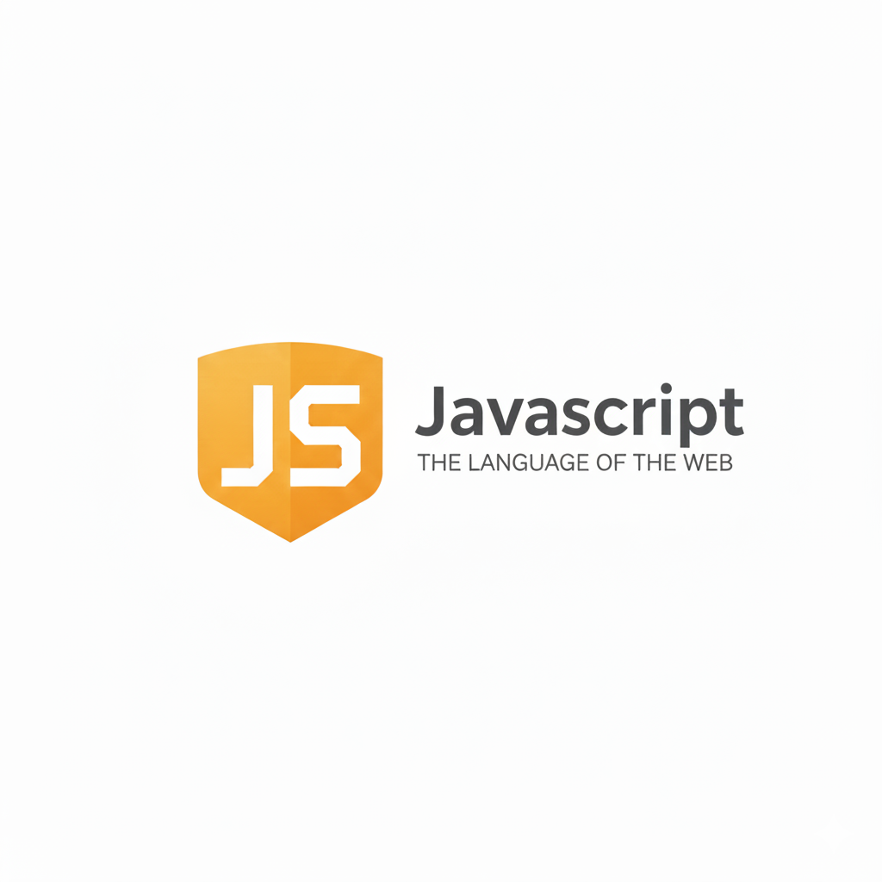

**JavaScript in the Browser:**

**JavaScript in the Browser**

When JavaScript runs inside a web browser, it can interact with the webpage (HTML) and the user. Browsers like Chrome, Firefox, Edge, etc., have a built-in JavaScript Engine that reads and executes JavaScript code.

Example:

* Chrome → uses V8 Engine
* Firefox → uses SpiderMonkey

**JavaScript Script Tag:**

**<script> tag:**

Way 1: giving source “.js” address

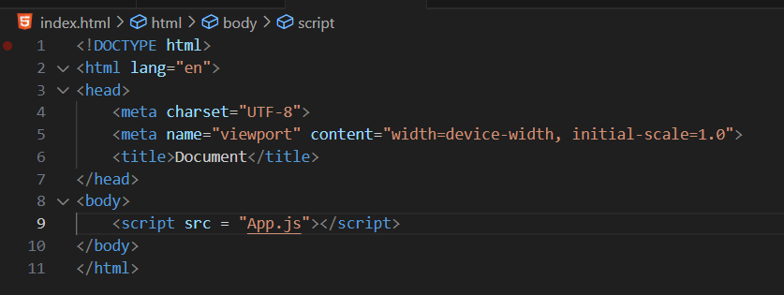

Way 2: writing JS code inside the <script> tag

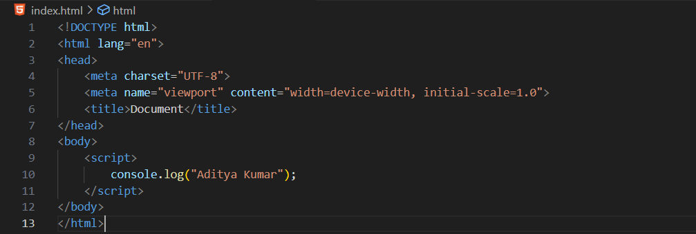

**JavaScript Console Object:**

**What is the Console Object in JavaScript?**

The console object is a built-in object in JavaScript that helps display messages, debug code, and check values while running your program — usually through the browser’s developer console.

You can open it by pressing: F12 → then click on the Console tab.

**Common methods:**

* log() → print messages
* error() → show errors
* warn() → show warnings
* table() → display data in table form
* clear() → clear console
* time() / timeEnd() → measure time

Example: to list all the available methods, we can use console.log(console)

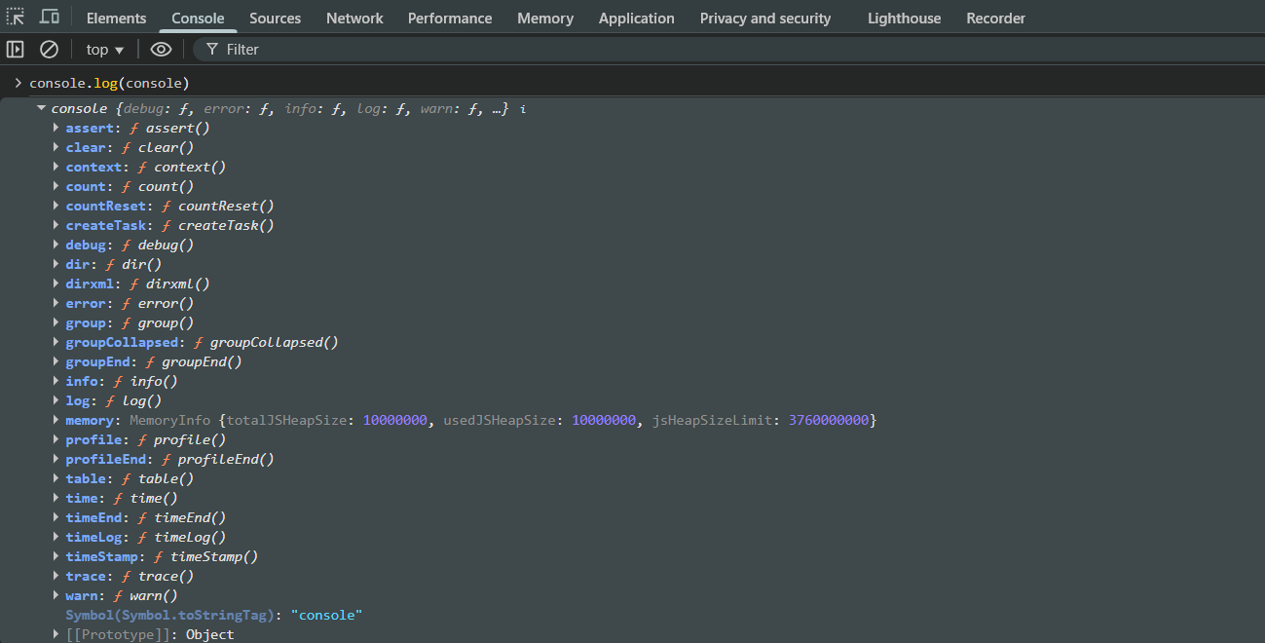

Example: console.log()

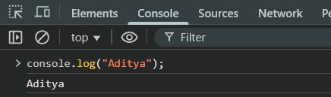

Example: console.error()

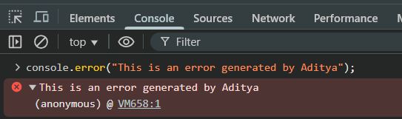

Also, in IDE:

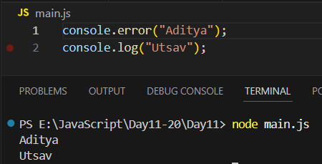

Example: console.assert()

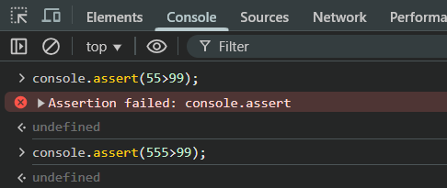

Also,

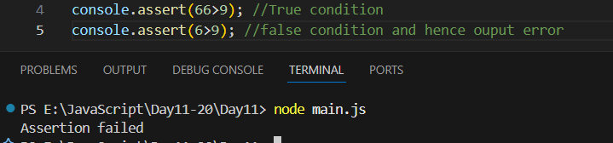

Example: console.clear()

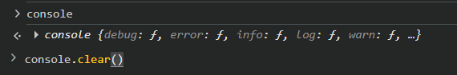

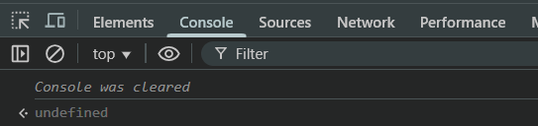

Example: Console.table()

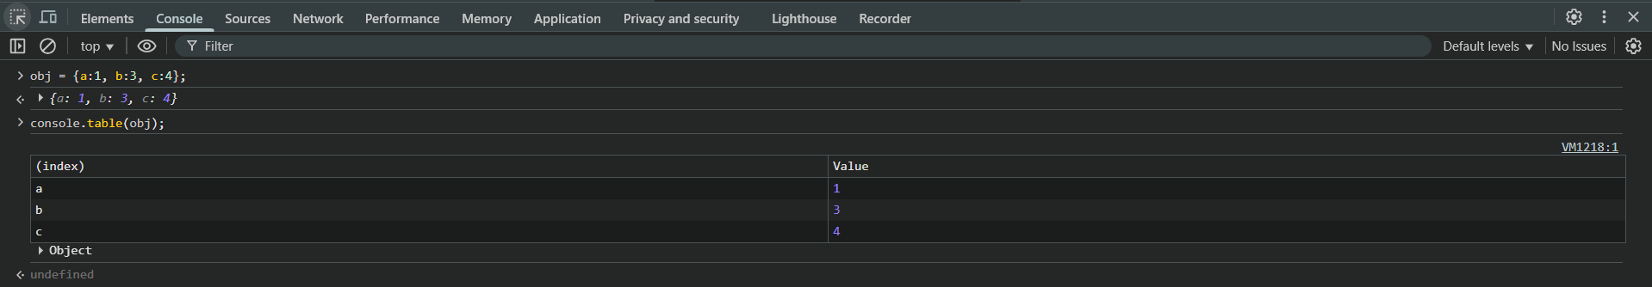

Example: console.warn()

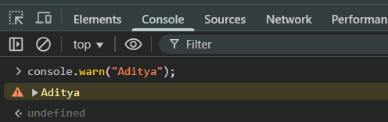

Also,

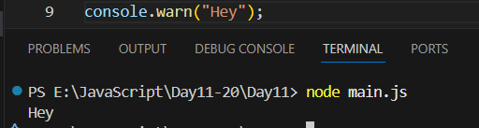

Example: console.info()

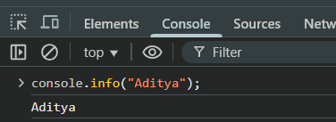

Also,

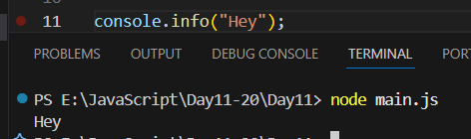

Example: console.time() and console.timeEnd()

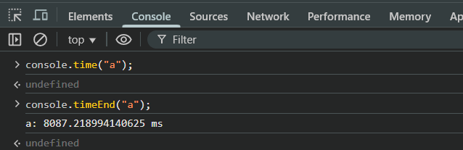

Example: printing the time taken in execution of for loop

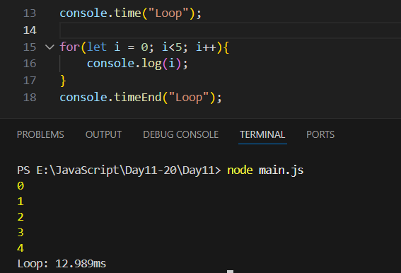

--The End--