**Day 12**

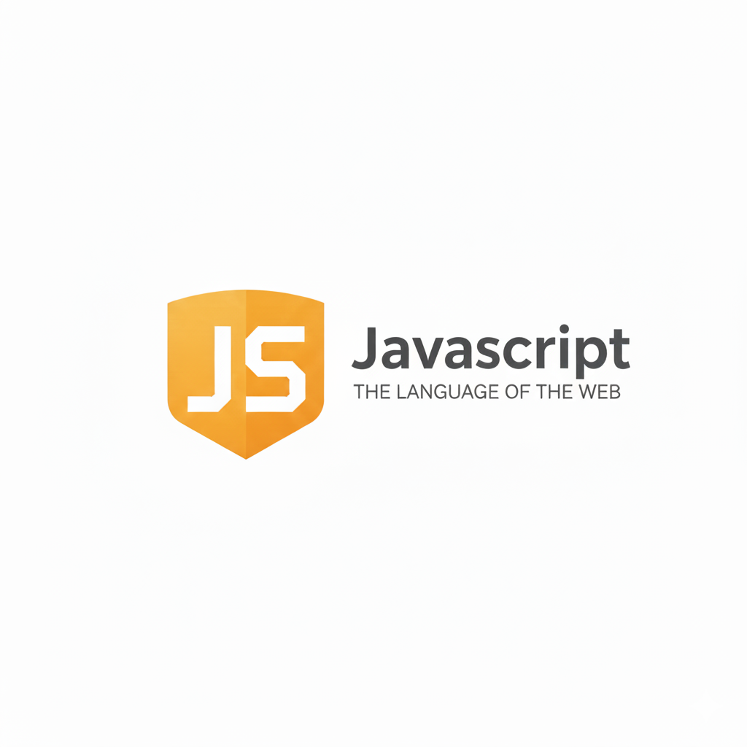

**JavaScript alert, prompt & confirm:**

**alert() — Show a Message**

Purpose: To display a simple message to the user.

Syntax:

*alert("This is an alert message!");*

How it works:

* Shows a popup with an OK button.
* Used to inform the user (no input is taken).

Example:

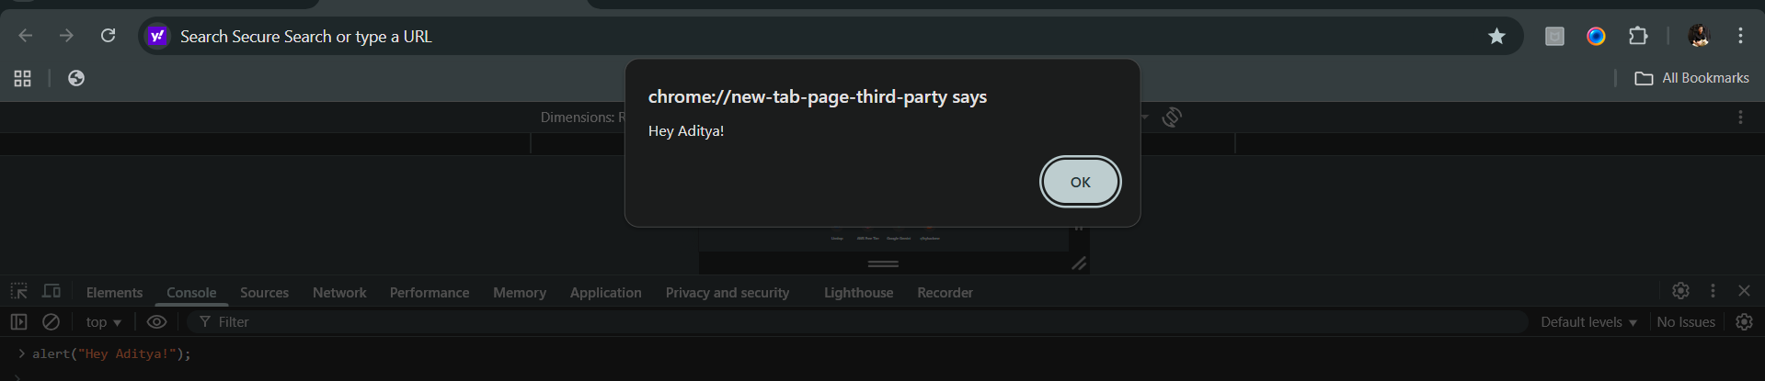

**prompt() — Take Input from the User**

Purpose: To ask the user for some input (like a name or number).

**Syntax:**

*prompt("Enter your name:");*

How it works:

* Shows a popup with a message, an input box, and OK/Cancel buttons.
* Returns the text entered by the user as a string.
* Returns null if the user presses Cancel.

Example:

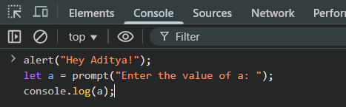

Output: 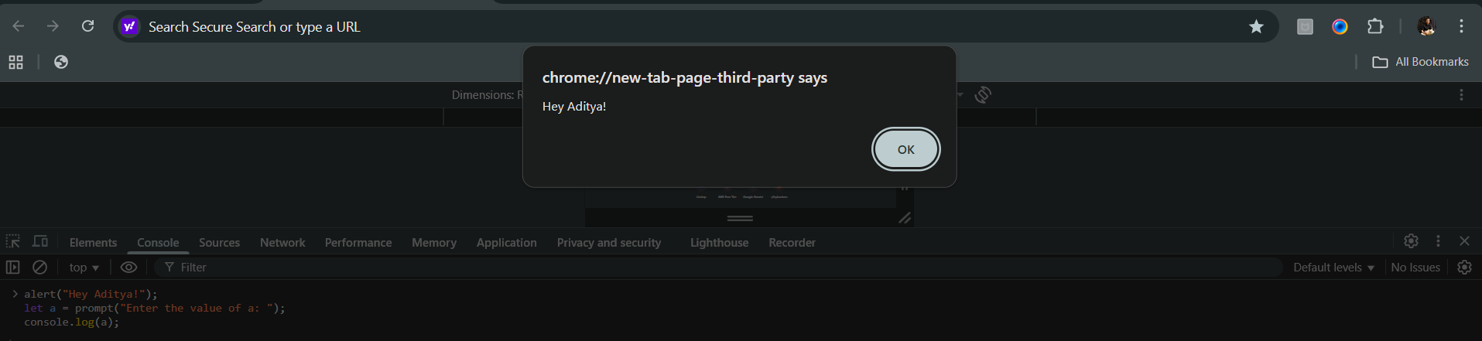

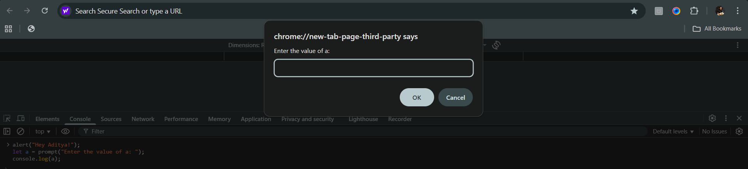



Example: since prompt takes user input as string, we need to convert it into number.

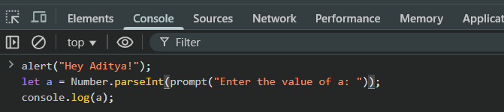

Example: giving default value to the prompt

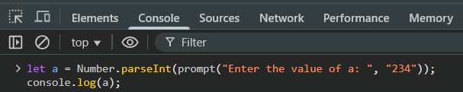

Output:

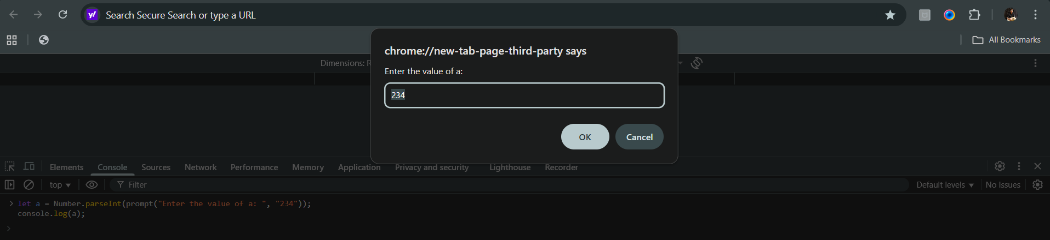

**confirm() — Ask for Confirmation**

Purpose: To ask the user a Yes/No or OK/Cancel type question.

Syntax:

*confirm("Are you sure?");*

How it works:

* Shows a popup with OK and Cancel buttons.
* Returns:
  + true → if the user clicks OK
  + false → if the user clicks Cancel

Example:

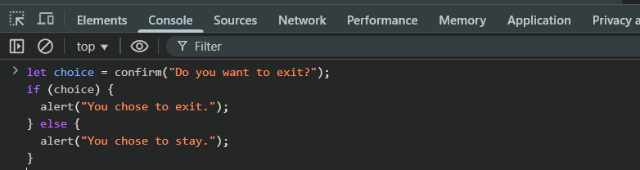

Output:

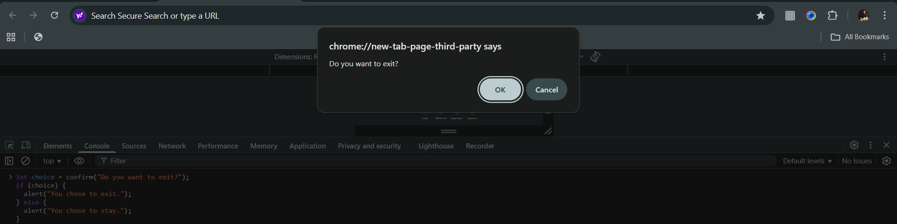

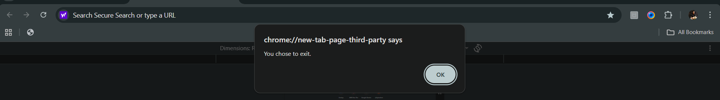

--The End--