**Day 13**



**DOM, BOM & Window Object :**

**What is the Browser Environment?**

When JavaScript runs in a browser, it can interact with:

1. The web page (HTML content)
2. The browser itself
3. The window that contains everything

These are handled using three main parts: DOM, BOM, and Window Object

**Window Object**

The window object is the top-level object in the browser. It represents the browser window or tab where the web page is displayed.

Everything (like alert(), console.log(), document, etc.) is part of the window object.

**DOM (Document Object Model)**

The DOM represents the HTML document as a tree structure. Each HTML element (like <p>, <div>, <h1>) becomes a JavaScript object that you can access or change.

**BOM (Browser Object Model)**

The BOM lets JavaScript interact with the browser (outside the webpage) — like the address bar, alert boxes, history, or screen size.

**Relation Between Them**

Window Object

|── Document Object (DOM)

└── Browser Object Model (BOM)

**Summary**

| **Concept** | **Full Form** | **Deals With** | **Example** |
| --- | --- | --- | --- |
| **Window** | — | Whole browser window/tab | window.alert(), window.innerWidth |
| **DOM** | Document Object Model | Web page (HTML elements) | document.getElementById() |
| **BOM** | Browser Object Model | Browser (URL, history, etc.) | window.location.href, window.open() |

Example: You can skip writing window. because it’s the global object.

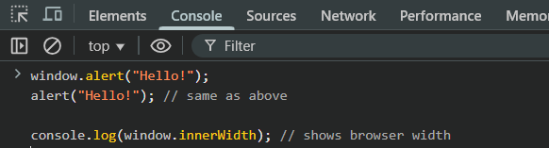

Output:

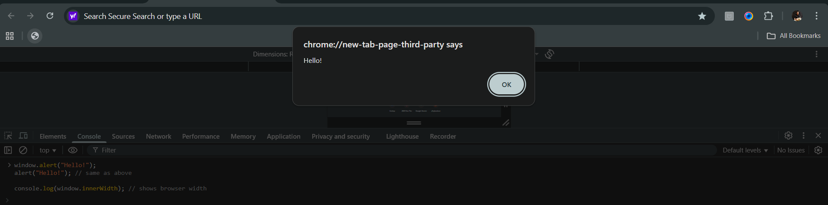



Example: 