Day 47

Hoisting in JavaScript:
Hoisting means:
JavaScript moves variable declarations and function declarations to the top of their scope (before code runs). This allows you to use a variable or function before writing it in the code — but with different behaviors depending on var, let, const, and function types.
How Hoisting Works:
JavaScript has two phases:
1. Creation Phase (Memory Allocation Phase)
- JS scans the entire code.
- It allocates memory for:
  - var declarations → set to undefined
  - let/const → memory reserved but not initialized (they stay in the “Temporal Dead Zone”)
  - function declarations → stored as complete functions
2. Execution Phase
- Code runs line by line.
- Variables get their assigned values during execution.
Why Hoisting Exists?
It helps JavaScript:
- scan code first,
- allocate memory,
- make functions available early.
It is part of JavaScript’s Execution Context creation.
Example:
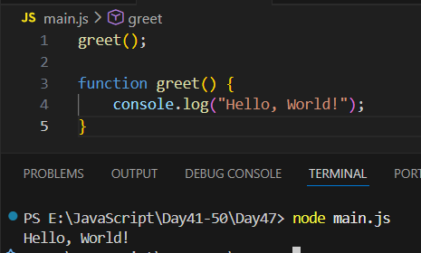
Example: variable is declared later but used earlier, so gives ‘undefined’ as output.
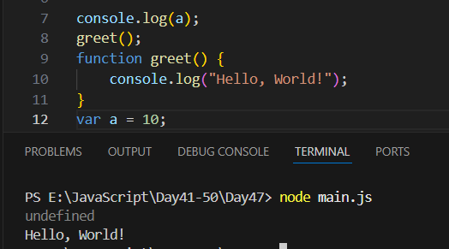
Example: let is used in above example.
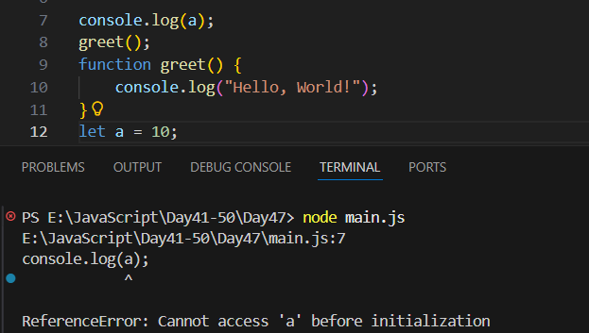

Closures in JavaScript:
What Is a Closure in JavaScript?
A closure is created when a function remembers and can access variables from its outer (parent) function—even after that outer function has finished executing.
Think of a closure as: A backpack that a function carries with it, containing the variables from where it was created.
In simple words:
- A function inside another function
- Inner function keeps access to the outer function’s variables
- Even when the outer function is no longer active
Why Closures Happen:
Closures happen because of how JavaScript works:
- JS creates a scope chain
- Inner functions keep a reference to their outer scope
- Nothing is deleted until JS sees no references
How Closures Work:
Step 1: You create a function inside another function
Step 2: The inner function uses a variable from the outer function
Step 3: You return the inner function
Step 4: Even after the outer function finishes, the returned inner function still remembers the outer variables.
Why Closures Are Useful
- Data privacy (private variables)
- Functions that remember state
- Memoization
- Event handlers
- Callback functions
- Module pattern

Example:
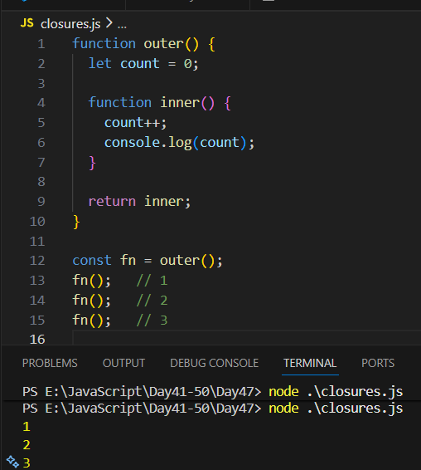
Why does this work?
Even though outer() finished,
inner() still remembers count → closure.

--The End--

