Day 28

Callback Hell & Pyramid of Doom:
What is Callback Hell?
Callback Hell happens when you have too many callbacks inside each other, making the code look messy, confusing, and hard to read.
Simply:
Callback Hell = too many nested functions.
What Causes Callback Hell?
Callback hell happens when:
- Each task depends on the previous one
- And each task uses a callback
- So you keep nesting functions inside functions
Example:
Task 1 → inside it Task 2 → inside it Task 3 → inside it Task 4
This creates deep nesting.
What is the Pyramid of Doom?
When callbacks keep going inward (right side more and more), the code shape looks like a pyramid or stairs.
Example: callback hell
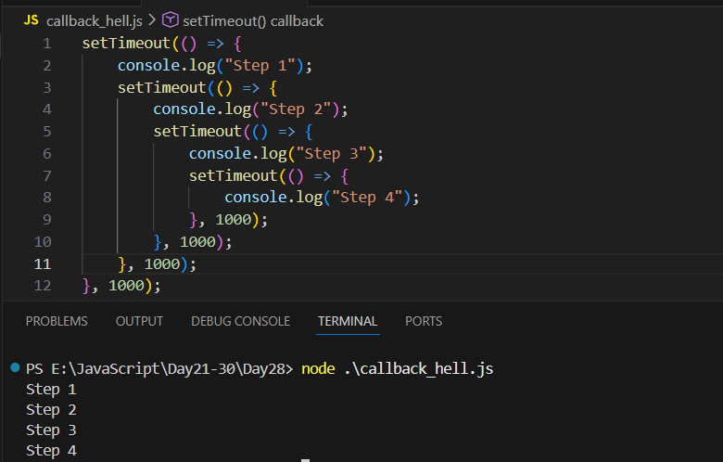
Why is Callback Hell Bad?
- Hard to read
- Hard to understand
- Hard to debug
- Hard to maintain
- Hard to add new code
- Errors become difficult to handle
Solution: Use Promises or async/await.
--The End--

