Day 45

IIFE - Immediately Invoked Function Expressions:
An IIFE is a function in JavaScript that runs immediately as soon as it is created. You don’t need to call it separately. It executes instantly.
Why is it called “Immediately Invoked”?
Because:
- The function is written
- And right after, it is called automatically
In short:
Function is defined + executed at the same moment.
Syntax
The most common IIFE format is:
(function () {
console.log("I run immediately!");
})();
Explanation:
- Function is wrapped inside () → makes it an expression
- Another () invokes it immediately
Where is IIFE used?
- To avoid global variables
- To create private variables
- To run setup code immediately
- To avoid variable conflicts in old JS (before modules)
Example: most basic example
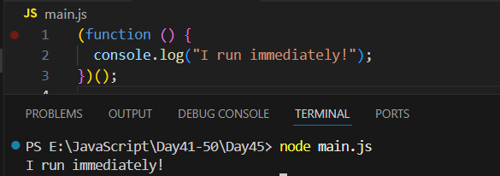
Destructuring assignment and Spread Operator:
What is Destructuring?
Destructuring allows you to extract values from arrays or objects and store them into variables easily.
It is just a short and clean way of writing:
- Take data from array/object
- Put into variables
- Without writing long code
Spread Operator (...)
The spread operator (...) is used to expand (spread) an array or object into individual elements. It spreads values out.
Difference Between Destructuring and Spread in Simple Words
Feature | Destructuring | Spread Operator
Purpose | Extract values | Expand values
Works On | Arrays, Objects | Arrays, Objects
Output | Variables | New array/object
Example | let {a} = obj | {...obj}

Example: array destructuring
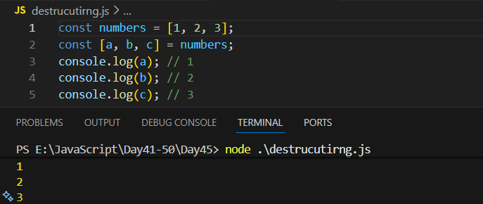

Example:
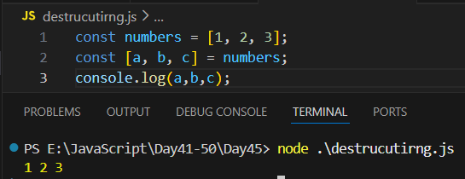
Example: printing something which is not there. It will give an error.
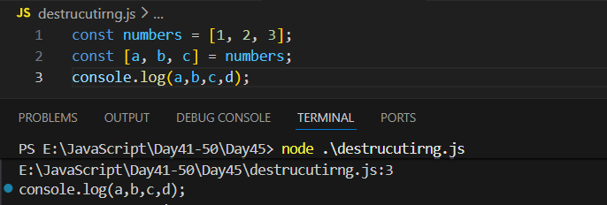
Example: introducing “…rest”
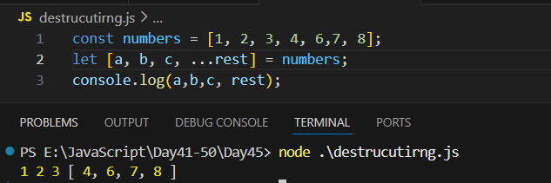
Example: skipping items.
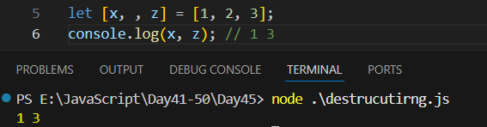
Example: default items.
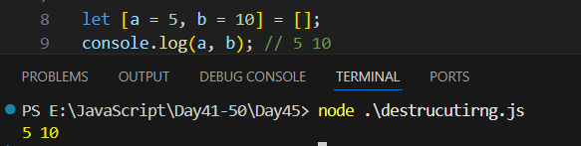
Example: destructuring object
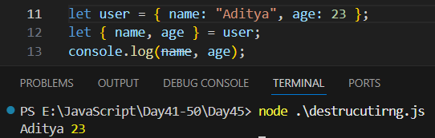
Example: renaming variables
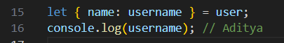
Example: default values
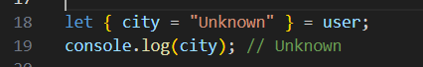
Example: spread operator
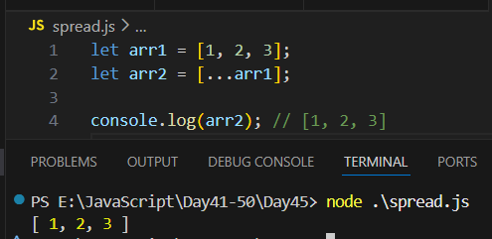
Example: merging array.
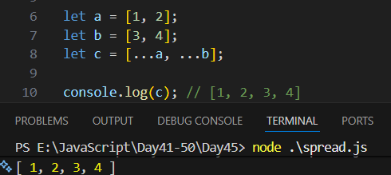
Example: spread with object
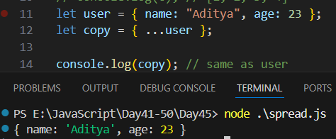
--The End--

