Day 27
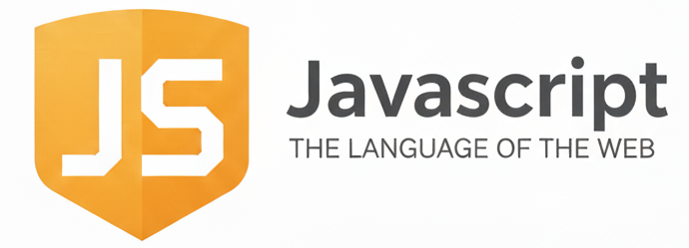
Introduction to Callbacks:
What is a Callback?
A callback is a function that you pass as an argument to another function so that it can run later.
In simple words:
A callback = a function you give to another function to call when it is needed.
Why do we use Callbacks?
Because JavaScript does not wait for things like:
- setTimeout
- file loading
- API requests
- animations
- user actions
So, we use callbacks to run code after something finishes.
Example: a basic example of callback
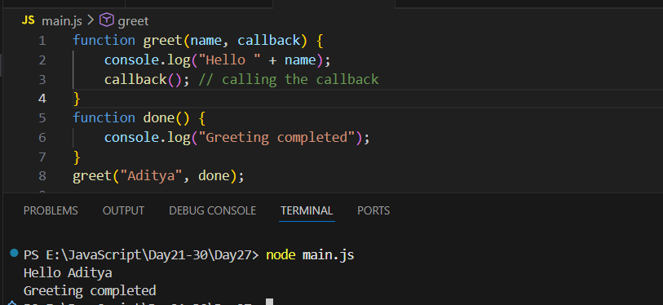

Example:
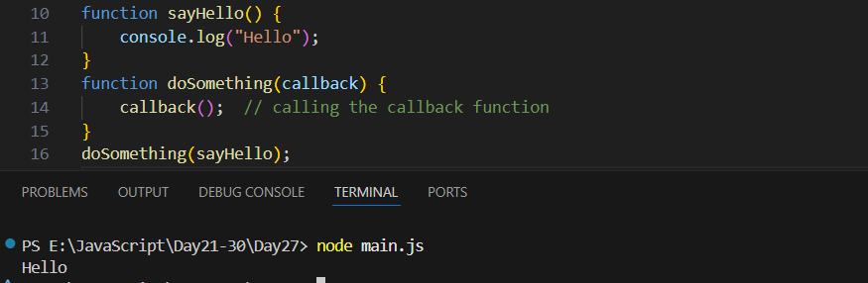
Example: The function inside setTimeout is a callback.
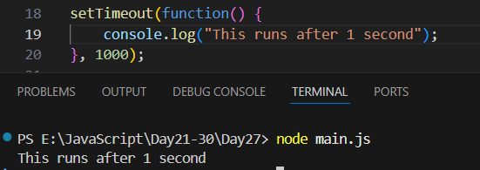
Example: callback with a message
