Day 14
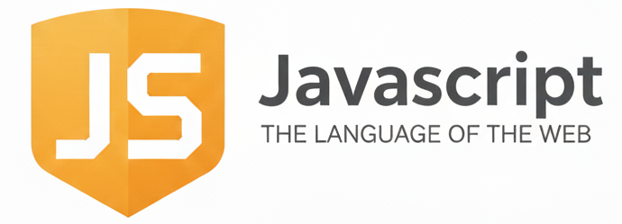
DOM, BOM & Window Object :
What is the Browser Environment?

