Day 36

Cookies in JavaScript:
What are Cookies?
Cookies are small pieces of data stored in the browser. Websites use them to remember things like:
- Login information
- User preferences
- Items in a cart
- Last visited page
Cookies are stored as key–value pairs.
Where can we find cookie for a website?
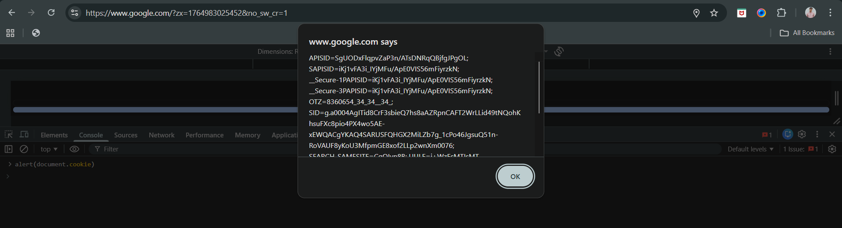
How to Create/Set a Cookie
You set a cookie by writing to document.cookie. By doing so we are adding cookies to the existing cookies, not replacing any cookie.
Example:
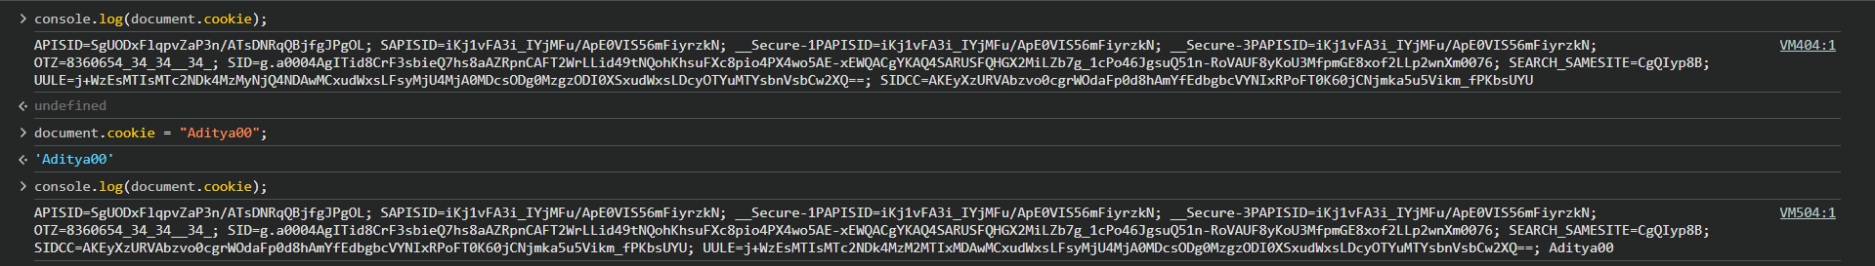

Now, we can also take user input and set them as the part of the cookie:
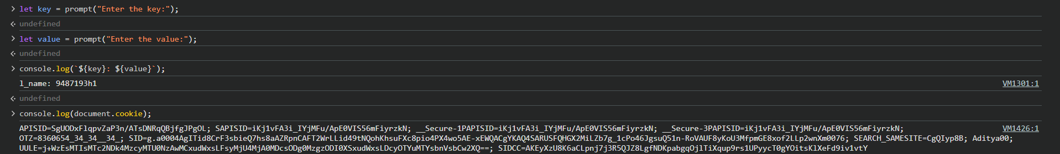
But, will it be able to take and store URI component and store by above method? No! We need to use encodeURIComponent to do so.
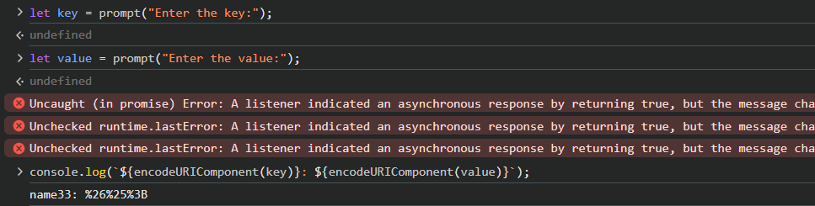
Also, to decode it we are using decodeURIComponent:
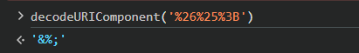
Cookie Options:
Common attributes you can add:
Option | Meaning
expires | When cookie should expire
max-age | How long cookie stays (seconds)
path=/ | Cookie valid for whole site
secure | Only sent over HTTPS
SameSite | Controls cross-site cookie sending

We can’t add multiple cookies just by separating them with “;”:
Important points about cookies:
- Cookies are automatically sent to the server with every request.
- Maximum size is about 4 KB per cookie.
- Cookies can expire using expires or max-age.
- Without expiry, cookies are deleted when the browser closes.
- Cookies are stored as plain text, so avoid storing sensitive data.
- Use secure, HttpOnly, and SameSite for better security.
- Updating a cookie is done by writing it again with the same name.
- Deleting a cookie requires setting an old expiration date.
- Cookies work across pages of the same domain (unless restricted).
- Cookies slow down requests because they are sent every time.
- Cookies store only strings, so objects must be converted using JSON.stringify().

--The End--

