Day 34
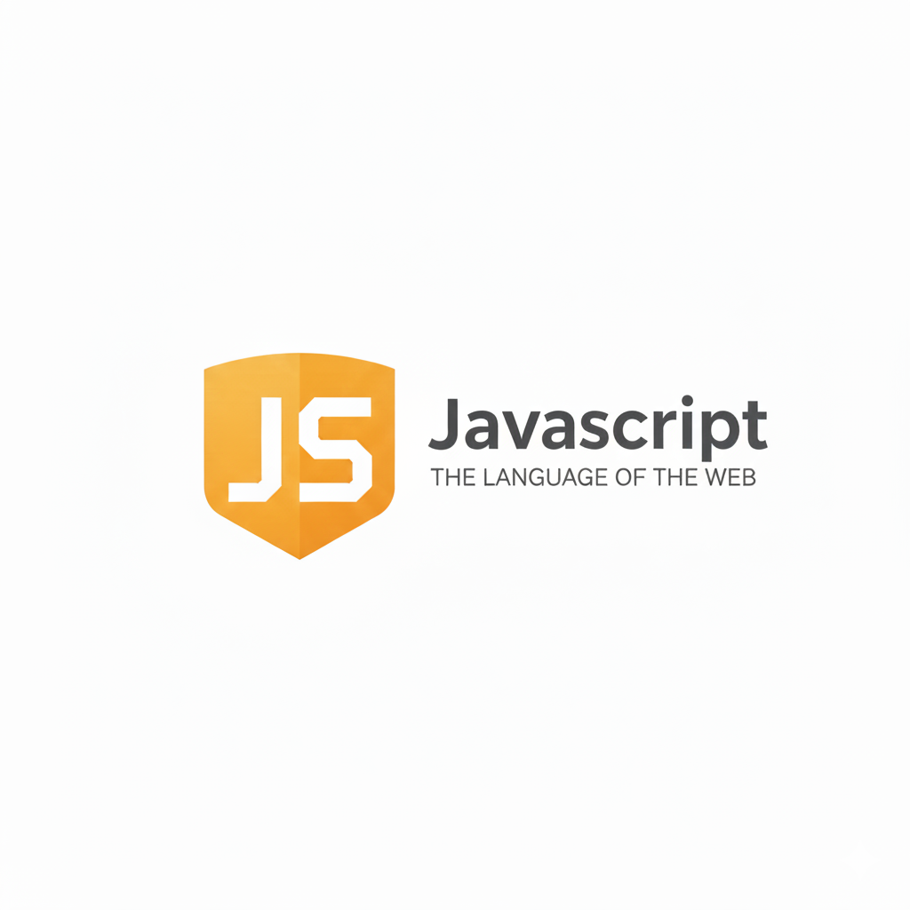
The Finally Clause:
What is the Finally Clause?
The finally block is a part of JavaScript’s error-handling structure (try → catch → finally). It is used to write code that must run no matter what happens—whether an error occurs or not.
Basic idea
- try → code that may cause an error
- catch → runs only if an error happens
- finally → always runs, after try or catch, no matter what
This is why finally is used for things like closing files, stopping timers, cleaning up memory, resetting variables, etc.
Example: a basic try…catch block without finally.
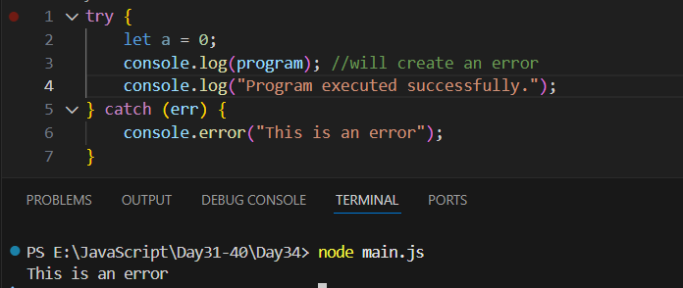

Example: introducing error in the catch block as well as in try block
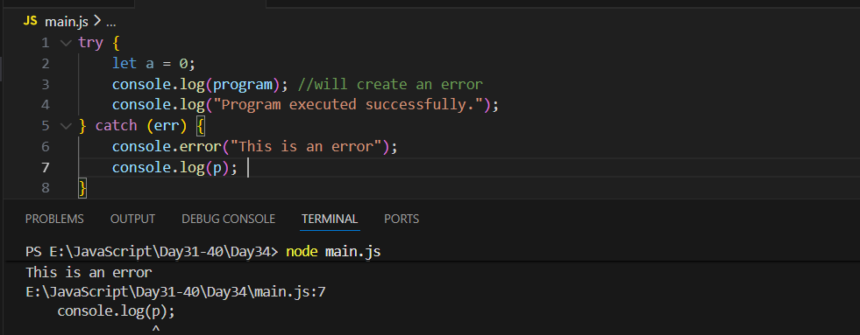
So, what if we write some code after the catch block? It will not run:
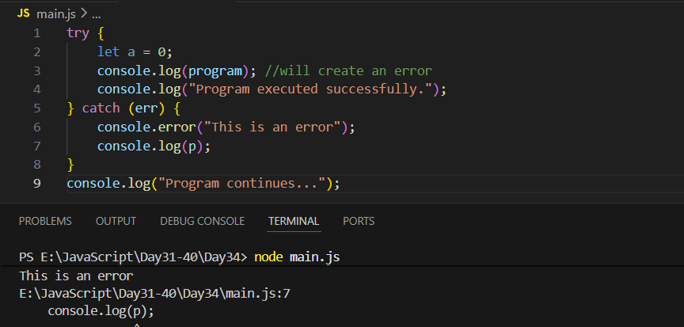
Then how we make sure that if error occurred in “catch” block then the rest of the code should work? We can do so by using the “finally” block:
