Day 33
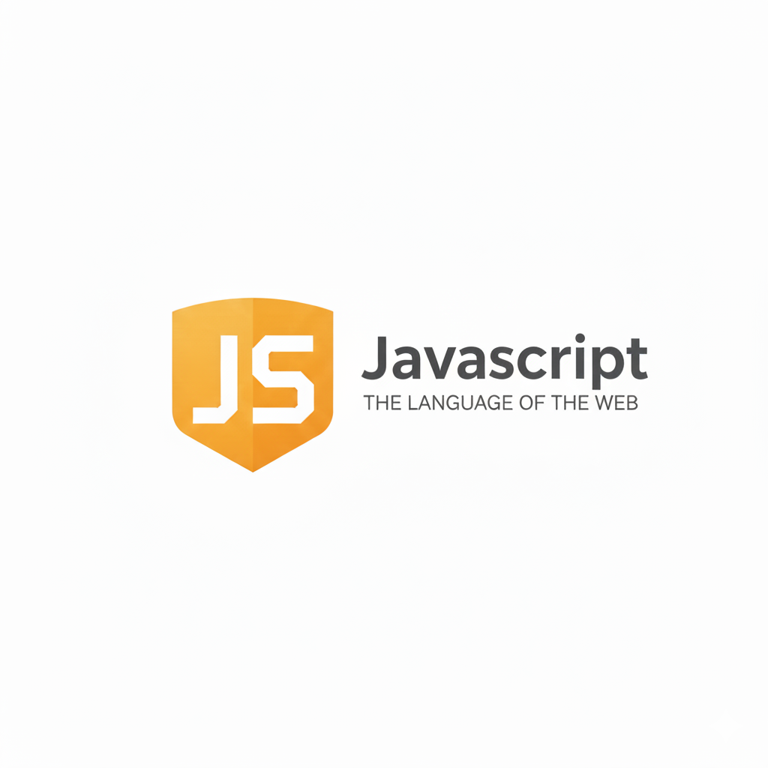
The Error Object & Custom Errors:
What is the Error Object?
In JavaScript, whenever something goes wrong, the language creates an Error object. This object contains useful information about what went wrong.
The Error object has important properties:
Property | Meaning
name | Type of error (Error, ReferenceError, TypeError, etc.)
message | Description of the problem
stack | Where the error happened (line number)

Built-in Error Types (common)
Error Type | When it happens
ReferenceError | Using a variable that doesn't exist
TypeError | Using a wrong data type (calling a number like a function)
SyntaxError | Code written incorrectly (usually caught before running)
RangeError | Number out of allowed range (stack overflow)
Error | Generic error

Example: a basic example showing try…catch.
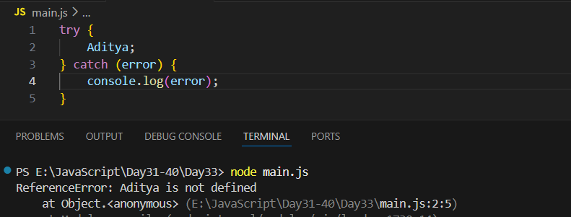
Now, getting the name and message for an error:
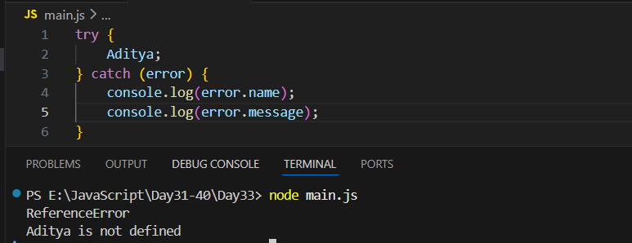
Creating Custom Errors
You can create your own errors using the Error constructor — useful for validation, API responses, and logic checks.
Example:
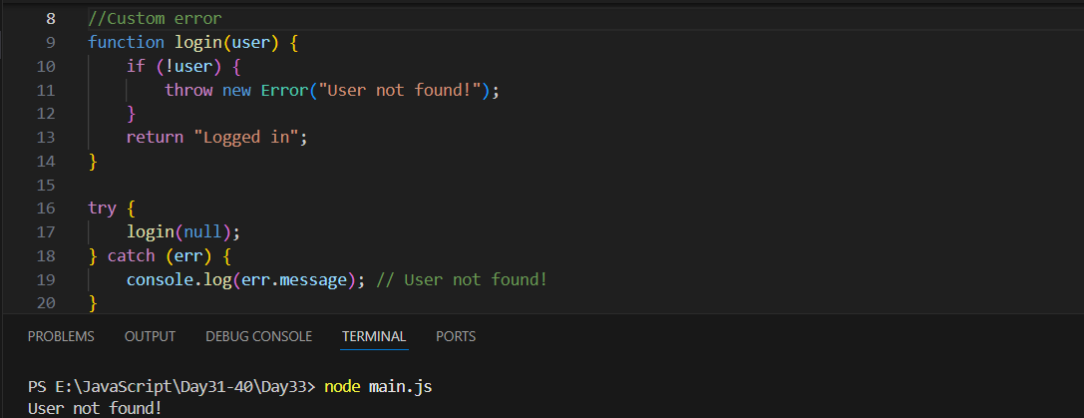

Example: throwing errors manually
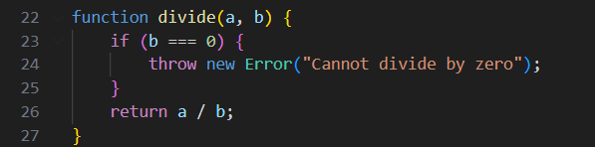
--The End--

