Day 44
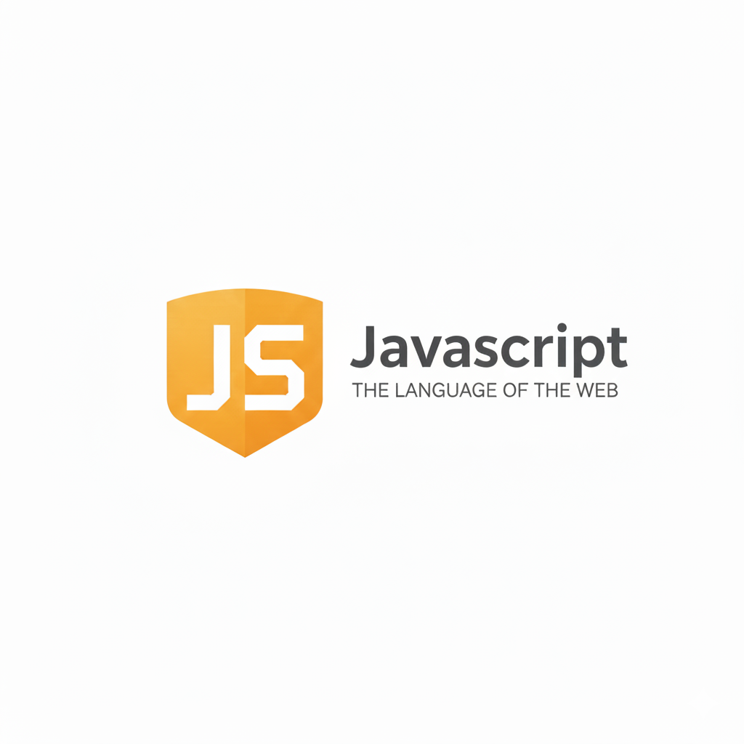
getters, setters & instanceOf Operator in JavaScript:
Getters in JavaScript
A getter is a special method that lets you access a property like a variable, but behind the scenes a function runs. Used to return computed or formatted values.
Syntax
class User {
constructor(name) {
this._name = name; // "_" used to show it's private-like
}

get name() { // getter method
return this._name.toUpperCase();
}
}

const u = new User("aditya");
console.log(u.name); // ADITYA (accessed like a property)

Key Points
- Accessed like a property: obj.property
- No need to call like a function.
- Good for computed values and hiding internal logic.
Example:
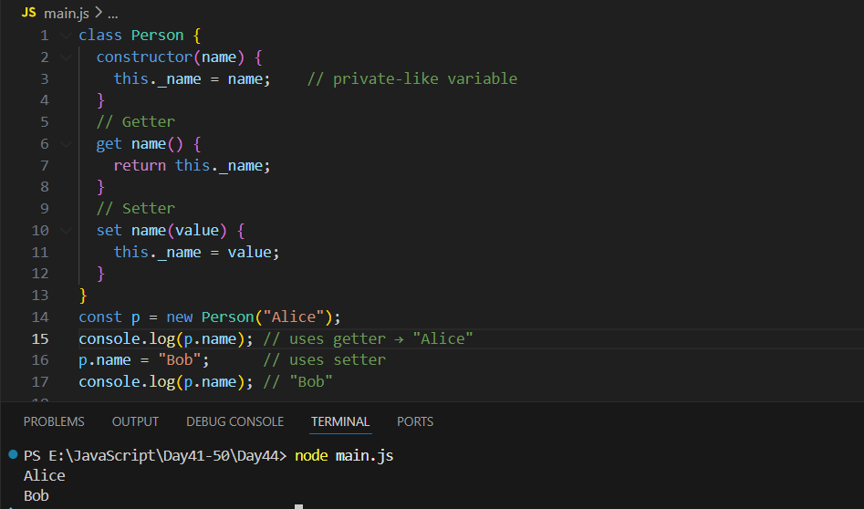
This code creates a Person class where the name is stored in a private-like variable _name. The getter name() lets you read the person's name, and the setter name(value) lets you change it safely. When you create a new person (new Person("Alice")), the getter returns "Alice". Then the setter updates the name to "Bob", and the getter shows the updated value.

Setters in JavaScript
A setter allows you to set/update a property using simple assignment (obj.property = value). Used for validation, formatting, or controlling updates.
Syntax
class User {
constructor(name) {
this._name = name;
}

set name(value) { // setter method
if (value.length < 3) {
console.log("Name too short!");
return;
}
this._name = value;
}
}

const u = new User("Adi");
u.name = "Ak"; // too short → validation triggers
u.name = "Akshay"; // setter updates value

Key Points
- Used like a normal assignment.
- Good for validation & controlling updates.
- Usually paired with a getter.

instanceof Operator:

Checks if an object belongs to a specific class. Returns true/false.

Example:
instanceof checks whether an object was created from a certain class.
Since p was created using new Person(), p instanceof Person is true. And because all classes in JavaScript come from the built-in Object, p instanceof Object is also true.

