Day 38

sessionStorage & related methods:
What is sessionStorage?
sessionStorage is a small key-value storage inside the browser that:
- Stores data only for one browser tab
- Data is deleted when the tab is closed
- Works like localStorage but shorter lifetime
- Stores everything as strings
Why use sessionStorage?
Use it when you want data to exist only while one tab is open, such as:
- Tracking temporary form inputs
- Storing a user’s progress on one page
- Holding JWT tokens for one tab
- Preventing data from leaking across tabs
Important Notes (Very Simple)
- Data stays only until the tab is closed
- Does not share data between tabs
- Max storage ~5MB
- Stores values as strings only
- Not secure → avoid storing passwords
- Data persists on refresh (not lost)
Where can I find this Session storage in my browser?
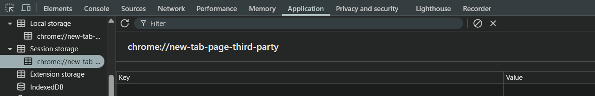

Example: to store a value “sessionStorage.setItem”
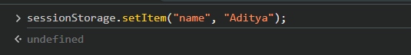
This thing will get reflected as:
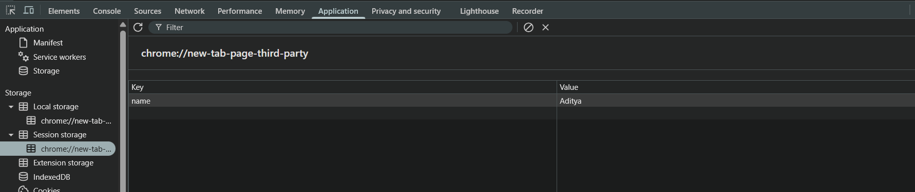
Some other methods:
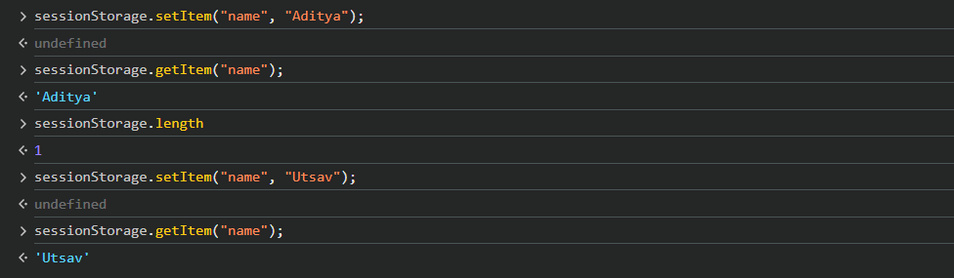
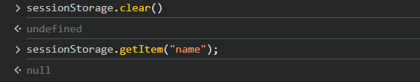

What is the Storage Event?
The storage event is a browser event that triggers when localStorage or sessionStorage changes in another tab.
It fires only in other tabs, NOT in the same tab that made the change.
Why does it exist?
To help multiple tabs sync data.
Example:
- User logs out in one tab → all other tabs also log out.
- Change theme in one tab → update theme in all tabs.
What Data Does the Event Give?
Property | Meaning
key | Key that changed
oldValue | Previous stored value
newValue | Updated value
url | URL of the tab that made the change
storageArea | Tells whether it was localStorage or sessionStorage

Important Notes:
- Fires only in other tabs, not in the same tab.
- Works only for localStorage, not sessionStorage in many browsers.
- Useful for multi-tab communication.
- clear() also triggers the event.
Example:
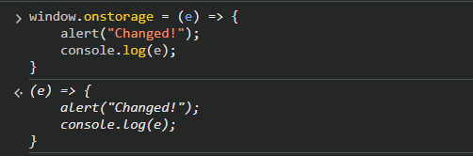
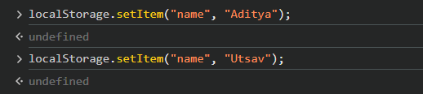
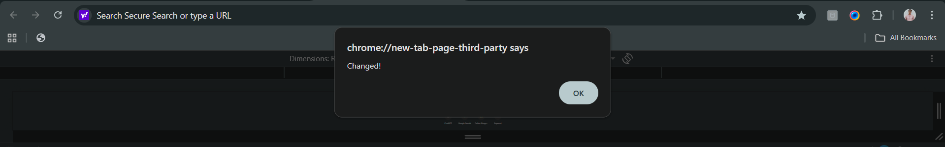
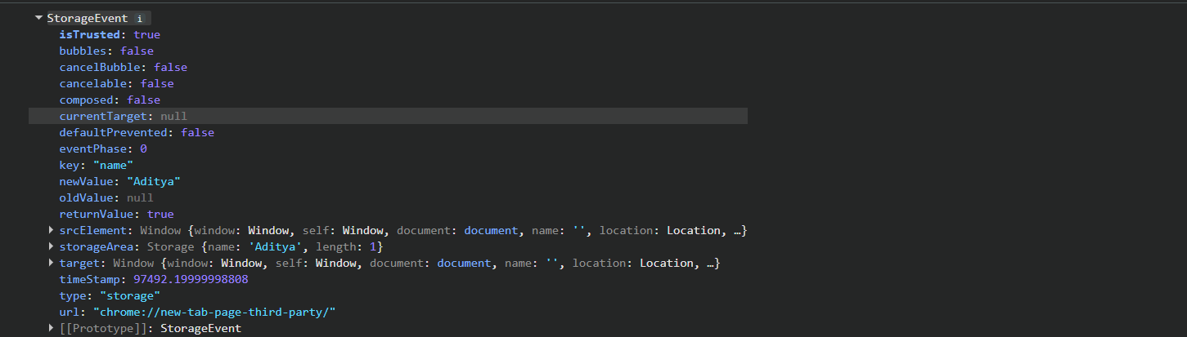
--The End--

