Day 21

HTML Insertion Methods:
HTML Insertion Methods — From Basics
HTML insertion methods are used to add new HTML elements to the page using JavaScript.
Method | Where content is added
append() | inside → end
prepend() | inside → start
before() | outside → before
after() | outside → after
replaceWith() | replace element
insertAdjacentHTML() | anywhere (4 positions)
Example: append()
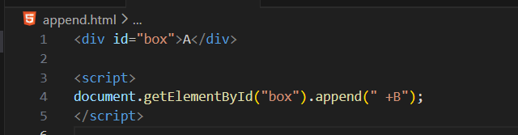
Output:
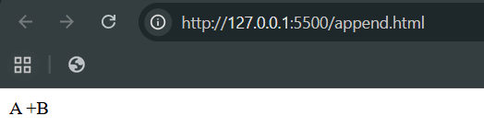

Example: prepend()
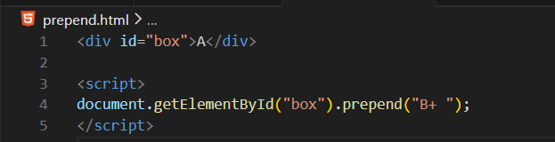
Output:
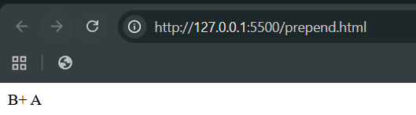
Example: before()
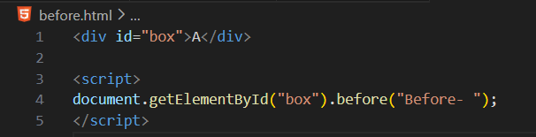
Output:
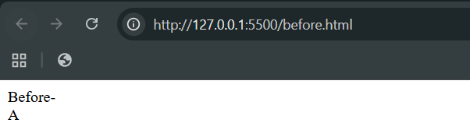

Example: after()
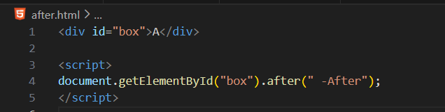
Output:
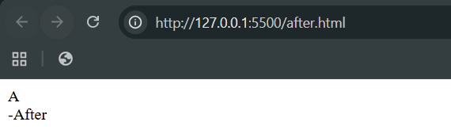
Example: replaceWith()
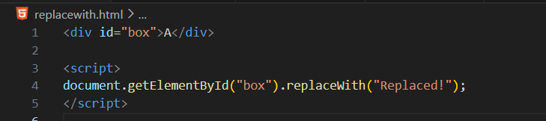
Output:
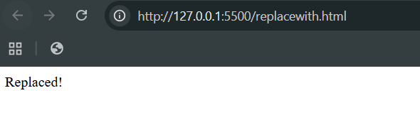

Example: insertAdjacentHTML()
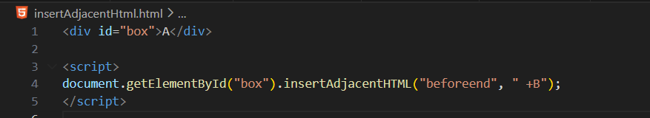
Output:
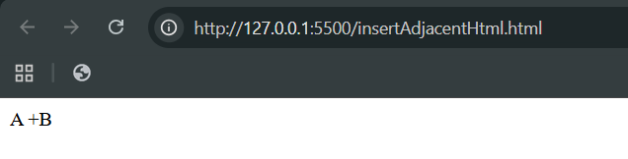
--The End--

